UNITED STATES
SECURITIES AND EXCHANGE COMMISSION
Washington, D.C. 20549
FORM 8-K
CURRENT REPORT
Pursuant to Section 13 or 15(d) of
The Securities Exchange Act of 1934
Date of Report (Date of earliest event reported): July 28, 2026
CTO Realty Growth, Inc.
(Exact name of registrant as specified in its charter)
​  ​ | ​  ​ | ​  ​
Maryland  (State or other jurisdiction of incorporation) | 001-11350  (Commission File Number) | 59-0483700  (IRS Employer Identification No.)
 | 369 N. New York Avenue,  Suite 201  Winter Park, Florida  (Address of principal executive offices) | 32789  (Zip Code)

Registrant’s telephone number, including area code: (407) 904-3324

Not Applicable
(Former name or former address, if changed since last report.)

Check the appropriate box below if the Form 8-K filing is intended to simultaneously satisfy the filing obligation of the registrant under any of the following provisions:
☐ Written communications pursuant to Rule 425 under the Securities Act (17 CFR 230.425)
☐ Soliciting material pursuant to Rule 14a-12 under the Exchange Act (17 CFR 240.14a-12)
☐ Pre-commencement communications pursuant to Rule 14d-2(b) under the Exchange Act (17 CFR 240.14d-2(b))
☐ Pre-commencement communications pursuant to Rule 13e-4(c) under the Exchange Act (17 CFR 240.13e-4(c))
Securities registered pursuant to Section 12(b) of the Act:

.01
Title of each class: | ​ ​ ​ | Trading Symbol | ​ ​ ​ | Name of each exchange on which registered:
Common Stock, $0.01 par value per share |  | CTO |  | NYSE  ​
6.375% Series A Cumulative Redeemable Preferred Stock, $0.01 par value per share | ​ | ​  CTO/PA | ​ | ​  NYSE

Indicate by check mark whether the registrant is an emerging growth company as defined in Rule 405 of the Securities Act of 1933 (§230.405 of this chapter) or Rule 12b-2 of the Securities Exchange Act of 1934 (§240.12b-2 of this chapter).
Emerging growth company ☐
If an emerging growth company, indicate by check mark if the registrant has elected not to use the extended transition period for complying with any new or revised financial accounting standards provided pursuant to Section 13(a) of the Exchange Act. ☐

​
Item 2.02. Results of Operations and Financial Condition
On July 28, 2026, CTO Realty Growth, Inc., a Maryland corporation (the "Company"), issued an earnings press release, an investor presentation, and a supplemental disclosure package relating to the Company’s financial results for the quarter and six months ended June 30, 2026. Copies of the press release, investor presentation, and supplemental disclosure package are attached hereto as Exhibits 99.1, 99.2 and 99.3, respectively, and are incorporated herein by reference.
The information in Item 2.02 of this Current Report, including Exhibits 99.1, 99.2 and 99.3, is being furnished and shall not be deemed “filed” for purposes of Section 18 of the Securities Exchange Act of 1934, as amended (the “Exchange Act”), or otherwise subject to the liabilities of that Section. The information in this Current Report shall not be incorporated by reference into any registration statement or other document pursuant to the Securities Act of 1933, as amended (the “Securities Act”), or the Exchange Act, unless it is specifically incorporated by reference therein.
Item 7.01. Regulation FD Disclosure
On July 28, 2026, the Company issued an earnings press release, an investor presentation, and a supplemental disclosure package relating to the Company’s financial results for the quarter and six months ended June 30, 2026. Copies of the earnings press release, investor presentation, and supplemental disclosure package are attached hereto as Exhibits 99.1, 99.2 and 99.3, respectively, and are incorporated herein by reference.
The furnishing of these materials is not intended to constitute a representation that such furnishing is required by Regulation FD or other securities laws, or that the materials include material investor information that is not otherwise publicly available. In addition, the Company does not assume any obligation to update such information in the future.
The information in Item 7.01 of this Current Report, including Exhibits 99.1, 99.2 and 99.3, is being furnished and shall not be deemed to be “filed” for purposes of Section 18 of the Exchange Act or otherwise subject to the liabilities of that Section. The information in this Current Report shall not be incorporated by reference into any registration statement or other document pursuant to the Securities Act or the Exchange Act, unless it is specifically incorporated by reference therein.
Item 9.01. Financial Statements and Exhibits
​
(d) Exhibits
​
​
99.1 Earnings Press Release dated July 28, 2026
99.2 Investor Presentation dated July 28, 2026
99.3 Supplemental Disclosure Package
104 Cover Page Interactive Data File (embedded within the Inline XBRL document)
​
​
​
SIGNATURES
​
Pursuant to the requirements of the Securities Exchange Act of 1934, the registrant has duly caused this report to be signed on its behalf by the undersigned hereunto duly authorized.
​
Date: July 28, 2026
​
CTO Realty Growth, Inc.
​
By: /s/ Philip R. Mays
Senior Vice President, Chief Financial Officer,
and Treasurer (Principal Financial Officer)

​
​
​
Exhibit 99.1
​
​

DRAFT DRATDDD
Press Release
​  ​  ​ |  | First  2024 Operating Results  ​
FOR  IMMEDIATE  RELEASE | ​  CTO Realty Growth Reports Second  Quarter 2026 Operating and Financial Results  ​  – Closed $153 million of investments at a weighted average initial yield of 10.2% –  – Raises Investment Guidance to $300 million to $400 million –  – Increases 2026 Core FFO Per Diluted Share Guidance to $2.09 to $2.13 –  ​
​
WINTER PARK, FL – July 28, 2026 – CTO Realty Growth, Inc. (NYSE: CTO) (the “Company” or “CTO”), an owner and operator of shopping centers located primarily in higher-growth markets, today announced its operating and financial results for the quarter ended June 30, 2026. Net Income attributable to common stockholders was $0.38 per diluted share for the second quarter.
Second Quarter 2026 Highlights
◾Core Funds from Operations (“Core FFO”) attributable to common stockholders of $0.53 per diluted share.
◾Adjusted Funds from Operations (“AFFO”) attributable to common stockholders of $0.55 per diluted share.
◾Executed 184,000 square feet of comparable retail leases at a positive cash rent spread of 6%.
◾Acquired Gallery on the Parkway, a 152,000 square foot open-air retail center anchored by Dick’s House of Sport located in Dallas, Texas, for $53.3 million.
◾Invested $75.0 million of preferred equity in a Class A premier retail property located in the Southwest. The investment generates a 12.0% initial cash yield, with a two-year term.
◾Invested $21.4 million of preferred equity in a Whole Foods-anchored retail development located in the Northeast. The investment generates a 12.0% initial yield, including 3.0% accrued PIK, with an 18-month term.
◾Completed $90.7 million of property dispositions at a weighted average exit cash cap rate of 6.7%.
◾Under contract to sell, subject to certain closing conditions, 76,500 square feet formerly leased to Value City Furniture and Jo-Ann Fabrics at Carolina Pavilion, located in Charlotte, North Carolina, to a national retailer.
◾Income from Alpine Income Property Trust (NYSE: PINE) for the quarter was $2.1 million, consisting of $1.4 million in management fees and $0.7 million in dividend income. Prospectively, the new annualized run-rate for income from PINE is $8.9 million as of June 30, 2026, consisting of $5.7 million in management fees and $3.2 million in dividend income.
◾Issued 4,183,616 common shares under our common stock ATM program at a weighted average gross price of $20.29 per share, for total net proceeds of $83.6 million.
​
“We delivered another strong quarter, deploying $153 million of capital at a weighted average initial yield of 10.2% and strong same-property NOI growth,” stated John P. Albright, President and Chief Executive Officer of CTO Realty Growth. “We believe that the acquisition of Gallery on the Parkway in Dallas, together with our structured investment activity during the quarter, reflects our disciplined strategy of acquiring and financing high-quality, well-located retail centers predominantly in our core growth markets. With a robust acquisition pipeline and meaningful embedded NOI growth across the portfolio, we believe that the Company is well positioned to deliver continued earnings growth into 2027.”

Financial Results
​
​ | ​ | ​ | ​ | ​ | ​ | ​ | ​ | ​ | ​ | ​ | ​ | ​
(in thousands, except per share data) | ​ ​ ​ | 2Q 2026 |  | ​ | 2Q 2025 |  | ​ | YTD 2026 |  | ​ | YTD 2025
Net Income (Loss) | ​ | $ | 13,234 | ​ | $ | (25,296) | ​ | $ | 17,561 | ​ | $ | (24,913)
Net Income (Loss) per Common Share - Diluted | ​ | $ | 0.38 | ​ | $ | (0.77) | ​ | $ | 0.52 | ​ | $ | (0.78)
​ | ​ | ​ | ​ | ​ | ​ | ​ | ​ | ​ | ​ | ​ | ​ | ​
Core FFO | ​ | $ | 18,438 | ​ | $ | 14,659 | ​ | $ | 35,369 | ​ | $ | 29,104
Core FFO per Common Share - Diluted | ​ | $ | 0.53 | ​ | $ | 0.45 | ​ | $ | 1.05 | ​ | $ | 0.90
​ | ​ | ​ | ​ | ​ | ​ | ​ | ​ | ​ | ​ | ​ | ​ | ​
AFFO | ​ | $ | 19,135 | ​ | $ | 15,267 | ​ | $ | 37,373 | ​ | $ | 30,788
AFFO per Common Share - Diluted | ​ | $ | 0.55 | ​ | $ | 0.47 | ​ | $ | 1.11 | ​ | $ | 0.96
Metrics reflect amounts attributable to common stockholders. Refer to “Non-GAAP Financial Measures” for definitions and additional detail. Reconciliations of non-GAAP measures to the most directly comparable GAAP measure are provided in the tables accompanying this press release.
​
​
Second Quarter and Year-to-Date June 30, 2026 Portfolio Performance
Retail Leasing Activity
 | ◾ | During the three months ended June 30, 2026, the Company executed 25 new leases, renewals and extensions totaling 213,000 square feet. On a comparable space basis, the Company executed 184,000 square feet of leases at an average cash rent spread increase of 6%.
 | ◾ | During the six months ended June 30, 2026, the Company executed 50 new leases, renewals and extensions totaling 366,000 square feet. On a comparable space basis, the Company executed 330,000 square feet of leases at an average cash rent spread increase of 10%.
​
Same Property NOI
 | ◾ | During the three months ended June 30, 2026, shopping center same property NOI increased by 10.1% versus the comparable 2025 period.
 | ◾ | During the six months ended June 30, 2026, shopping center same property NOI increased by 8.2% versus the comparable 2025 period. Excluding certain non-recurring recovery benefits, shopping center same property NOI increased by 7.0% versus the comparable 2025 period.
 | ◾ | Including other/non-core properties, same-property NOI increased by 6.7% for the second quarter and 4.5% for the six months ended June 30, 2026. This growth was impacted by one tenant vacating 98,000 of our 212,000 square feet Albuquerque, New Mexico property in December 2025. As previously announced, this vacancy was leased by the State of New Mexico which is expected to commence paying rent in late 2026.
​
Occupancy
 | ◾ | As of June 30, 2026, total property portfolio leased occupancy was 95.4%, up 150 basis points compared to June 30, 2025, and a decrease of 50 basis points compared to December 31, 2025.
 | ◾ | As of June 30, 2026, same-property shopping center portfolio leased occupancy was 95.0%, up 60 basis points compared to June 30, 2025.
​
​
​
Page 2
​

Second Quarter and Year-to-Date June 30, 2026 Investment and Disposition Activity
Investment Activity
 | ◾ | During the three months ended June 30, 2026, completed $152.6 million of investments at a weighted average yield of 10.2% consisting of:
 | o | $53.3 million acquisition of Gallery on the Parkway, a 152,000 square-foot open-air retail power center in Dallas, Texas. The property is anchored by Dick’s House of Sport, Nordstrom Rack, Cost Plus World Market, and a Portillo’s, and is 100% occupied. Situated on 12 acres just two miles from the site of the Dallas Mavericks’ proposed new arena and entertainment district, the center serves a dense trade area with a population of approximately 368,000 within a five-mile radius.
 | o | $96.4 million of two newly originated structured investments consisting of:
 | ◾ | $21.4 million preferred equity investment in a grocery-anchored development located in the Northeast, fully funded at close, with an initial yield of 12.0% (including 3.0% paid-in-kind interest).
 | ◾ | $75.0 million preferred equity investment in a class A retail property located in the Southwest, fully funded at close, with an initial cash yield of 12.0%.
 | o | $3.0 million acquisition of 1.3 acres of beachfront land in Daytona Beach, Florida, to expand two existing restaurant tenants.
 | ◾ | During the six months ended June 30, 2026, completed $234.2 million of investments at a weighted average yield of 9.5%.
 | ◾ | Subsequent to June 30, 2026, on July 15, 2026, the Company originated a $37.0 million loan, of which $29.8 million was funded at closing. The investment is secured by a leasehold interest in a mixed-use property located in Austin, Texas, generates a 9.75% initial cash yield, and has a two-year term.
​
Disposition Activity
 | ◾ | During the three months ended June 30, 2026, completed $90.7 million of property dispositions at a weighted average exit cash cap rate of 6.7%, generating aggregate gains of $2.1 million.
 | o | $17.4 million sale of Granada Plaza, a 74,000 square-foot grocery-anchored shopping center in Tampa, Florida.
 | o | $73.3 million sale of Madison Yards, a 163,000-square-foot grocery-anchored shopping center in Atlanta, Georgia.
 | ◾ | Additionally, during the six months ended June 30, 2026, the Company’s preferred investment in Watters Creek Village, a grocery-anchored, mixed-use property located in Allen, Texas, was repaid in full for $30.0 million.
Balance Sheet and Liquidity
Balance sheet highlights as of June 30, 2026, included:
​
 | ◾ | Total liquidity of $131.8 million, consisting of $107.0 million of undrawn commitments and $24.8 million of cash on hand.
 | ◾ | Total borrowings of $660.8 million at a weighted average interest rate of 4.6%, including $643.0 million of unsecured borrowings and a $17.8 million mortgage payable.
 | ◾ | Net Debt to Pro Forma Adjusted EBITDA of 5.8 times, a decrease from 6.4 times as of March 31, 2026.
 | ◾ | During the quarter ended June 30, 2026, the Company issued 4,183,616 common shares under its common stock ATM program at a weighted average gross price of $20.29 per share, for total net proceeds of $83.6 million. During the six months ended June 30, 2026, the Company issued 4,917,499 common shares under its common stock ATM program at a weighted average gross price of $20.18 per share, for total net proceeds of $97.8 million.
 | ◾ | The Company’s only 2026 loan maturity is a $17.8 million mortgage note payable, maturing in August at an interest rate of 4.06%.
Page 3
​

2026 Outlook
​
The Company is revising its 2026 outlook. The Company’s 2026 guidance is based on current plans and a number of assumptions and is subject to risks and uncertainties, many of which are outside the Company’s control, and are more fully described in this press release and in the Company's reports filed with the U.S. Securities and Exchange Commission.
​
The Company has raised its 2026 outlook as follows:
​
​ | ​ | ​ | ​ | ​
(Unaudited) | ​ | Current | ​ | Previous
Core FFO per Common Share - Diluted | ​ | $2.09 to $2.13 | ​ | $2.06 to $2.11
AFFO per Common Share - Diluted | ​ | $2.21 to $2.25 | ​ | $2.19 to $2.24
Metrics above reflect amounts attributable to common stockholders.
​
The Company’s revised 2026 outlook includes but is not limited to the following assumptions (dollars in millions):
​
​ | ​ | ​ | ​ | ​
​ | ​ | Current | ​ | Previous
Investment Volume, Including Commercial Loans & Structured Investments | ​ | $300 to $400 | ​ | $175 to $250
Same-Property NOI Growth for Shopping Centers | ​ | 5.0% to 6.0% | ​ | 3.5% to 4.5%
General & Administrative Expenses | ​ | $20.0 to $20.2 | ​ | $19.7 to $20.2
​
Reconciliation of the outlook range of the Company’s 2026 estimated Net Income Attributable to the Company per Diluted Share to estimated Core FFO Attributable to Common Stockholders per Diluted Share, and AFFO Attributable to Common Stockholders per Diluted Share:
​
​ | ​ | ​ | ​ | ​ | ​ | ​
​ | ​ | Revised 2026 Outlook
(Unaudited) | ​ | Low |  | ​ | High
Net Income Attributable to the Company per Common Share - Diluted | ​ | $ | 0.87 | ​ | $ | 0.92
Depreciation and Amortization of Real Estate | ​ | ​ | 1.87 | ​ | ​ | 1.87
Gain on Disposition of Assets (1) | ​ | ​ | (0.06) | ​ | ​ | (0.06)
Provision for Impairment and Adjustment to CECL Reserve (1) | ​ | ​ | 0.02 | ​ | ​ | 0.02
Realized and Unrealized Gain on Investment Securities, Net of Income Tax (1) | ​ | ​ | (0.31) | ​ | ​ | (0.31)
Funds from Operations, per Common Share - Diluted | ​ | $ | 2.39 | ​ | $ | 2.44
Distributions to Preferred Stockholders | ​ | ​ | (0.21) | ​ | ​ | (0.21)
Funds From Operations Attributable to Common Stockholders per Common Share - Diluted | ​ | $ | 2.18 | ​ | $ | 2.23
Amortization of Intangibles to Lease Income | ​ | ​ | (0.09) | ​ | ​ | (0.10)
Core FFO Attributable to Common Stockholders per Common Share - Diluted | ​ | $ | 2.09 | ​ | $ | 2.13
Adjustments: | ​ | ​ | ​ | ​ | ​ | ​
Straight-Line Rent Adjustment | ​ | ​ | (0.03) | ​ | ​ | (0.03)
Amortization of Loan Costs and Capitalized Interest | ​ | ​ | 0.02 | ​ | ​ | 0.02
Non-Cash Compensation | ​ | ​ | 0.13 | ​ | ​ | 0.13
AFFO Attributable to Common Stockholders per Common Share - Diluted | ​ | $ | 2.21 | ​ | $ | 2.25

 | (1) | Gain on Disposition of Assets, Provision for Impairment and Adjustment to CECL Reserve, and Realized and Unrealized Gain on Investment Securities, Net of Income Tax represents the actual adjustment for the six months ended June 30, 2026. The Company’s outlook excludes projections related to these measures.
​
​
​
Page 4
​

​
Page 5
​

Earnings Conference Call & Webcast
​
The Company will host a conference call to present its operating results for the second quarter ended June 30, 2026, on Wednesday, July 29, 2026 at 9:00 AM ET.
​
A live webcast of the call will be available on the Investor Relations page of the Company’s website at www.ctoreit.com or at the link provided in the event details below. To access the call by phone, please go to the registration link provided in the event details below and you will be provided with dial-in details.
​
Event Details:
​
Webcast:https://edge.media-server.com/mmc/p/7q5n9ti2
Registration:https://register-conf.media-server.com/register/BIc01825e2bd914f5e81afcd0d4e53232f
​
We encourage participants to register and dial into the conference call at least fifteen minutes ahead of the scheduled start time. A replay of the earnings call will be archived and available online through the Investor Relations section of the Company’s website at www.ctoreit.com.
​
​
​
About CTO Realty Growth, Inc.
​
CTO Realty Growth, Inc. is a publicly traded real estate investment trust that owns and operates a portfolio of high-quality shopping centers, located primarily in higher growth markets in the United States. CTO also externally manages and owns a meaningful interest in Alpine Income Property Trust, Inc. (NYSE: PINE), a publicly traded net lease REIT.
​
We encourage you to review our most recent investor presentation and supplemental financial information, which is available on our website at www.ctoreit.com.
​
Contact:Investor Relations
ir@ctoreit.com
​
​
Page 6
​

Safe Harbor

Certain statements contained in this press release (other than statements of historical fact) are forward-looking statements within the meaning of Section 27A of the Securities Act of 1933, as amended, and Section 21E of the Securities Exchange Act of 1934, as amended. Forward-looking statements can typically be identified by words such as “outlook,” “guidance,” “believe,” “estimate,” “expect,” “intend,” “anticipate,” “will,” “could,” “may,” “should,” “plan,” “potential,” “predict,” “forecast,” “project,” and similar expressions, as well as variations or negatives of these words.

Although forward-looking statements are made based upon management’s present expectations and beliefs concerning future developments and their potential effect upon the Company, a number of factors could cause the Company’s actual results to differ materially from those set forth in the forward-looking statements. Such factors may include, but are not limited to: the Company’s ability to remain qualified as a REIT; the Company’s exposure to U.S. federal and state income tax law changes, including changes to the REIT requirements; general adverse economic and real estate conditions; macroeconomic and geopolitical factors, including but not limited to inflationary pressures, interest rate volatility, ongoing geopolitical war, distress in the banking sector, and global supply chain disruptions; credit risk associated with the Company investing in commercial loans, preferred equity, and similarly structured investments; the ultimate geographic spread, severity and duration of pandemics, actions that may be taken by governmental authorities to contain or address the impact of such pandemics, and the potential negative impacts of such pandemics on the global economy and the Company’s financial condition and results of operations; the inability of major tenants or borrowers to continue paying their rent or obligations due to bankruptcy, insolvency or a general downturn in their business; the loss or failure, or decline in the business or assets of PINE; the completion of 1031 exchange transactions; the availability of investment properties that meet the Company’s investment goals and criteria; the uncertainties associated with obtaining required governmental permits and satisfying other closing conditions for planned acquisitions and sales; and the uncertainties and risk factors discussed in the Company’s Annual Report on Form 10-K for the fiscal year ended December 31, 2025 and other risks and uncertainties discussed from time to time in the Company’s filings with the U.S. Securities and Exchange Commission.

There can be no assurance that future developments will be in accordance with management’s expectations or that the effect of future developments on the Company will be those anticipated by management. Readers are cautioned not to place undue reliance on these forward-looking statements, which speak only as of the date of this press release. The Company undertakes no obligation to update the information contained in this press release to reflect subsequently occurring events or circumstances.

Non-GAAP Financial Measures

Our reported results are presented in accordance with accounting principles generally accepted in the United States of America (“GAAP”). We also disclose Funds From Operations (“FFO”), Core Funds From Operations (“Core FFO”), Adjusted Funds From Operations (“AFFO”), Pro Forma Earnings Before Interest, Taxes, Depreciation and Amortization (“Pro Forma Adjusted EBITDA”), and Same-Property Net Operating Income (“Same-Property NOI”), each of which are non-GAAP financial measures. We believe these non-GAAP financial measures are useful to investors because they are widely accepted industry measures used by analysts and investors to compare the operating performance of REITs.

FFO, Core FFO, AFFO, Pro Forma Adjusted EBITDA, and Same-Property NOI do not represent cash generated from operating activities and are not necessarily indicative of cash available to fund cash requirements; accordingly, they should not be considered alternatives to net income as a performance measure or cash flows from operating activities as reported on our statement of cash flows as a liquidity measure and should be considered in addition to, and not in lieu of, GAAP financial measures.

We compute FFO in accordance with the definition adopted by the Board of Governors of the National Association of Real Estate Investment Trusts, or NAREIT.

Page 7
​

NAREIT defines FFO as GAAP net income or loss adjusted to exclude real estate related depreciation and amortization, as well as extraordinary items (as defined by GAAP) such as net gain or loss from sales of depreciable real estate assets, impairment write-downs associated with depreciable real estate assets and impairments associated with the current expected credit losses on commercial loans and investments at the time of origination and repayment, including the pro rata share of such adjustments of unconsolidated subsidiaries. The Company also excludes the gains or losses from sales of assets incidental to the primary business of the REIT which specifically include the sales of investment securities (which are presented net of income tax expense or benefit, if applicable), in addition to the mark-to-market of the Company’s investment securities. To derive Core FFO, we modify the NAREIT computation of FFO to include other adjustments to GAAP net income related to gains and losses recognized on the extinguishment of debt, amortization of above- and below-market lease related intangibles, and other unforecastable market- or transaction-driven non-cash items. To derive AFFO, we further modify the NAREIT computation of FFO and Core FFO to include other adjustments to GAAP net income related to non-cash revenues and expenses such as straight-line rental revenue, non-cash compensation, and other non-cash amortization. Such items may cause short-term fluctuations in net income but have no impact on operating cash flows or long-term operating performance. We use AFFO as one measure of our performance when we formulate corporate goals.

To derive Pro Forma Adjusted EBITDA, GAAP net income or loss attributable to the Company is adjusted to exclude real estate related depreciation and amortization, as well as extraordinary items (as defined by GAAP) such as net gain or loss from sales of depreciable real estate assets, impairment write-downs associated with depreciable real estate assets, impairments associated with the current expected credit losses on commercial loans and investments at the time of origination and repayment, including the pro rata share of such adjustments of unconsolidated subsidiaries, non-cash revenues and expenses such as straight-line rental revenue, amortization of deferred financing costs, gains and losses recognized on the extinguishment of debt, above- and below-market lease related intangibles, non-cash compensation, other non-recurring items such as termination fees, forfeitures of tenant security deposits, and other non-recurring items, and other non-cash income or expense. The Company also excludes the gains or losses from sales of assets incidental to the primary business of the REIT which specifically include the sales of investment securities (which are presented net of income tax expense or benefit, if applicable), in addition to the mark-to-market of the Company’s investment securities. Cash interest expense is also excluded from Pro Forma Adjusted EBITDA, and GAAP net income or loss is adjusted for the annualized impact of acquisitions, dispositions and other similar activities.

​
To derive Same-Property NOI, GAAP net income or loss attributable to the Company is adjusted to exclude real estate related depreciation and amortization, as well as extraordinary items (as defined by GAAP) such as net gain or loss from sales of depreciable real estate assets, impairment write-downs associated with depreciable real estate assets, impairments associated with the current expected credit losses on commercial loans and investments at the time of origination and repayment, including the pro rata share of such adjustments of unconsolidated subsidiaries, non-cash revenues and expenses such as straight-line rental revenue, amortization of deferred financing costs, gains and losses recognized on the extinguishment of debt, above- and below-market lease related intangibles, non-cash compensation, other non-recurring items such as termination fees, forfeitures of tenant security deposits, and other non-recurring items, and other non-cash income or expense. Interest expense, general and administrative expenses, investment and other income or loss, income tax benefit or expense, management fee income, and interest income from commercial loans and investments are also excluded from Same-Property NOI. GAAP net income or loss is further adjusted to remove the impact of properties that were not owned for the full current and prior year reporting periods presented. Cash rental income received under the leases pertaining to the Company’s assets that are presented as commercial loans and investments in accordance with GAAP is also used in lieu of the interest income equivalent.

FFO is used by management, investors and analysts to facilitate meaningful comparisons of operating performance between periods and among our peers primarily because it excludes the effect of real estate depreciation and amortization and net gains or losses on sales, which are based on historical costs and implicitly assume that the value of real estate diminishes predictably over time, rather than fluctuating based on existing market conditions. We believe that Core FFO and AFFO are additional useful supplemental measures for investors to consider because they will help them to better assess our operating performance without the distortions created by other non-cash revenues or expenses. We also believe that Pro Forma Adjusted EBITDA is an additional useful supplemental measure for investors to consider as it allows for a better assessment of our operating performance without the distortions created by other non-
Page 8
​

cash revenues, expenses or certain effects of the Company’s capital structure on our operating performance. We use Same-Property NOI to compare the operating performance of our assets between periods. It is an accepted and important measurement used by management, investors and analysts because it includes all property-level revenues from the Company’s properties, less operating and maintenance expenses, real estate taxes and other property-specific expenses (“Net Operating Income” or “NOI”) of properties that have been owned and stabilized for the entire current and prior year reporting periods. Same-Property NOI attempts to eliminate differences due to the acquisition or disposition of properties during the particular period presented, and therefore provides a more comparable and consistent performance measure for the comparison of the Company’s properties. FFO, Core FFO, AFFO, Pro Forma Adjusted EBITDA, and Same-Property NOI may not be comparable to similarly titled measures employed by other companies.
​
Page 9
​

CTO Realty Growth, Inc.
Consolidated Balance Sheets
(In thousands, except share and per share data)
​
​ | ​ | ​ | ​ | ​ | ​ | ​
​ | ​ | As of
​ | ​ ​ ​ | (Unaudited)  June 30, 2026 |  | ​ ​ ​ | December 31, 2025
ASSETS | ​ | ​ | ​ | ​ | ​ | ​
Real Estate: | ​ | ​ | ​ | ​ | ​ | ​
Land, at Cost | ​ | $ | 298,959 | ​ | $ | 289,012
Building and Improvements, at Cost | ​ | ​ | 799,569 | ​ | ​ | 766,371
Other Furnishings and Equipment, at Cost | ​ | ​ | 934 | ​ | ​ | 923
Construction in Process, at Cost | ​ | ​ | 8,501 | ​ | ​ | 4,091
Total Real Estate, at Cost | ​ | ​ | 1,107,963 | ​ | ​ | 1,060,397
Less, Accumulated Depreciation | ​ | ​ | (119,530) | ​ | ​ | (107,268)
Real Estate—Net | ​ | ​ | 988,433 | ​ | ​ | 953,129
Land and Development Costs | ​ | ​ | — | ​ | ​ | 300
Intangible Lease Assets—Net | ​ | ​ | 83,791 | ​ | ​ | 84,710
Investment in Alpine Income Property Trust, Inc. | ​ | ​ | 51,310 | ​ | ​ | 41,324
Commercial Loans and Investments | ​ | ​ | 187,388 | ​ | ​ | 104,804
Cash and Cash Equivalents | ​ | ​ | 8,056 | ​ | ​ | 6,467
Restricted Cash | ​ | ​ | 35,447 | ​ | ​ | 34,652
Deferred Income Taxes—Net | ​ | ​ | 1,307 | ​ | ​ | 2,309
Other Assets | ​ | ​ | 49,997 | ​ | ​ | 36,207
Total Assets | ​ | $ | 1,405,729 | ​ | $ | 1,263,902
LIABILITIES AND STOCKHOLDERS’ EQUITY | ​ | ​ | ​ | ​ | ​ | ​
Liabilities: | ​ | ​ | ​ | ​ | ​ | ​
Accounts Payable | ​ | $ | 2,245 | ​ | $ | 1,709
Accrued and Other Liabilities | ​ | ​ | 24,322 | ​ | ​ | 28,185
Deferred Revenue | ​ | ​ | 25,651 | ​ | ​ | 18,802
Intangible Lease Liabilities—Net | ​ | ​ | 31,572 | ​ | ​ | 31,486
Income Taxes Payable | ​ | ​ | 51 | ​ | ​ | 29
Long-Term Debt—Net | ​ | ​ | 658,705 | ​ | ​ | 616,345
Total Liabilities | ​ | ​ | 742,546 | ​ | ​ | 696,556
Commitments and Contingencies | ​ | ​ | ​ | ​ | ​ | ​
Stockholders’ Equity: | ​ | ​ | ​ | ​ | ​ | ​
Preferred Stock – 100,000,000 shares authorized; $0.01 par value per share, 6.375% Series A Cumulative Redeemable Preferred Stock, $25.00 Per Share Liquidation Preference, 4,713,069 shares issued and outstanding at June 30, 2026 and December 31, 2025 | ​ | ​ | 47 | ​ | ​ | 47
Common Stock – 500,000,000 shares authorized; $0.01 par value per share, 37,482,158 shares issued and outstanding at June 30, 2026 and 32,372,291 shares issued and outstanding at December 31, 2025 | ​ | ​ | 375 | ​ | ​ | 324
Additional Paid-In Capital | ​ | ​ | 481,134 | ​ | ​ | 382,494
Retained Earnings | ​ | ​ | 175,556 | ​ | ​ | 184,886
Accumulated Other Comprehensive Income (Loss) | ​ | ​ | 6,071 | ​ | ​ | (405)
Total Stockholders’ Equity | ​ | ​ | 663,183 | ​ | ​ | 567,346
Total Liabilities and Stockholders’ Equity | ​ | $ | 1,405,729 | ​ | $ | 1,263,902
​
​
​
​
​
​
​
​
​
​
​
Page 10
​

CTO Realty Growth, Inc.
Consolidated Statements of Operations
(Unaudited, in thousands, except share, per share and dividend data)
​
​ | ​ | ​ | ​ | ​ | ​ | ​ | ​ | ​ | ​ | ​ | ​ | ​
​ | ​ | Three Months Ended  June 30, |  |  |  |  | ​ | Six Months Ended  June 30,
​ | ​ ​ ​ | 2026 |  | ​ ​ ​ | 2025 |  | ​ ​ ​ | 2026 |  | ​ ​ ​ | 2025
Revenues | ​ | ​ | ​ | ​ | ​ | ​ | ​ | ​ | ​ | ​ | ​ | ​
Income Properties | ​ | $ | 37,136 | ​ | $ | 33,375 | ​ | $ | 73,716 | ​ | $ | 65,047
Management Fee Income | ​ | ​ | 1,466 | ​ | ​ | 1,247 | ​ | ​ | 2,815 | ​ | ​ | 2,425
Interest Income From Commercial Loans and Investments | ​ | ​ | 5,229 | ​ | ​ | 3,016 | ​ | ​ | 8,473 | ​ | ​ | 5,977
Total Revenues | ​ | ​ | 43,831 | ​ | ​ | 37,638 | ​ | ​ | 85,004 | ​ | ​ | 73,449
Direct Cost of Revenues | ​ | ​ | ​ | ​ | ​ | ​ | ​ | ​ | ​ | ​ | ​ | ​
Income Properties | ​ | ​ | (11,126) | ​ | ​ | (10,178) | ​ | ​ | (21,294) | ​ | ​ | (19,069)
Total Direct Cost of Revenues | ​ | ​ | (11,126) | ​ | ​ | (10,178) | ​ | ​ | (21,294) | ​ | ​ | (19,069)
General and Administrative Expenses | ​ | ​ | (4,630) | ​ | ​ | (4,448) | ​ | ​ | (9,707) | ​ | ​ | (9,131)
Provision for Impairment and Adjustment to CECL Reserve | ​ | ​ | (1,084) | ​ | ​ | — | ​ | ​ | (763) | ​ | ​ | —
Depreciation and Amortization | ​ | ​ | (15,847) | ​ | ​ | (15,294) | ​ | ​ | (31,803) | ​ | ​ | (29,658)
Total Operating Expenses | ​ | ​ | (32,687) | ​ | ​ | (29,920) | ​ | ​ | (63,567) | ​ | ​ | (57,858)
Gain on Disposition of Assets | ​ | ​ | 2,107 | ​ | ​ | — | ​ | ​ | 2,107 | ​ | ​ | —
Loss on Extinguishment of Debt | ​ | ​ | — | ​ | ​ | (20,396) | ​ | ​ | — | ​ | ​ | (20,396)
Other Gain (Loss) | ​ | ​ | 2,107 | ​ | ​ | (20,396) | ​ | ​ | 2,107 | ​ | ​ | (20,396)
Total Operating Income (Loss) | ​ | ​ | 13,251 | ​ | ​ | (12,678) | ​ | ​ | 23,544 | ​ | ​ | (4,805)
Investment and Other Income (Loss) | ​ | ​ | 10,765 | ​ | ​ | (3,687) | ​ | ​ | 14,008 | ​ | ​ | (3,112)
Interest Expense | ​ | ​ | (7,783) | ​ | ​ | (6,859) | ​ | ​ | (15,054) | ​ | ​ | (12,995)
Income (Loss) Before Income Tax Expense | ​ | ​ | 16,233 | ​ | ​ | (23,224) | ​ | ​ | 22,498 | ​ | ​ | (20,912)
Income Tax Expense | ​ | ​ | (1,121) | ​ | ​ | (194) | ​ | ​ | (1,181) | ​ | ​ | (245)
Net Income (Loss) Attributable to the Company | ​ | ​ | 15,112 | ​ | ​ | (23,418) | ​ | ​ | 21,317 | ​ | ​ | (21,157)
Distributions to Preferred Stockholders | ​ | ​ | (1,878) | ​ | ​ | (1,878) | ​ | ​ | (3,756) | ​ | ​ | (3,756)
Net Income (Loss) Attributable to Common Stockholders | ​ | $ | 13,234 | ​ | $ | (25,296) | ​ | $ | 17,561 | ​ | $ | (24,913)
​ | ​ | ​ | ​ | ​ | ​ | ​ | ​ | ​ | ​ | ​ | ​ | ​
Per Share Information: | ​ | ​ | ​ | ​ | ​ | ​ | ​ | ​ | ​ | ​ | ​ | ​
Basic and Diluted Net Income (Loss) Attributable to Common Stockholders | ​ | $ | 0.38 | ​ | $ | (0.77) | ​ | $ | 0.52 | ​ | $ | (0.78)
​ | ​ | ​ | ​ | ​ | ​ | ​ | ​ | ​ | ​ | ​ | ​ | ​
Weighted Average Number of Common Shares | ​ | ​ | ​ | ​ | ​ | ​ | ​ | ​ | ​ | ​ | ​ | ​
Basic | ​ | ​ | 34,988,612 | ​ | ​ | 32,678,771 | ​ | ​ | 33,760,706 | ​ | ​ | 32,118,982
Diluted | ​ | ​ | 35,024,642 | ​ | ​ | 32,727,831 | ​ | ​ | 33,788,343 | ​ | ​ | 32,174,574
​ | ​ | ​ | ​ | ​ | ​ | ​ | ​ | ​ | ​ | ​ | ​ | ​
Dividends Declared and Paid - Preferred Stock | ​ | $ | 0.40 | ​ | $ | 0.40 | ​ | $ | 0.80 | ​ | $ | 0.80
Dividends Declared and Paid - Common Stock | ​ | $ | 0.38 | ​ | $ | 0.38 | ​ | $ | 0.76 | ​ | $ | 0.76
​
​
​
​
​
​
​
​
​
​
​
Page 11
​

CTO Realty Growth, Inc.
Non-GAAP Financial Measures
Funds from Operations, Core Funds from Operations, and Adjusted Funds from Operations
Attributable to Common Stockholders
(Unaudited)
(In thousands, except per share data)
​
​ | ​ | ​ | ​ | ​ | ​ | ​ | ​ | ​ | ​ | ​ | ​ | ​
​ | ​ | Three Months Ended  June 30, |  |  |  |  | ​ | Six Months Ended  June 30,
​ | ​ | 2026 |  | ​ | 2025 |  | ​ | 2026 |  | ​ | 2025
Net Income (Loss) Attributable to the Company | ​ | $ | 15,112 | ​ | $ | (23,418) | ​ | $ | 21,317 | ​ | $ | (21,157)
Adjustments: | ​ | ​ | ​ | ​ | ​ | ​ | ​ | ​ | ​ | ​ | ​ | ​
Depreciation and Amortization of Real Estate | ​ | ​ | 15,831 | ​ | ​ | 15,277 | ​ | ​ | 31,769 | ​ | ​ | 29,623
Gain on Disposition of Assets | ​ | ​ | (2,107) | ​ | ​ | — | ​ | ​ | (2,107) | ​ | ​ | —
Provision for Impairment and Adjustment to CECL Reserve | ​ | ​ | 1,084 | ​ | ​ | — | ​ | ​ | 763 | ​ | ​ | —
Realized and Unrealized Loss (Gain) on Investment Securities, Net of Income Tax | ​ | ​ | (8,905) | ​ | ​ | 4,549 | ​ | ​ | (11,008) | ​ | ​ | 4,714
Funds from Operations | ​ | $ | 21,015 | ​ | $ | (3,592) | ​ | $ | 40,734 | ​ | $ | 13,180
Distributions to Preferred Stockholders | ​ | ​ | (1,878) | ​ | ​ | (1,878) | ​ | ​ | (3,756) | ​ | ​ | (3,756)
Funds From Operations Attributable to Common Stockholders | ​ | $ | 19,137 | ​ | $ | (5,470) | ​ | $ | 36,978 | ​ | $ | 9,424
Adjustments: | ​ | ​ | ​ | ​ | ​ | ​ | ​ | ​ | ​ | ​ | ​ | ​
Loss on Extinguishment of Debt | ​ | ​ | — | ​ | ​ | 20,396 | ​ | ​ | — | ​ | ​ | 20,396
Amortization of Intangibles to Lease Income | ​ | ​ | (699) | ​ | ​ | (267) | ​ | ​ | (1,609) | ​ | ​ | (716)
Core Funds From Operations Attributable to Common Stockholders | ​ | $ | 18,438 | ​ | $ | 14,659 | ​ | $ | 35,369 | ​ | $ | 29,104
Adjustments: | ​ | ​ | ​ | ​ | ​ | ​ | ​ | ​ | ​ | ​ | ​ | ​
Straight-Line Rent Adjustment | ​ | ​ | (423) | ​ | ​ | (712) | ​ | ​ | (863) | ​ | ​ | (1,285)
Other Depreciation and Amortization | ​ | ​ | (2) | ​ | ​ | (1) | ​ | ​ | (2) | ​ | ​ | (2)
Amortization of Loan Costs, Discount on Convertible Debt, and Capitalized Interest | ​ | ​ | 6 | ​ | ​ | 318 | ​ | ​ | 347 | ​ | ​ | 685
Non-Cash Compensation | ​ | ​ | 1,116 | ​ | ​ | 1,003 | ​ | ​ | 2,522 | ​ | ​ | 2,286
Adjusted Funds From Operations Attributable to Common Stockholders | ​ | $ | 19,135 | ​ | $ | 15,267 | ​ | $ | 37,373 | ​ | $ | 30,788
​ | ​ | ​ | ​ | ​ | ​ | ​ | ​ | ​ | ​ | ​ | ​ | ​
FFO Attributable to Common Stockholders per Common Share - Diluted | ​ | $ | 0.55 | ​ | $ | (0.17) | ​ | $ | 1.09 | ​ | $ | 0.29
Core FFO Attributable to Common Stockholders per Common Share - Diluted | ​ | $ | 0.53 | ​ | $ | 0.45 | ​ | $ | 1.05 | ​ | $ | 0.90
AFFO Attributable to Common Stockholders per Common Share - Diluted | ​ | $ | 0.55 | ​ | $ | 0.47 | ​ | $ | 1.11 | ​ | $ | 0.96
​ | ​ | ​ | ​ | ​ | ​ | ​ | ​ | ​ | ​ | ​ | ​ | ​
Supplemental Disclosure: | ​ | ​ | ​ | ​ | ​ | ​ | ​ | ​ | ​ | ​ | ​ | ​
PIK Interest Earned | ​ | $ | 125 | ​ | $ | — | ​ | $ | 133 | ​ | $ | —
PIK Interest Paid | ​ | ​ | — | ​ | ​ | — | ​ | ​ | — | ​ | ​ | —
PIK Interest Earned in Excess of PIK Interest Paid | ​ | $ | 125 | ​ | $ | — | ​ | $ | 133 | ​ | $ | —
​
​
Page 12
​

CTO Realty Growth, Inc.
Non-GAAP Financial Measures
Same-Property NOI Reconciliation
(Unaudited)
(In thousands)
​
​ | ​ | ​ | ​ | ​ | ​ | ​ | ​ | ​ | ​ | ​ | ​ | ​
​ | ​ | Three Months Ended  June 30, |  |  |  |  | ​ | Six Months Ended  June 30,
​ | ​ | 2026 |  | ​ | 2025 |  | ​ | 2026 |  | ​ | 2025
Net Income (Loss) Attributable to the Company | ​ | $ | 15,112 | ​ | $ | (23,418) | ​ | $ | 21,317 | ​ | $ | (21,157)
Gain on Disposition of Assets | ​ | ​ | (2,107) | ​ | ​ | — | ​ | ​ | (2,107) | ​ | ​ | —
Loss on Extinguishment of Debt | ​ | ​ | — | ​ | ​ | 20,396 | ​ | ​ | — | ​ | ​ | 20,396
Provision for Impairment and Adjustment to CECL Reserve | ​ | ​ | 1,084 | ​ | ​ | — | ​ | ​ | 763 | ​ | ​ | —
Depreciation and Amortization | ​ | ​ | 15,847 | ​ | ​ | 15,294 | ​ | ​ | 31,803 | ​ | ​ | 29,658
Amortization of Intangibles to Lease Income | ​ | ​ | 699 | ​ | ​ | 267 | ​ | ​ | 1,609 | ​ | ​ | 716
Straight-Line Rent Adjustment | ​ | ​ | 423 | ​ | ​ | 712 | ​ | ​ | 863 | ​ | ​ | 1,285
Accretion of Tenant Contribution | ​ | ​ | 13 | ​ | ​ | 13 | ​ | ​ | 26 | ​ | ​ | 26
Interest Expense | ​ | ​ | 7,783 | ​ | ​ | 6,859 | ​ | ​ | 15,054 | ​ | ​ | 12,995
General and Administrative Expenses | ​ | ​ | 4,630 | ​ | ​ | 4,448 | ​ | ​ | 9,707 | ​ | ​ | 9,131
Investment and Other Income | ​ | ​ | (10,765) | ​ | ​ | 3,687 | ​ | ​ | (14,008) | ​ | ​ | 3,112
Income Tax Expense | ​ | ​ | 1,121 | ​ | ​ | 194 | ​ | ​ | 1,181 | ​ | ​ | 245
Management Fee Income | ​ | ​ | (1,466) | ​ | ​ | (1,247) | ​ | ​ | (2,815) | ​ | ​ | (2,425)
Interest Income From Commercial Loans and Investments | ​ | ​ | (5,229) | ​ | ​ | (3,016) | ​ | ​ | (8,473) | ​ | ​ | (5,977)
Other Non-Recurring Items (1) | ​ | ​ | (164) | ​ | ​ | (97) | ​ | ​ | (765) | ​ | ​ | (207)
Less: Impact of Properties Not Owned for the Full Reporting Period | ​ | ​ | (5,982) | ​ | ​ | (4,418) | ​ | ​ | (16,151) | ​ | ​ | (11,441)
Same-Property NOI | ​ | $ | 20,999 | ​ | $ | 19,674 | ​ | $ | 38,004 | ​ | $ | 36,357
Less: Same Property NOI for Other Properties | ​ | ​ | (703) | ​ | ​ | (1,242) | ​ | ​ | (1,261) | ​ | ​ | (2,406)
Same-Property NOI for Shopping Centers | ​ | $ | 20,296 | ​ | $ | 18,432 | ​ | $ | 36,743 | ​ | $ | 33,951
 | (1) | Includes non-recurring items such as termination fees, forfeitures of tenant security deposits, and other non-recurring items.
​
Page 13
​

CTO Realty Growth, Inc.
Non-GAAP Financial Measures
Reconciliation of Net Debt to Pro Forma Adjusted EBITDA
(Unaudited)
(In thousands)
​
​ | ​ | ​ | ​ | ​
​ | ​ | Three Months Ended |  | ​
​ | ​ | June 30, 2026 |  | ​
Net Income Attributable to the Company | ​ | $ | 15,112 | ​
Depreciation and Amortization of Real Estate | ​ | ​ | 15,831 | ​
Gain on Disposition of Assets | ​ | ​ | (2,107) | ​
Provision for Impairment and Adjustment to CECL Reserve | ​ | ​ | 1,084 | ​
Unrealized Gain & Realized Loss on Investment Securities, Net of Income Tax | ​ | ​ | (8,905) | ​
Distributions to Preferred Stockholders | ​ | ​ | (1,878) | ​
Amortization of Intangibles to Lease Income | ​ | ​ | (699) | ​
Straight-Line Rent Adjustment | ​ | ​ | (423) | ​
Other Depreciation and Amortization | ​ | ​ | (2) | ​
Amortization of Loan Costs and Capitalized Interest | ​ | ​ | 6 | ​
Non-Cash Compensation | ​ | ​ | 1,116 | ​
Other Non-Recurring Items (1) | ​ | ​ | (164) | ​
Interest Expense, Net of Amortization of Loan Costs | ​ | ​ | 7,777 | ​
Adjusted EBITDA | ​ | $ | 26,748 | ​
​ | ​ | ​ | ​ | ​
Annualized Adjusted EBITDA | ​ | $ | 106,992 | ​
Pro Forma Annualized Impact of Current Quarter Investments and Dispositions, Net (2) | ​ | ​ | 2,550 | ​
Pro Forma Adjusted EBITDA | ​ | $ | 109,542 | ​
​ | ​ | ​ | ​ | ​
Total Long-Term Debt | ​ | $ | 658,705 | ​
Financing Costs, Net of Accumulated Amortization | ​ | ​ | 2,095 | ​
Cash and Cash Equivalents | ​ | ​ | (8,056) | ​
Restricted Cash (3) | ​ | ​ | (16,761) | ​
Net Debt | ​ | $ | 635,983 | ​
​ | ​ | ​ | ​ | ​
Net Debt to Pro Forma Adjusted EBITDA | ​ | ​ | 5.8 | x
​
 | (1) | Includes non-recurring items such as termination fees, forfeitures of tenant security deposits, and other non-recurring items.
 | (2) | Reflects the pro forma annualized impact on Annualized Adjusted EBITDA of the Company’s investments and disposition activity during the three months ended June 30, 2026.
 | (3) | Includes restricted cash to be reinvested through the like-kind exchange structure.
Page 14
​

Exhibit 99.2
 | 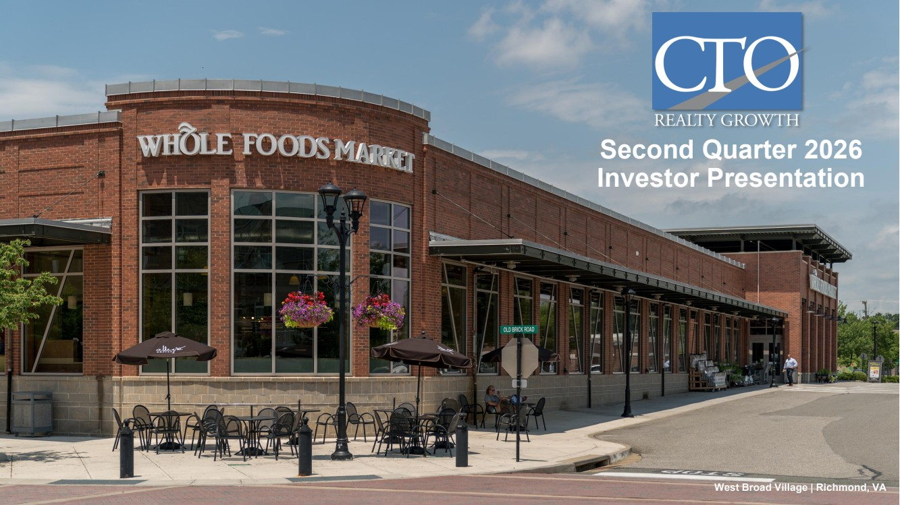 | Second Quarter 2026 Investor Presentation West Broad Village | Richmond, VA
 | 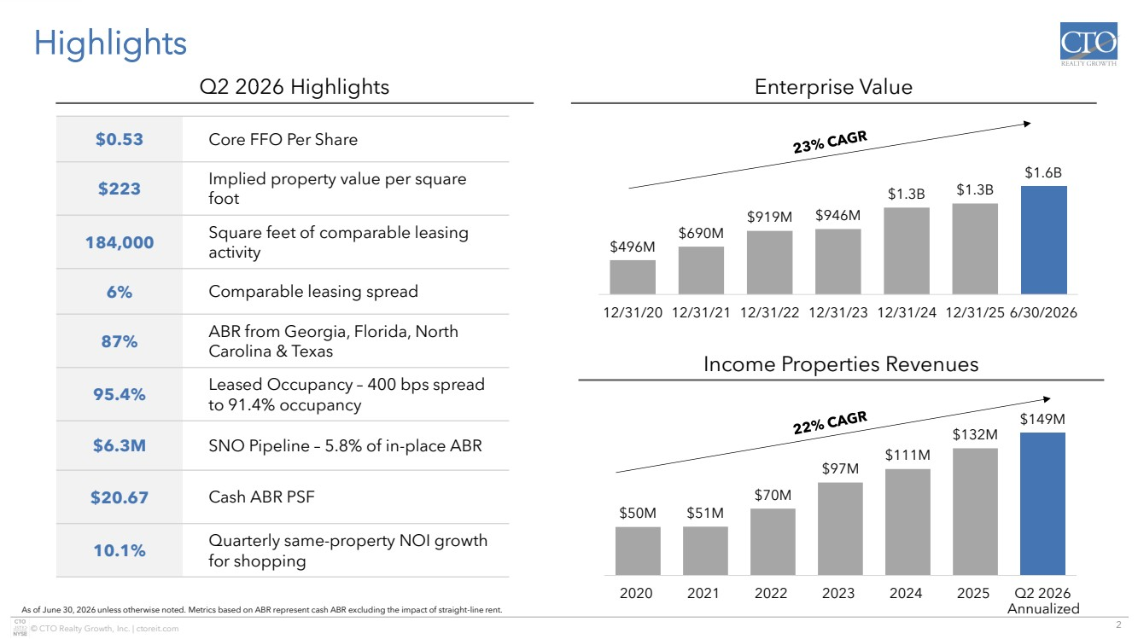 | 2 © CTO Realty Growth, Inc. | ctoreit.com $50M $51M $70M $97M $111M $132M $149M 2020 2021 2022 2023 2024 2025 Q2 2026 $496M $690M $919M $946M $1.3B $1.3B $1.6B 12/31/20 12/31/21 12/31/22 12/31/23 12/31/24 12/31/25 6/30/2026 Highlights Income Properties Revenues Enterprise Value As of June 30, 2026 unless otherwise noted. Metrics based on ABR represent cash ABR excluding the impact of straight-line rent. $0.53 Core FFO Per Share $223 Implied property value per square foot 184,000 Square feet of comparable leasing activity 6% Comparable leasing spread 87% ABR from Georgia, Florida, North Carolina & Texas 95.4% Leased Occupancy – 400 bps spread to 91.4% occupancy $6.3M SNO Pipeline – 5.8% of in-place ABR $20.67 Cash ABR PSF 10.1% Quarterly same-property NOI growth for shopping Q2 2026 Highlights Annualized
 | 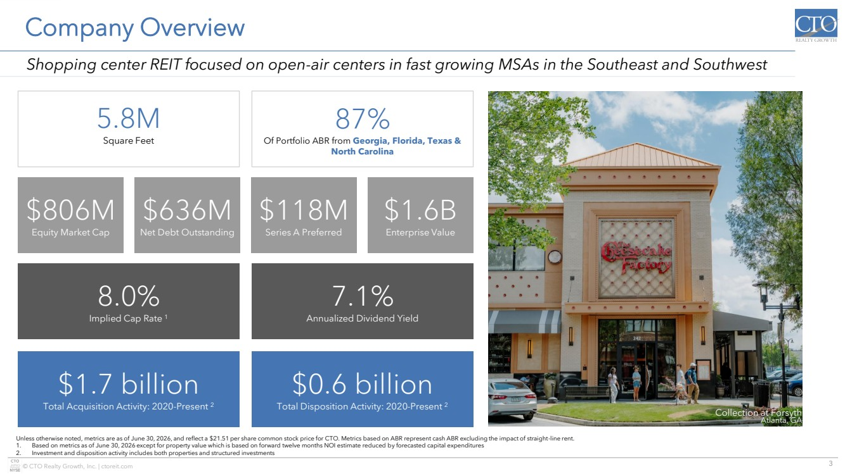 | 3 © CTO Realty Growth, Inc. | ctoreit.com Shopping center REIT focused on open-air centers in fast growing MSAs in the Southeast and Southwest Company Overview Unless otherwise noted, metrics are as of June 30, 2026, and reflect a $21.51 per share common stock price for CTO. Metrics based on ABR represent cash ABR excluding the impact of straight-line rent. 1. Based on metrics as of June 30, 2026 except for property value which is based on forward twelve months NOI estimate reduced by forecasted capital expenditures 2. Investment and disposition activity includes both properties and structured investments Collection at Forsyth Atlanta, GA 5.8M Square Feet 87% Of Portfolio ABR from Georgia, Florida, Texas & North Carolina 7.1% Annualized Dividend Yield 8.0% Implied Cap Rate 1 $0.6 billion Total Disposition Activity: 2020-Present 2 $1.7 billion Total Acquisition Activity: 2020-Present 2 $636M Net Debt Outstanding $118M Series A Preferred $1.6B Enterprise Value $806M Equity Market Cap
 | 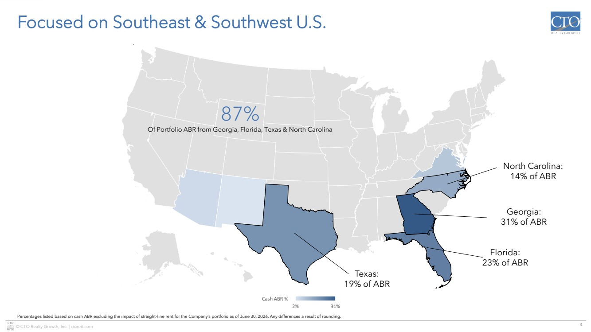 | 4 © CTO Realty Growth, Inc. | ctoreit.com © GeoNames, Microsoft, TomTom Powered by Bing 2% 31% Cash ABR % Focused on Southeast & Southwest U.S. Percentages listed based on cash ABR excluding the impact of straight-line rent for the Company’s portfolio as of June 30, 2026. Any differences a result of rounding. Texas: 19% of ABR Florida: 23% of ABR Georgia: 31% of ABR North Carolina: 14% of ABR 87% Of Portfolio ABR from Georgia, Florida, Texas & North Carolina
 | 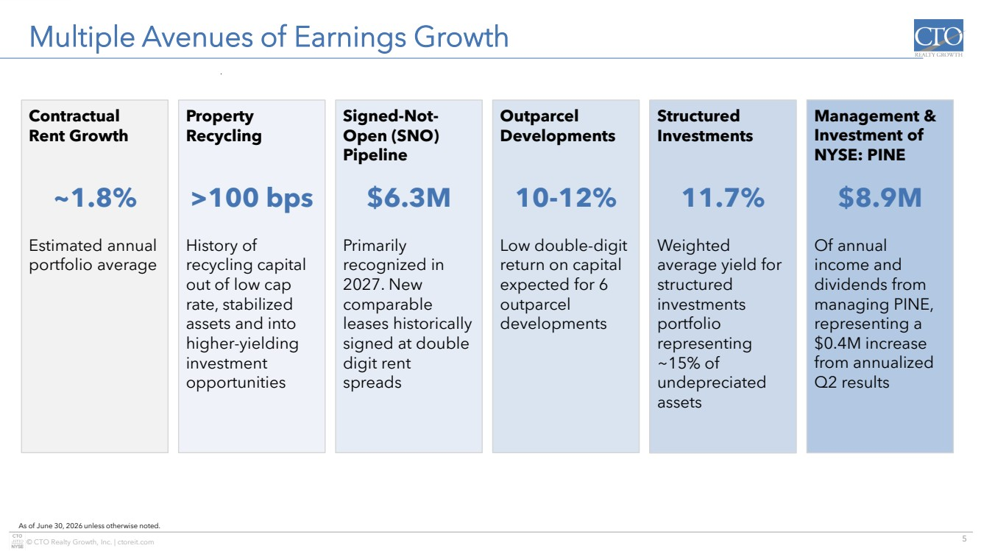 | 5 © CTO Realty Growth, Inc. | ctoreit.com Multiple Avenues of Earnings Growth As of June 30, 2026 unless otherwise noted. Contractual Rent Growth ~1.8% Estimated annual portfolio average Property Recycling >100 bps History of recycling capital out of low cap rate, stabilized assets and into higher-yielding investment opportunities Outparcel Developments 10-12% Low double-digit return on capital expected for 6 outparcel developments Structured Investments 11.7% Weighted average yield for structured investments portfolio representing ~15% of undepreciated assets Signed-Not-Open (SNO) Pipeline $6.3M Primarily recognized in 2027. New comparable leases historically signed at double digit rent spreads Management & Investment of NYSE: PINE $8.9M Of annual income and dividends from managing PINE, representing a $0.4M increase from annualized Q2 results
 | 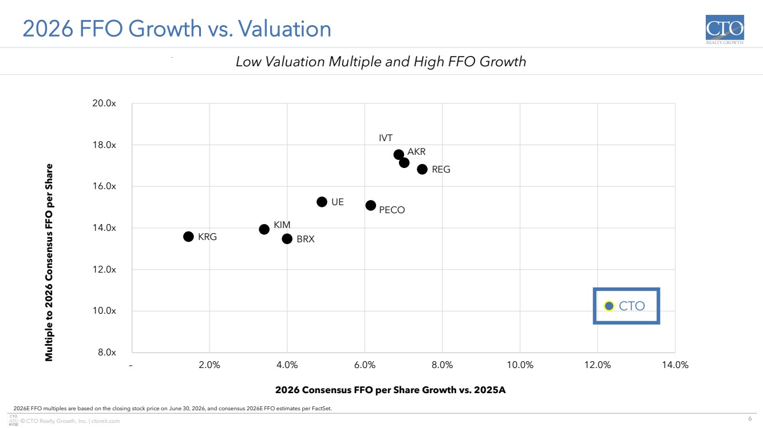 | 6 © CTO Realty Growth, Inc. | ctoreit.com KRG KIM BRX UE PECO REG CTO IVT AKR 8.0x 10.0x 12.0x 14.0x 16.0x 18.0x 20.0x – 2.0% 4.0% 6.0% 8.0% 10.0% 12.0% 14.0% Multiple to 2026 Consensus FFO per Share 2026 Consensus FFO per Share Growth vs. 2025A 2026 FFO Growth vs. Valuation 2026E FFO multiples are based on the closing stock price on June 30, 2026, and consensus 2026E FFO estimates per FactSet. Low Valuation Multiple and High FFO Growth Ashford Lane Atlanta, GA
 | 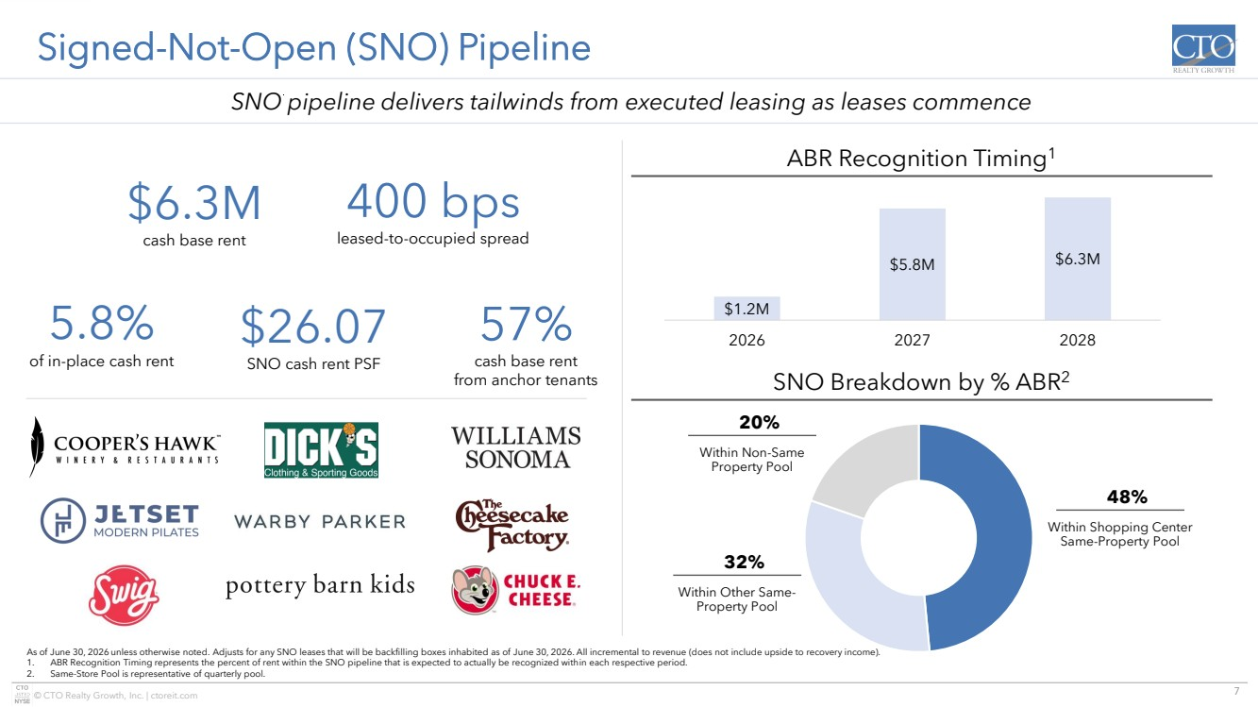 | 7 © CTO Realty Growth, Inc. | ctoreit.com Signed-Not-Open (SNO) Pipeline As of June 30, 2026 unless otherwise noted. Adjusts for any SNO leases that will be backfilling boxes inhabited as of June 30, 2026. All incremental to revenue (does not include upside to recovery income). 1. ABR Recognition Timing represents the percent of rent within the SNO pipeline that is expected to actually be recognized within each respective period. 2. Same-Store Pool is representative of quarterly pool. SNO pipeline delivers tailwinds from executed leasing as leases commence ABR Recognition Timing1 $6.3M cash base rent $26.07 SNO cash rent PSF 5.8% of in-place cash rent 57% cash base rent from anchor tenants 400 bps leased-to-occupied spread $1.2M $5.8M $6.3M 2026 2027 2028 SNO Breakdown by % ABR2 Within Shopping Center Same-Property Pool 48% Within Other Same-Property Pool 32% Within Non-Same Property Pool 20%
 | 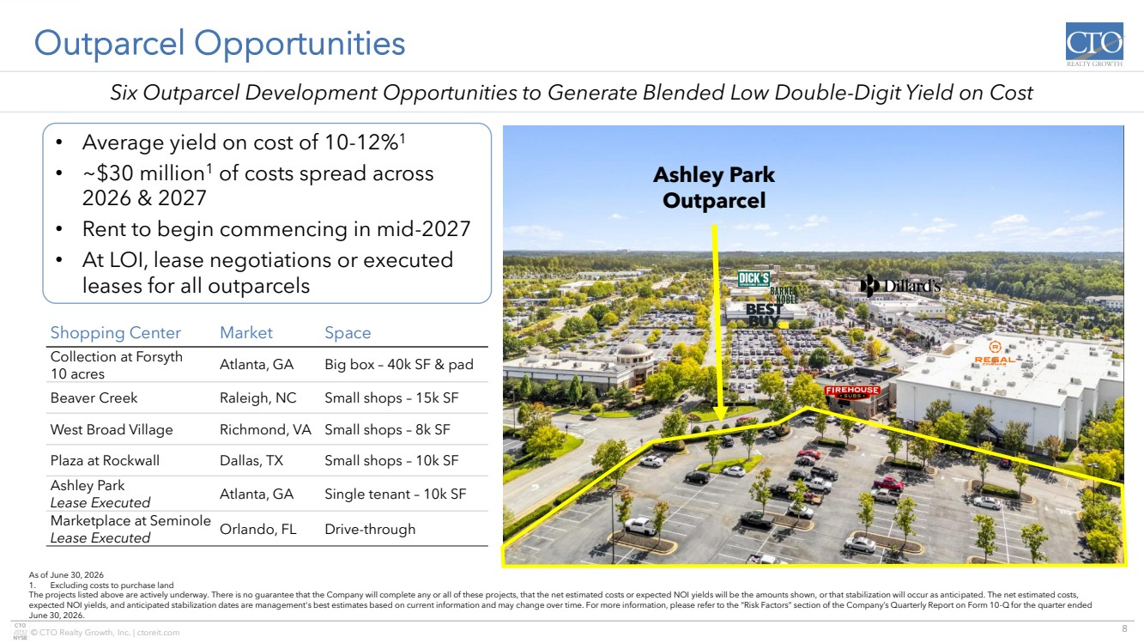 | 8 © CTO Realty Growth, Inc. | ctoreit.com Outparcel Opportunities Shopping Center Market Space Collection at Forsyth 10 acres Atlanta, GA Big box – 40k SF & pad Beaver Creek Raleigh, NC Small shops – 15k SF West Broad Village Richmond, VA Small shops – 8k SF Plaza at Rockwall Dallas, TX Small shops – 10k SF Ashley Park Lease Executed Atlanta, GA Single tenant – 10k SF Marketplace at Seminole Lease Executed Orlando, FL Drive-through As of June 30, 2026 1. Excluding costs to purchase land The projects listed above are actively underway. There is no guarantee that the Company will complete any or all of these projects, that the net estimated costs or expected NOI yields will be the amounts shown, or that stabilization will occur as anticipated. The net estimated costs, expected NOI yields, and anticipated stabilization dates are management's best estimates based on current information and may change over time. For more information, please refer to the “Risk Factors” section of the Company’s Quarterly Report on Form 10-Q for the quarter ended June 30, 2026. Six Outparcel Development Opportunities to Generate Blended Low Double-Digit Yield on Cost • Average yield on cost of 10-12%1 • ~$30 million1 of costs spread across 2026 & 2027 • Rent to begin commencing in mid-2027 • At LOI, lease negotiations or executed leases for all outparcels Ashley Park Outparcel
 | 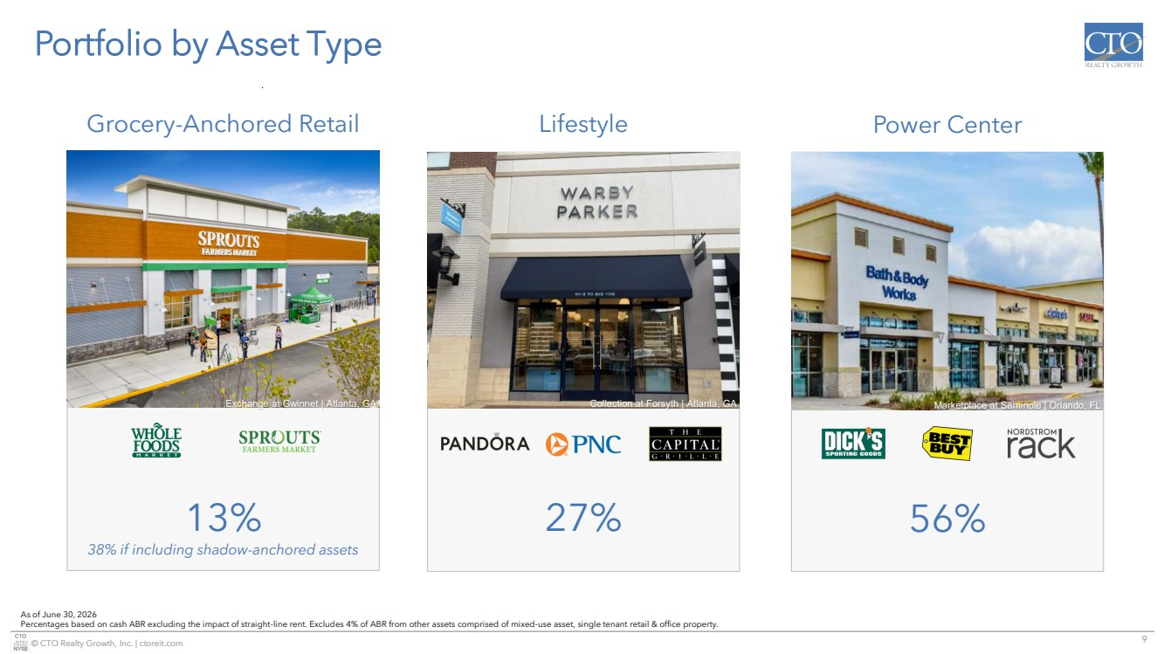 | 9 © CTO Realty Growth, Inc. | ctoreit.com Portfolio by Asset Type 13% 38% if including shadow-anchored assets 27% 56% As of June 30, 2026 Percentages based on cash ABR excluding the impact of straight-line rent. Excludes 4% of ABR from other assets comprised of mixed-use asset, single tenant retail & office property. Exchange at Gwinnet | Atlanta, GA Collection at Forsyth | Atlanta, GA Marketplace at Seminole | Orlando, FL Grocery-Anchored Retail Lifestyle Power Center
 | 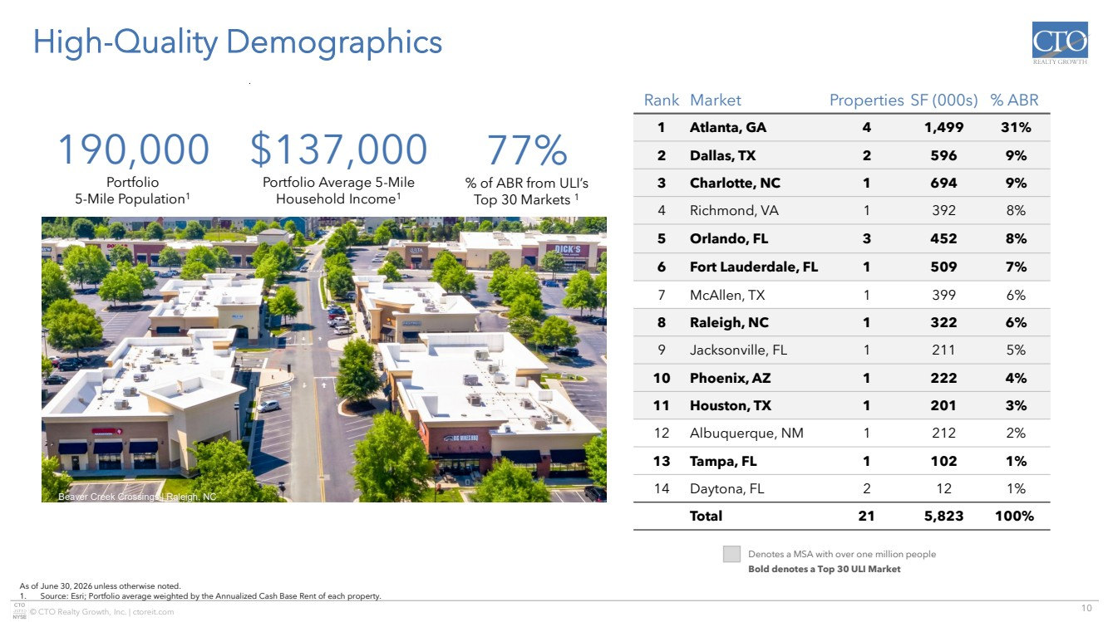 | 10 © CTO Realty Growth, Inc. | ctoreit.com High-Quality Demographics As of June 30, 2026 unless otherwise noted. 1. Source: Esri; Portfolio average weighted by the Annualized Cash Base Rent of each property. Rank Market Properties SF (000s) % ABR 1 Atlanta, GA 4 1,499 31% 2 Dallas, TX 2 596 9% 3 Charlotte, NC 1 694 9% 4 Richmond, VA 1 392 8% 5 Orlando, FL 3 452 8% 6 Fort Lauderdale, FL 1 509 7% 7 McAllen, TX 1 399 6% 8 Raleigh, NC 1 322 6% 9 Jacksonville, FL 1 211 5% 10 Phoenix, AZ 1 222 4% 11 Houston, TX 1 201 3% 12 Albuquerque, NM 1 212 2% 13 Tampa, FL 1 102 1% 14 Daytona, FL 2 12 1% Total 21 5,823 100% Denotes a MSA with over one million people Bold denotes a Top 30 ULI Market 77% % of ABR from ULI’s Top 30 Markets 1 190,000 Portfolio 5-Mile Population1 $137,000 Portfolio Average 5-Mile Household Income1 Beaver Creek Crossings | Raleigh, NC
 | 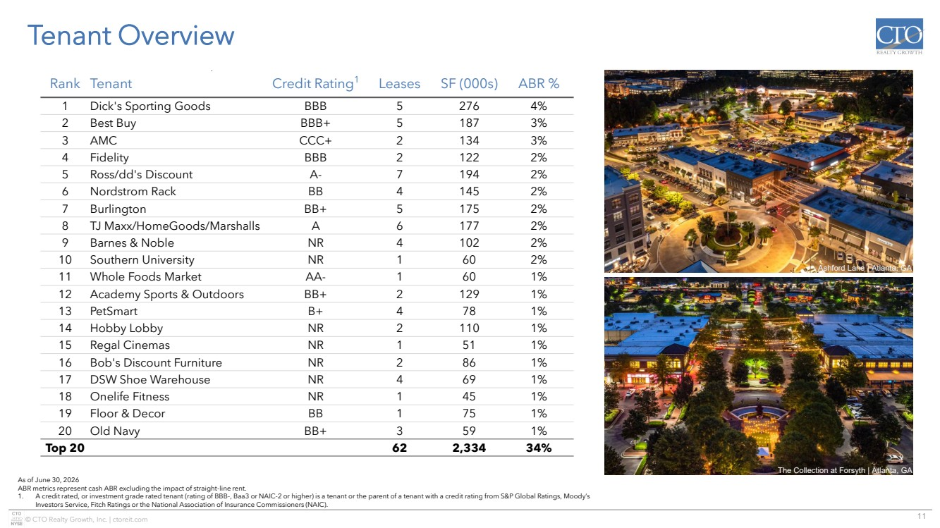 | 11 © CTO Realty Growth, Inc. | ctoreit.com Tenant Overview Rank Tenant Credit Rating1 Leases SF (000s) ABR % 1 Dick's Sporting Goods BBB 5 276 4% 2 Best Buy BBB+ 5 187 3% 3 AMC CCC+ 2 134 3% 4 Fidelity BBB 2 122 2% 5 Ross/dd's Discount A- 7 194 2% 6 Nordstrom Rack BB 4 145 2% 7 Burlington BB+ 5 175 2% 8 TJ Maxx/HomeGoods/Marshalls A 6 177 2% 9 Barnes & Noble NR 4 102 2% 10 Southern University NR 1 60 2% 11 Whole Foods Market AA- 1 60 1% 12 Academy Sports & Outdoors BB+ 2 129 1% 13 PetSmart B+ 4 78 1% 14 Hobby Lobby NR 2 110 1% 15 Regal Cinemas NR 1 51 1% 16 Bob's Discount Furniture NR 2 86 1% 17 DSW Shoe Warehouse NR 4 69 1% 18 Onelife Fitness NR 1 45 1% 19 Floor & Decor BB 1 75 1% 20 Old Navy BB+ 3 59 1% Top 20 62 2,334 34% As of June 30, 2026 ABR metrics represent cash ABR excluding the impact of straight-line rent. 1. A credit rated, or investment grade rated tenant (rating of BBB-, Baa3 or NAIC-2 or higher) is a tenant or the parent of a tenant with a credit rating from S&P Global Ratings, Moody’s Investors Service, Fitch Ratings or the National Association of Insurance Commissioners (NAIC). Ashford Lane | Atlanta, GA The Collection at Forsyth | Atlanta, GA
 | 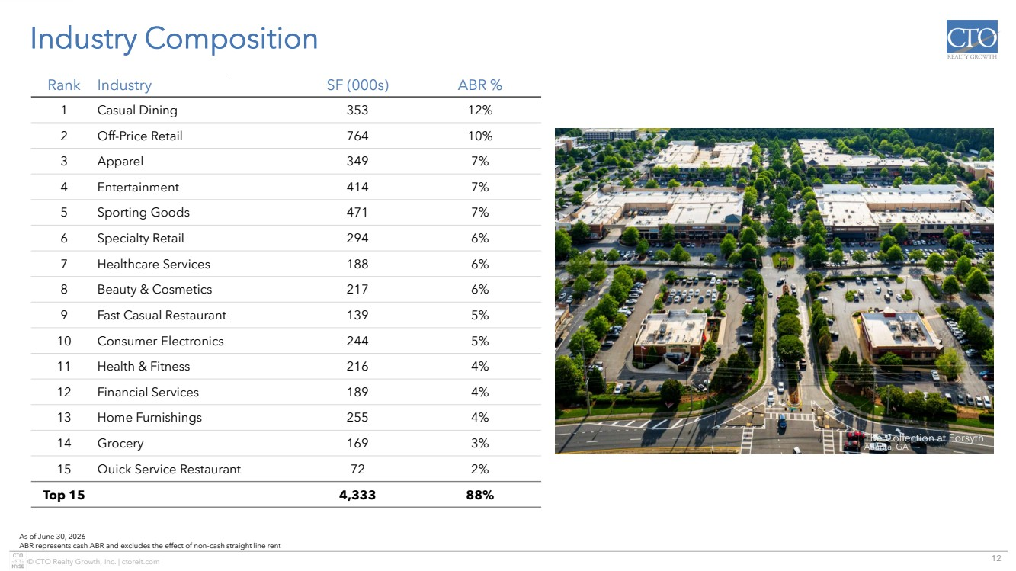 | 12 © CTO Realty Growth, Inc. | ctoreit.com Rank Industry SF (000s) ABR % 1 Casual Dining 353 12% 2 Off-Price Retail 764 10% 3 Apparel 349 7% 4 Entertainment 414 7% 5 Sporting Goods 471 7% 6 Specialty Retail 294 6% 7 Healthcare Services 188 6% 8 Beauty & Cosmetics 217 6% 9 Fast Casual Restaurant 139 5% 10 Consumer Electronics 244 5% 11 Health & Fitness 216 4% 12 Financial Services 189 4% 13 Home Furnishings 255 4% 14 Grocery 169 3% 15 Quick Service Restaurant 72 2% Top 15 4,333 88% Industry Composition As of June 30, 2026 ABR represents cash ABR and excludes the effect of non-cash straight line rent The Collection at Forsyth Atlanta, GA
 | 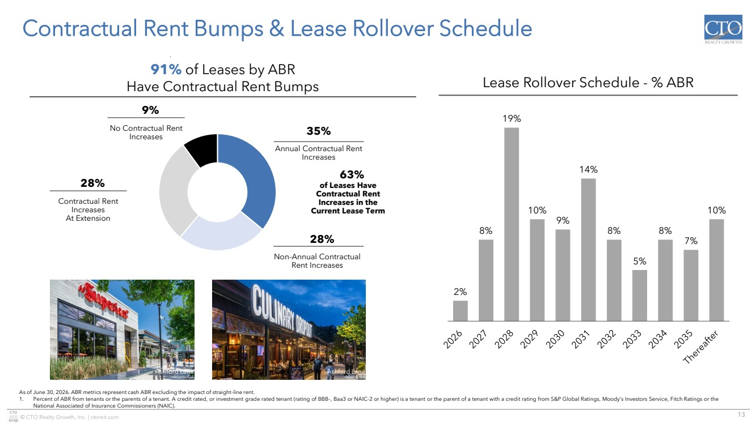 | 13 © CTO Realty Growth, Inc. | ctoreit.com 2% 8% 19% 10% 9% 14% 8% 5% 8% 7% 10% Contractual Rent Bumps & Lease Rollover Schedule As of June 30, 2026. ABR metrics represent cash ABR excluding the impact of straight-line rent. 1. Percent of ABR from tenants or the parents of a tenant. A credit rated, or investment grade rated tenant (rating of BBB-, Baa3 or NAIC-2 or higher) is a tenant or the parent of a tenant with a credit rating from S&P Global Ratings, Moody’s Investors Service, Fitch Ratings or the National Associated of Insurance Commissioners (NAIC). Lease Rollover Schedule - % ABR Non-Annual Contractual Rent Increases 28% Contractual Rent Increases At Extension 28% Annual Contractual Rent Increases 35% of Leases Have Contractual Rent Increases in the Current Lease Term 63% No Contractual Rent Increases 9% 91% of Leases by ABR Have Contractual Rent Bumps Ashford Lane Atlanta, GA Ashford Lane Atlanta, GA
 | 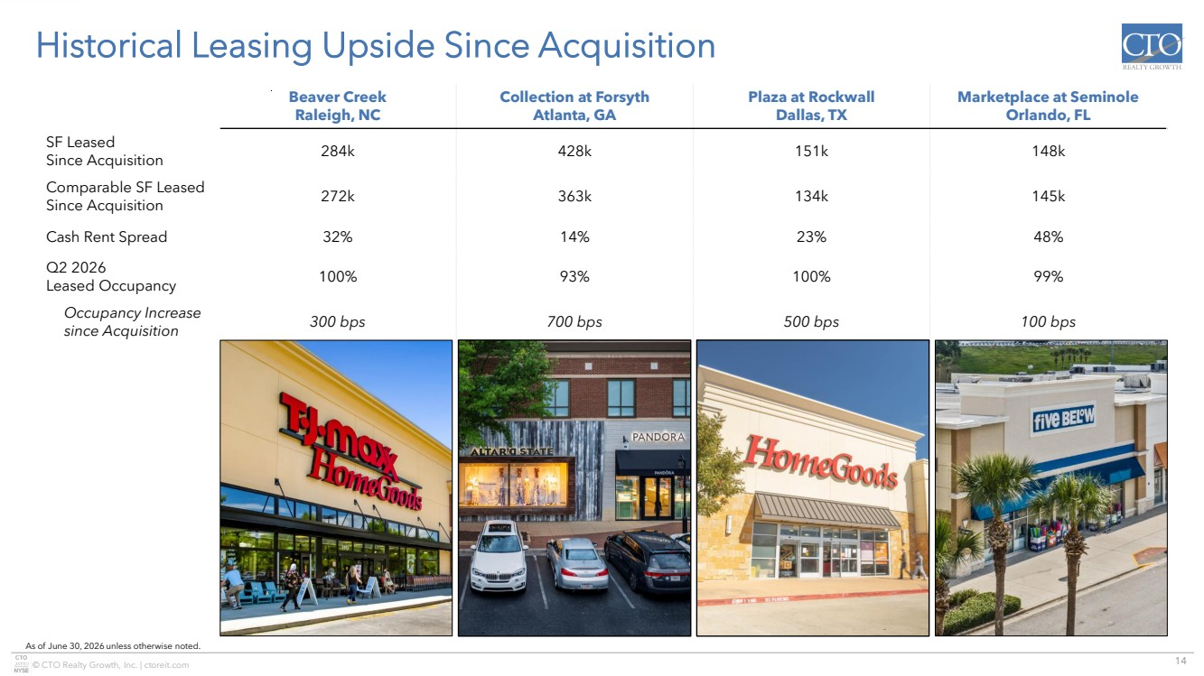 | 14 © CTO Realty Growth, Inc. | ctoreit.com Historical Leasing Upside Since Acquisition As of June 30, 2026 unless otherwise noted. Beaver Creek Raleigh, NC Collection at Forsyth Atlanta, GA Plaza at Rockwall Dallas, TX Marketplace at Seminole Orlando, FL SF Leased Since Acquisition 284k 428k 151k 148k Comparable SF Leased Since Acquisition 272k 363k 134k 145k Cash Rent Spread 32% 14% 23% 48% Q2 2026 Leased Occupancy 100% 93% 100% 99% Occupancy Increase since Acquisition 300 bps 700 bps 500 bps 100 bps
 | 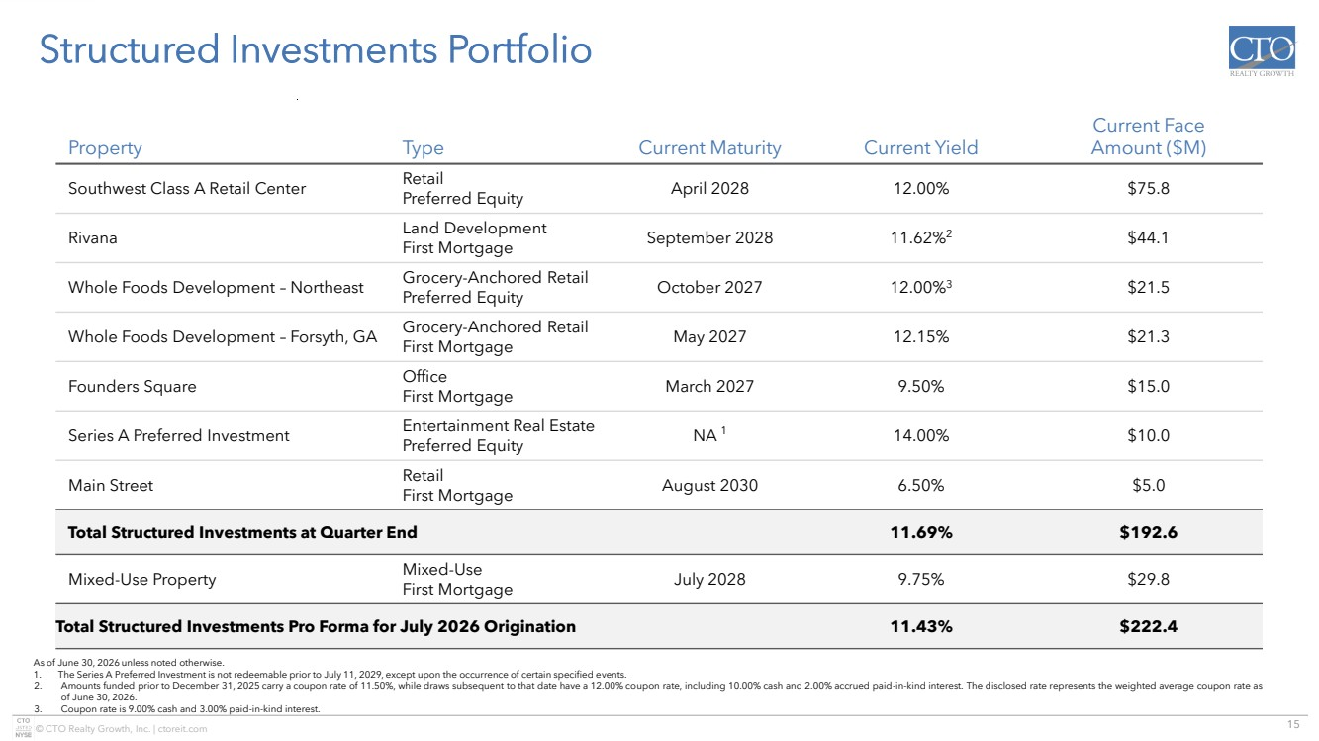 | 15 © CTO Realty Growth, Inc. | ctoreit.com Structured Investments Portfolio Property Type Current Maturity Current Yield Current Face Amount ($M) Southwest Class A Retail Center Retail Preferred Equity April 2028 12.00% $75.8 Rivana Land Development First Mortgage September 2028 11.62%2 $44.1 Whole Foods Development – Northeast Grocery-Anchored Retail Preferred Equity October 2027 12.00%3 $21.5 Whole Foods Development – Forsyth, GA Grocery-Anchored Retail First Mortgage May 2027 12.15% $21.3 Founders Square Office First Mortgage March 2027 9.50% $15.0 Series A Preferred Investment Entertainment Real Estate Preferred Equity NA 1 14.00% $10.0 Main Street Retail First Mortgage August 2030 6.50% $5.0 Total Structured Investments at Quarter End 11.69% $192.6 Mixed-Use Property Mixed-Use First Mortgage July 2028 9.75% $29.8 Total Structured Investments Pro Forma for July 2026 Origination 11.43% $222.4 As of June 30, 2026 unless noted otherwise. 1. The Series A Preferred Investment is not redeemable prior to July 11, 2029, except upon the occurrence of certain specified events. 2. Amounts funded prior to December 31, 2025 carry a coupon rate of 11.50%, while draws subsequent to that date have a 12.00% coupon rate, including 10.00% cash and 2.00% accrued paid-in-kind interest. The disclosed rate represents the weighted average coupon rate as of June 30, 2026. 3. Coupon rate is 9.00% cash and 3.00% paid-in-kind interest.
 | 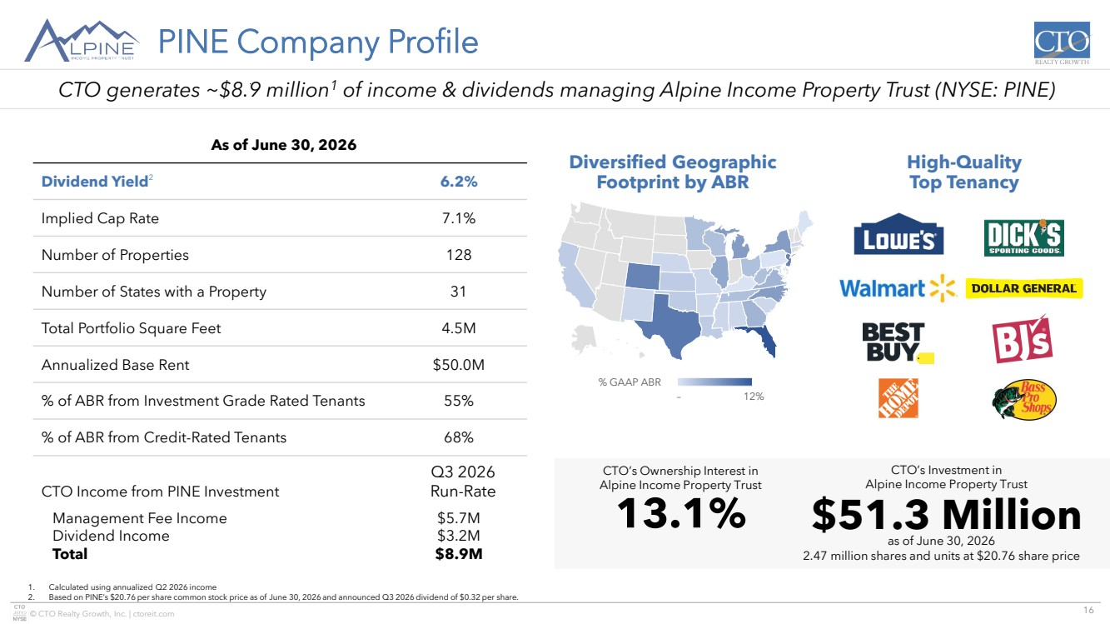 | 16 © CTO Realty Growth, Inc. | ctoreit.com © GeoNames, Microsoft, TomTom Powered by Bing – 12% % GAAP ABR PINE Company Profile 1. Calculated using annualized Q2 2026 income 2. Based on PINE’s $20.76 per share common stock price as of June 30, 2026 and announced Q3 2026 dividend of $0.32 per share. As of June 30, 2026 Dividend Yield2 6.2% Implied Cap Rate 7.1% Number of Properties 128 Number of States with a Property 31 Total Portfolio Square Feet 4.5M Annualized Base Rent $50.0M % of ABR from Investment Grade Rated Tenants 55% % of ABR from Credit-Rated Tenants 68% CTO Income from PINE Investment Q3 2026 Run-Rate Management Fee Income Dividend Income Total $5.7M $3.2M $8.9M Diversified Geographic Footprint by ABR High-Quality Top Tenancy 13.1% CTO’s Ownership Interest in Alpine Income Property Trust $51.3 Million CTO’s Investment in Alpine Income Property Trust as of June 30, 2026 2.47 million shares and units at $20.76 share price CTO generates ~$8.9 million1 of income & dividends managing Alpine Income Property Trust (NYSE: PINE)
 | 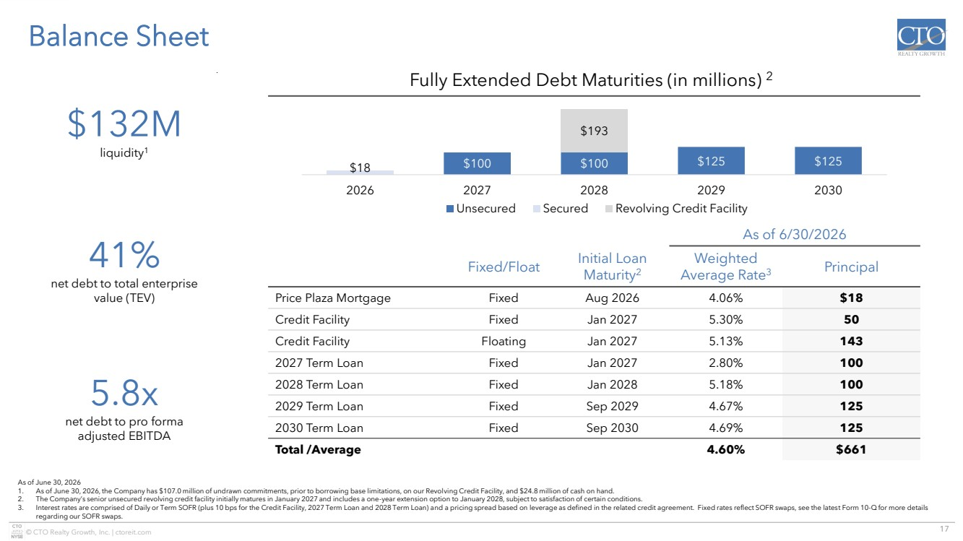 | 17 © CTO Realty Growth, Inc. | ctoreit.com Balance Sheet Exchange at Gwinnett Buford, GA As of June 30, 2026 1. As of June 30, 2026, the Company has $107.0 million of undrawn commitments, prior to borrowing base limitations, on our Revolving Credit Facility, and $24.8 million of cash on hand. 2. The Company’s senior unsecured revolving credit facility initially matures in January 2027 and includes a one-year extension option to January 2028, subject to satisfaction of certain conditions. 3. Interest rates are comprised of Daily or Term SOFR (plus 10 bps for the Credit Facility, 2027 Term Loan and 2028 Term Loan) and a pricing spread based on leverage as defined in the related credit agreement. Fixed rates reflect SOFR swaps, see the latest Form 10-Q for more details regarding our SOFR swaps. As of 6/30/2026 Fixed/Float Initial Loan Maturity2 Weighted Average Rate3 Principal Price Plaza Mortgage Fixed Aug 2026 4.06% $18 Credit Facility Fixed Jan 2027 5.30% 50 Credit Facility Floating Jan 2027 5.13% 143 2027 Term Loan Fixed Jan 2027 2.80% 100 2028 Term Loan Fixed Jan 2028 5.18% 100 2029 Term Loan Fixed Sep 2029 4.67% 125 2030 Term Loan Fixed Sep 2030 4.69% 125 Total /Average 4.60% $661 Fully Extended Debt Maturities (in millions) 2 $132M liquidity1 41% net debt to total enterprise value (TEV) 5.8x net debt to pro forma adjusted EBITDA $100 $100 $125 $125 $18 $193 2026 2027 2028 2029 2030 Unsecured Secured Revolving Credit Facility
 | 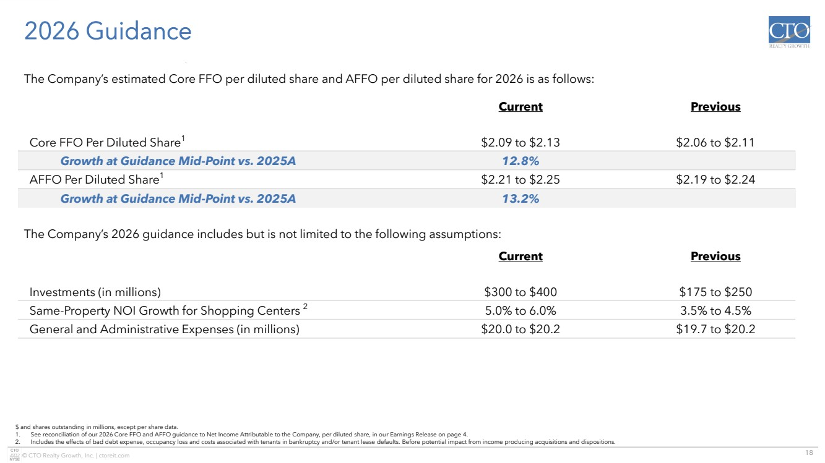 | 18 © CTO Realty Growth, Inc. | ctoreit.com 2026 Guidance Exchange at Gwinnett Buford, GA $ and shares outstanding in millions, except per share data. 1. See reconciliation of our 2026 Core FFO and AFFO guidance to Net Income Attributable to the Company, per diluted share, in our Earnings Release on page 4. 2. Includes the effects of bad debt expense, occupancy loss and costs associated with tenants in bankruptcy and/or tenant lease defaults. Before potential impact from income producing acquisitions and dispositions. Current Previous Core FFO Per Diluted Share1 $2.09 to $2.13 $2.06 to $2.11 Growth at Guidance Mid-Point vs. 2025A 12.8% AFFO Per Diluted Share1 $2.21 to $2.25 $2.19 to $2.24 Growth at Guidance Mid-Point vs. 2025A 13.2% The Company’s estimated Core FFO per diluted share and AFFO per diluted share for 2026 is as follows: The Company’s 2026 guidance includes but is not limited to the following assumptions: Current Previous Investments (in millions) $300 to $400 $175 to $250 Same-Property NOI Growth for Shopping Centers 2 5.0% to 6.0% 3.5% to 4.5% General and Administrative Expenses (in millions) $20.0 to $20.2 $19.7 to $20.2
 | 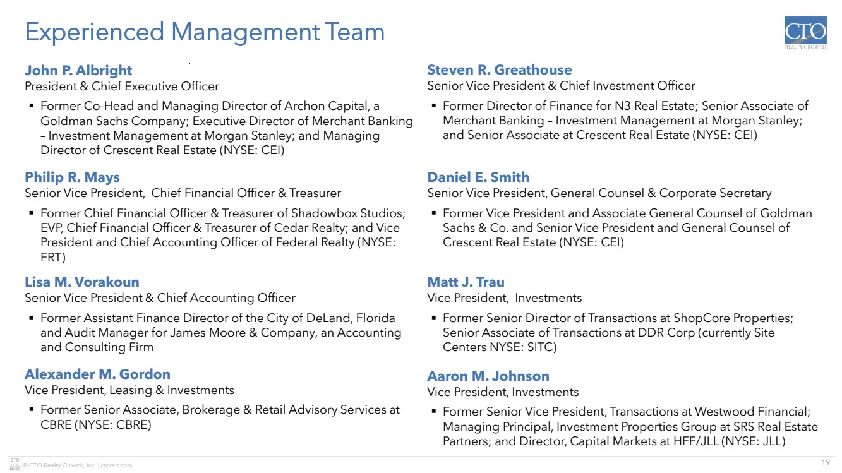 | 19 © CTO Realty Growth, Inc. | ctoreit.com Experienced Management Team Exchange at Gwinnett Buford, GA John P. Albright President & Chief Executive Officer ▪ Former Co-Head and Managing Director of Archon Capital, a Goldman Sachs Company; Executive Director of Merchant Banking – Investment Management at Morgan Stanley; and Managing Director of Crescent Real Estate (NYSE: CEI) Daniel E. Smith Senior Vice President, General Counsel & Corporate Secretary ▪ Former Vice President and Associate General Counsel of Goldman Sachs & Co. and Senior Vice President and General Counsel of Crescent Real Estate (NYSE: CEI) Philip R. Mays Senior Vice President, Chief Financial Officer & Treasurer ▪ Former Chief Financial Officer & Treasurer of Shadowbox Studios; EVP, Chief Financial Officer & Treasurer of Cedar Realty; and Vice President and Chief Accounting Officer of Federal Realty (NYSE: FRT) Steven R. Greathouse Senior Vice President & Chief Investment Officer ▪ Former Director of Finance for N3 Real Estate; Senior Associate of Merchant Banking – Investment Management at Morgan Stanley; and Senior Associate at Crescent Real Estate (NYSE: CEI) Lisa M. Vorakoun Senior Vice President & Chief Accounting Officer ▪ Former Assistant Finance Director of the City of DeLand, Florida and Audit Manager for James Moore & Company, an Accounting and Consulting Firm Matt J. Trau Vice President, Investments ▪ Former Senior Director of Transactions at ShopCore Properties; Senior Associate of Transactions at DDR Corp (currently Site Centers NYSE: SITC) Alexander M. Gordon Vice President, Leasing & Investments ▪ Former Senior Associate, Brokerage & Retail Advisory Services at CBRE (NYSE: CBRE) Aaron M. Johnson Vice President, Investments ▪ Former Senior Vice President, Transactions at Westwood Financial; Managing Principal, Investment Properties Group at SRS Real Estate Partners; and Director, Capital Markets at HFF/JLL (NYSE: JLL)
 | 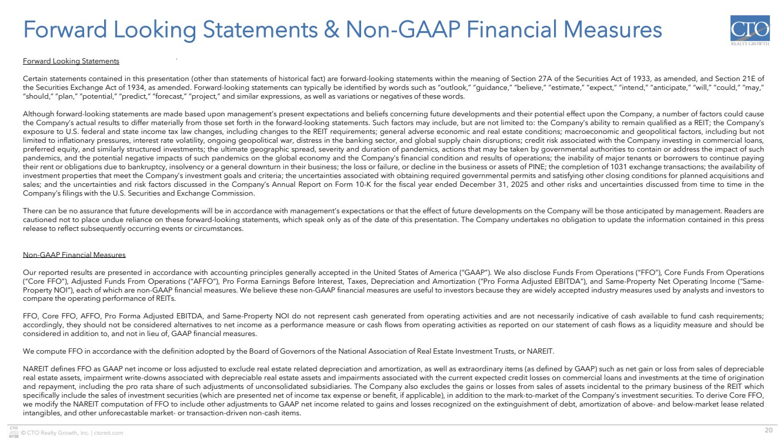 | 20 © CTO Realty Growth, Inc. | ctoreit.com Forward Looking Statements & Non-GAAP Financial Measures Forward Looking Statements Certain statements contained in this presentation (other than statements of historical fact) are forward-looking statements within the meaning of Section 27A of the Securities Act of 1933, as amended, and Section 21E of the Securities Exchange Act of 1934, as amended. Forward-looking statements can typically be identified by words such as “outlook,” “guidance,” “believe,” “estimate,” “expect,” “intend,” “anticipate,” “will,” “could,” “may,” “should,” “plan,” “potential,” “predict,” “forecast,” “project,” and similar expressions, as well as variations or negatives of these words. Although forward-looking statements are made based upon management’s present expectations and beliefs concerning future developments and their potential effect upon the Company, a number of factors could cause the Company’s actual results to differ materially from those set forth in the forward-looking statements. Such factors may include, but are not limited to: the Company’s ability to remain qualified as a REIT; the Company’s exposure to U.S. federal and state income tax law changes, including changes to the REIT requirements; general adverse economic and real estate conditions; macroeconomic and geopolitical factors, including but not limited to inflationary pressures, interest rate volatility, ongoing geopolitical war, distress in the banking sector, and global supply chain disruptions; credit risk associated with the Company investing in commercial loans, preferred equity, and similarly structured investments; the ultimate geographic spread, severity and duration of pandemics, actions that may be taken by governmental authorities to contain or address the impact of such pandemics, and the potential negative impacts of such pandemics on the global economy and the Company’s financial condition and results of operations; the inability of major tenants or borrowers to continue paying their rent or obligations due to bankruptcy, insolvency or a general downturn in their business; the loss or failure, or decline in the business or assets of PINE; the completion of 1031 exchange transactions; the availability of investment properties that meet the Company’s investment goals and criteria; the uncertainties associated with obtaining required governmental permits and satisfying other closing conditions for planned acquisitions and sales; and the uncertainties and risk factors discussed in the Company’s Annual Report on Form 10-K for the fiscal year ended December 31, 2025 and other risks and uncertainties discussed from time to time in the Company’s filings with the U.S. Securities and Exchange Commission. There can be no assurance that future developments will be in accordance with management’s expectations or that the effect of future developments on the Company will be those anticipated by management. Readers are cautioned not to place undue reliance on these forward-looking statements, which speak only as of the date of this presentation. The Company undertakes no obligation to update the information contained in this press release to reflect subsequently occurring events or circumstances. Non-GAAP Financial Measures Our reported results are presented in accordance with accounting principles generally accepted in the United States of America (“GAAP”). We also disclose Funds From Operations (“FFO”), Core Funds From Operations (“Core FFO”), Adjusted Funds From Operations (“AFFO”), Pro Forma Earnings Before Interest, Taxes, Depreciation and Amortization (“Pro Forma Adjusted EBITDA”), and Same-Property Net Operating Income (“Same-Property NOI”), each of which are non-GAAP financial measures. We believe these non-GAAP financial measures are useful to investors because they are widely accepted industry measures used by analysts and investors to compare the operating performance of REITs. FFO, Core FFO, AFFO, Pro Forma Adjusted EBITDA, and Same-Property NOI do not represent cash generated from operating activities and are not necessarily indicative of cash available to fund cash requirements; accordingly, they should not be considered alternatives to net income as a performance measure or cash flows from operating activities as reported on our statement of cash flows as a liquidity measure and should be considered in addition to, and not in lieu of, GAAP financial measures. We compute FFO in accordance with the definition adopted by the Board of Governors of the National Association of Real Estate Investment Trusts, or NAREIT. NAREIT defines FFO as GAAP net income or loss adjusted to exclude real estate related depreciation and amortization, as well as extraordinary items (as defined by GAAP) such as net gain or loss from sales of depreciable real estate assets, impairment write-downs associated with depreciable real estate assets and impairments associated with the current expected credit losses on commercial loans and investments at the time of origination and repayment, including the pro rata share of such adjustments of unconsolidated subsidiaries. The Company also excludes the gains or losses from sales of assets incidental to the primary business of the REIT which specifically include the sales of investment securities (which are presented net of income tax expense or benefit, if applicable), in addition to the mark-to-market of the Company’s investment securities. To derive Core FFO, we modify the NAREIT computation of FFO to include other adjustments to GAAP net income related to gains and losses recognized on the extinguishment of debt, amortization of above- and below-market lease related intangibles, and other unforecastable market- or transaction-driven non-cash items.
 | 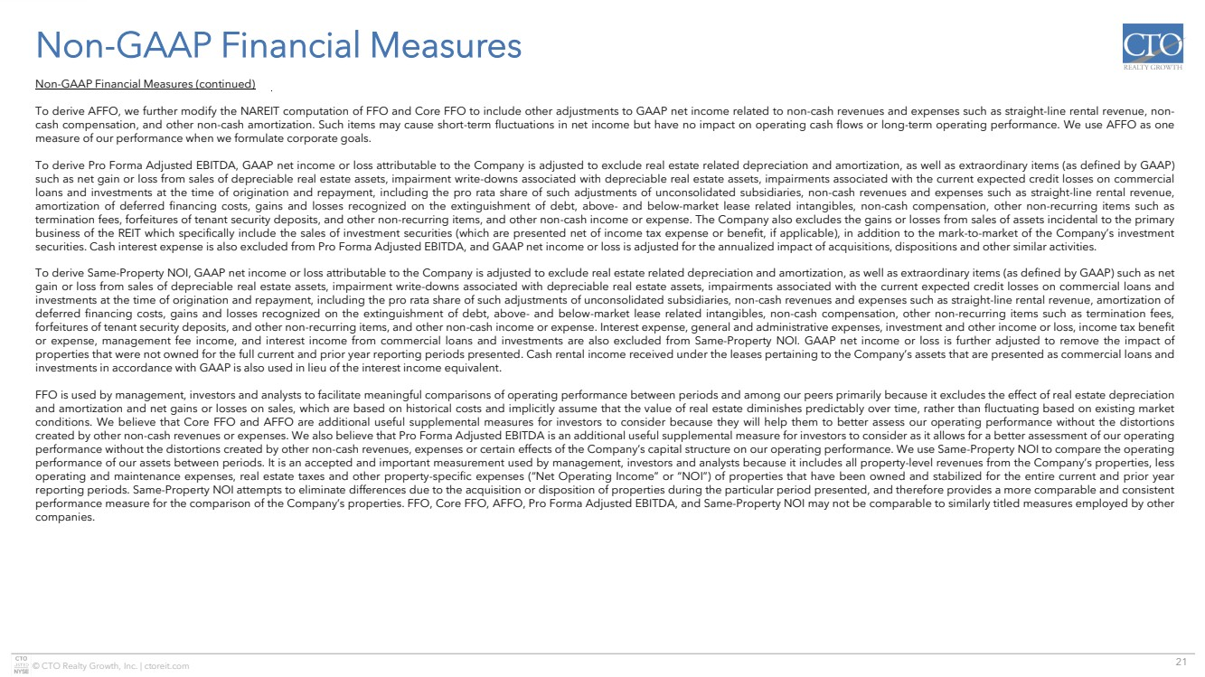 | 21 © CTO Realty Growth, Inc. | ctoreit.com Non-GAAP Financial Measures Non-GAAP Financial Measures (continued) To derive AFFO, we further modify the NAREIT computation of FFO and Core FFO to include other adjustments to GAAP net income related to non-cash revenues and expenses such as straight-line rental revenue, non-cash compensation, and other non-cash amortization. Such items may cause short-term fluctuations in net income but have no impact on operating cash flows or long-term operating performance. We use AFFO as one measure of our performance when we formulate corporate goals. To derive Pro Forma Adjusted EBITDA, GAAP net income or loss attributable to the Company is adjusted to exclude real estate related depreciation and amortization, as well as extraordinary items (as defined by GAAP) such as net gain or loss from sales of depreciable real estate assets, impairment write-downs associated with depreciable real estate assets, impairments associated with the current expected credit losses on commercial loans and investments at the time of origination and repayment, including the pro rata share of such adjustments of unconsolidated subsidiaries, non-cash revenues and expenses such as straight-line rental revenue, amortization of deferred financing costs, gains and losses recognized on the extinguishment of debt, above- and below-market lease related intangibles, non-cash compensation, other non-recurring items such as termination fees, forfeitures of tenant security deposits, and other non-recurring items, and other non-cash income or expense. The Company also excludes the gains or losses from sales of assets incidental to the primary business of the REIT which specifically include the sales of investment securities (which are presented net of income tax expense or benefit, if applicable), in addition to the mark-to-market of the Company’s investment securities. Cash interest expense is also excluded from Pro Forma Adjusted EBITDA, and GAAP net income or loss is adjusted for the annualized impact of acquisitions, dispositions and other similar activities. To derive Same-Property NOI, GAAP net income or loss attributable to the Company is adjusted to exclude real estate related depreciation and amortization, as well as extraordinary items (as defined by GAAP) such as net gain or loss from sales of depreciable real estate assets, impairment write-downs associated with depreciable real estate assets, impairments associated with the current expected credit losses on commercial loans and investments at the time of origination and repayment, including the pro rata share of such adjustments of unconsolidated subsidiaries, non-cash revenues and expenses such as straight-line rental revenue, amortization of deferred financing costs, gains and losses recognized on the extinguishment of debt, above- and below-market lease related intangibles, non-cash compensation, other non-recurring items such as termination fees, forfeitures of tenant security deposits, and other non-recurring items, and other non-cash income or expense. Interest expense, general and administrative expenses, investment and other income or loss, income tax benefit or expense, management fee income, and interest income from commercial loans and investments are also excluded from Same-Property NOI. GAAP net income or loss is further adjusted to remove the impact of properties that were not owned for the full current and prior year reporting periods presented. Cash rental income received under the leases pertaining to the Company’s assets that are presented as commercial loans and investments in accordance with GAAP is also used in lieu of the interest income equivalent. FFO is used by management, investors and analysts to facilitate meaningful comparisons of operating performance between periods and among our peers primarily because it excludes the effect of real estate depreciation and amortization and net gains or losses on sales, which are based on historical costs and implicitly assume that the value of real estate diminishes predictably over time, rather than fluctuating based on existing market conditions. We believe that Core FFO and AFFO are additional useful supplemental measures for investors to consider because they will help them to better assess our operating performance without the distortions created by other non-cash revenues or expenses. We also believe that Pro Forma Adjusted EBITDA is an additional useful supplemental measure for investors to consider as it allows for a better assessment of our operating performance without the distortions created by other non-cash revenues, expenses or certain effects of the Company’s capital structure on our operating performance. We use Same-Property NOI to compare the operating performance of our assets between periods. It is an accepted and important measurement used by management, investors and analysts because it includes all property-level revenues from the Company’s properties, less operating and maintenance expenses, real estate taxes and other property-specific expenses (“Net Operating Income” or “NOI”) of properties that have been owned and stabilized for the entire current and prior year reporting periods. Same-Property NOI attempts to eliminate differences due to the acquisition or disposition of properties during the particular period presented, and therefore provides a more comparable and consistent performance measure for the comparison of the Company’s properties. FFO, Core FFO, AFFO, Pro Forma Adjusted EBITDA, and Same-Property NOI may not be comparable to similarly titled measures employed by other companies.
 | 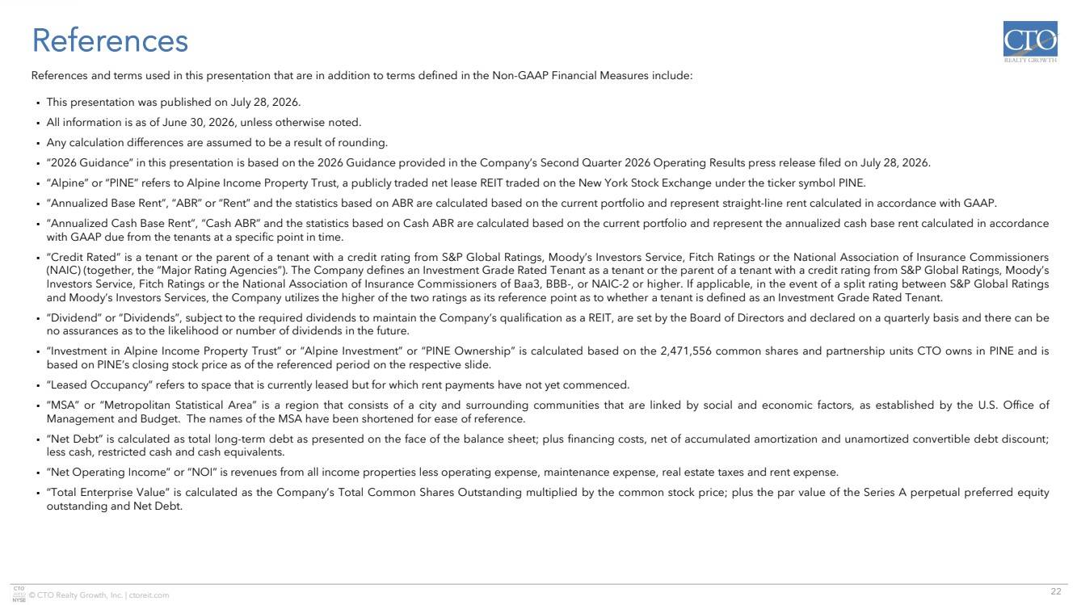 | 22 © CTO Realty Growth, Inc. | ctoreit.com References References and terms used in this presentation that are in addition to terms defined in the Non-GAAP Financial Measures include: ▪ This presentation was published on July 28, 2026. ▪ All information is as of June 30, 2026, unless otherwise noted. ▪ Any calculation differences are assumed to be a result of rounding. ▪ “2026 Guidance” in this presentation is based on the 2026 Guidance provided in the Company’s Second Quarter 2026 Operating Results press release filed on July 28, 2026. ▪ “Alpine” or “PINE” refers to Alpine Income Property Trust, a publicly traded net lease REIT traded on the New York Stock Exchange under the ticker symbol PINE. ▪ “Annualized Base Rent”, “ABR” or “Rent” and the statistics based on ABR are calculated based on the current portfolio and represent straight-line rent calculated in accordance with GAAP. ▪ “Annualized Cash Base Rent”, “Cash ABR” and the statistics based on Cash ABR are calculated based on the current portfolio and represent the annualized cash base rent calculated in accordance with GAAP due from the tenants at a specific point in time. ▪ “Credit Rated” is a tenant or the parent of a tenant with a credit rating from S&P Global Ratings, Moody’s Investors Service, Fitch Ratings or the National Association of Insurance Commissioners (NAIC) (together, the “Major Rating Agencies”). The Company defines an Investment Grade Rated Tenant as a tenant or the parent of a tenant with a credit rating from S&P Global Ratings, Moody’s Investors Service, Fitch Ratings or the National Association of Insurance Commissioners of Baa3, BBB-, or NAIC-2 or higher. If applicable, in the event of a split rating between S&P Global Ratings and Moody’s Investors Services, the Company utilizes the higher of the two ratings as its reference point as to whether a tenant is defined as an Investment Grade Rated Tenant. ▪ “Dividend” or “Dividends”, subject to the required dividends to maintain the Company’s qualification as a REIT, are set by the Board of Directors and declared on a quarterly basis and there can be no assurances as to the likelihood or number of dividends in the future. ▪ “Investment in Alpine Income Property Trust” or “Alpine Investment” or “PINE Ownership” is calculated based on the 2,471,556 common shares and partnership units CTO owns in PINE and is based on PINE’s closing stock price as of the referenced period on the respective slide. ▪ “Leased Occupancy” refers to space that is currently leased but for which rent payments have not yet commenced. ▪ “MSA” or “Metropolitan Statistical Area” is a region that consists of a city and surrounding communities that are linked by social and economic factors, as established by the U.S. Office of Management and Budget. The names of the MSA have been shortened for ease of reference. ▪ “Net Debt” is calculated as total long-term debt as presented on the face of the balance sheet; plus financing costs, net of accumulated amortization and unamortized convertible debt discount; less cash, restricted cash and cash equivalents. ▪ “Net Operating Income” or “NOI” is revenues from all income properties less operating expense, maintenance expense, real estate taxes and rent expense. ▪ “Total Enterprise Value” is calculated as the Company’s Total Common Shares Outstanding multiplied by the common stock price; plus the par value of the Series A perpetual preferred equity outstanding and Net Debt.
 | 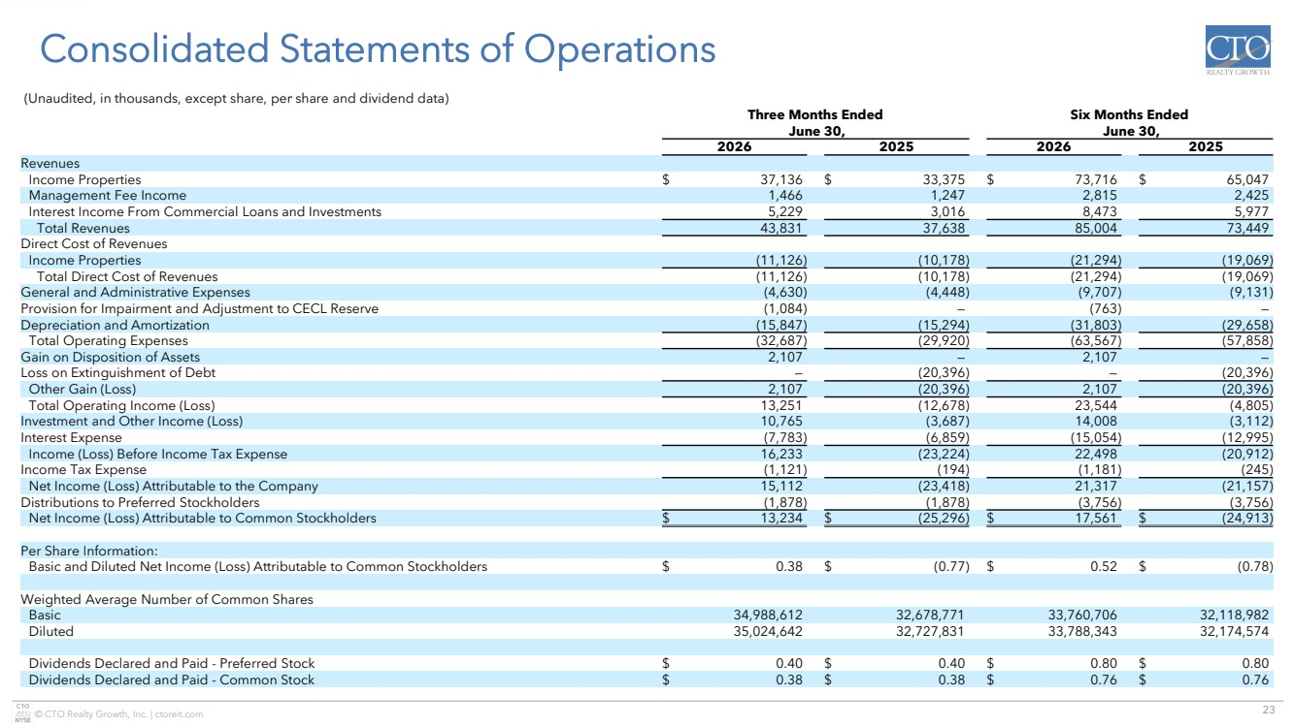 | 23 © CTO Realty Growth, Inc. | ctoreit.com Consolidated Statements of Operations (Unaudited, in thousands, except share, per share and dividend data) Three Months Ended June 30, Six Months Ended June 30, 2026 2025 2026 2025 Revenues Income Properties $ 37,136 $ 33,375 $ 73,716 $ 65,047 Management Fee Income 1,466 1,247 2,815 2,425 Interest Income From Commercial Loans and Investments 5,229 3,016 8,473 5,977 Total Revenues 43,831 37,638 85,004 73,449 Direct Cost of Revenues Income Properties (11,126) (10,178) (21,294) (19,069) Total Direct Cost of Revenues (11,126) (10,178) (21,294) (19,069) General and Administrative Expenses (4,630) (4,448) (9,707) (9,131) Provision for Impairment and Adjustment to CECL Reserve (1,084) — (763) — Depreciation and Amortization (15,847) (15,294) (31,803) (29,658) Total Operating Expenses (32,687) (29,920) (63,567) (57,858) Gain on Disposition of Assets 2,107 — 2,107 — Loss on Extinguishment of Debt — (20,396) — (20,396) Other Gain (Loss) 2,107 (20,396) 2,107 (20,396) Total Operating Income (Loss) 13,251 (12,678) 23,544 (4,805) Investment and Other Income (Loss) 10,765 (3,687) 14,008 (3,112) Interest Expense (7,783) (6,859) (15,054) (12,995) Income (Loss) Before Income Tax Expense 16,233 (23,224) 22,498 (20,912) Income Tax Expense (1,121) (194) (1,181) (245) Net Income (Loss) Attributable to the Company 15,112 (23,418) 21,317 (21,157) Distributions to Preferred Stockholders (1,878) (1,878) (3,756) (3,756) Net Income (Loss) Attributable to Common Stockholders $ 13,234 $ (25,296) $ 17,561 $ (24,913) Per Share Information: Basic and Diluted Net Income (Loss) Attributable to Common Stockholders $ 0.38 $ (0.77) $ 0.52 $ (0.78) Weighted Average Number of Common Shares Basic 34,988,612 32,678,771 33,760,706 32,118,982 Diluted 35,024,642 32,727,831 33,788,343 32,174,574 Dividends Declared and Paid - Preferred Stock $ 0.40 $ 0.40 $ 0.80 $ 0.80 Dividends Declared and Paid - Common Stock $ 0.38 $ 0.38 $ 0.76 $ 0.76
 | 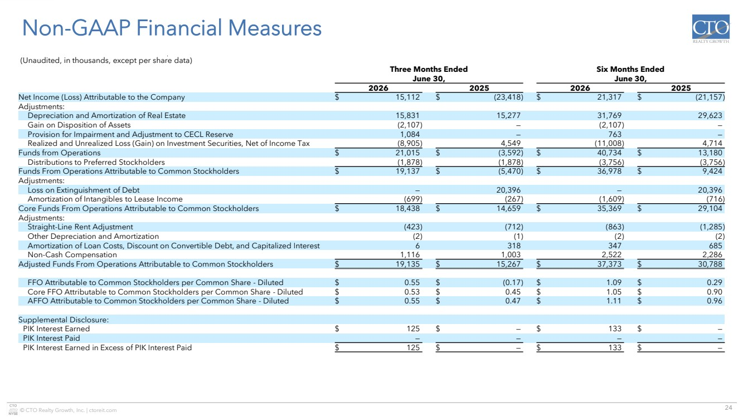 | 24 © CTO Realty Growth, Inc. | ctoreit.com Non-GAAP Financial Measures (Unaudited, in thousands, except per share data) Three Months Ended June 30, Six Months Ended June 30, 2026 2025 2026 2025 Net Income (Loss) Attributable to the Company $ 15,112 $ (23,418) $ 21,317 $ (21,157) Adjustments: Depreciation and Amortization of Real Estate 15,831 15,277 31,769 29,623 Gain on Disposition of Assets (2,107) — (2,107) — Provision for Impairment and Adjustment to CECL Reserve 1,084 — 763 — Realized and Unrealized Loss (Gain) on Investment Securities, Net of Income Tax (8,905) 4,549 (11,008) 4,714 Funds from Operations $ 21,015 $ (3,592) $ 40,734 $ 13,180 Distributions to Preferred Stockholders (1,878) (1,878) (3,756) (3,756) Funds From Operations Attributable to Common Stockholders $ 19,137 $ (5,470) $ 36,978 $ 9,424 Adjustments: Loss on Extinguishment of Debt — 20,396 — 20,396 Amortization of Intangibles to Lease Income (699) (267) (1,609) (716) Core Funds From Operations Attributable to Common Stockholders $ 18,438 $ 14,659 $ 35,369 $ 29,104 Adjustments: Straight-Line Rent Adjustment (423) (712) (863) (1,285) Other Depreciation and Amortization (2) (1) (2) (2) Amortization of Loan Costs, Discount on Convertible Debt, and Capitalized Interest 6 318 347 685 Non-Cash Compensation 1,116 1,003 2,522 2,286 Adjusted Funds From Operations Attributable to Common Stockholders $ 19,135 $ 15,267 $ 37,373 $ 30,788 FFO Attributable to Common Stockholders per Common Share - Diluted $ 0.55 $ (0.17) $ 1.09 $ 0.29 Core FFO Attributable to Common Stockholders per Common Share - Diluted $ 0.53 $ 0.45 $ 1.05 $ 0.90 AFFO Attributable to Common Stockholders per Common Share - Diluted $ 0.55 $ 0.47 $ 1.11 $ 0.96 Supplemental Disclosure: PIK Interest Earned $ 125 $ — $ 133 $ — PIK Interest Paid — — — — PIK Interest Earned in Excess of PIK Interest Paid $ 125 $ — $ 133 $ —
 | 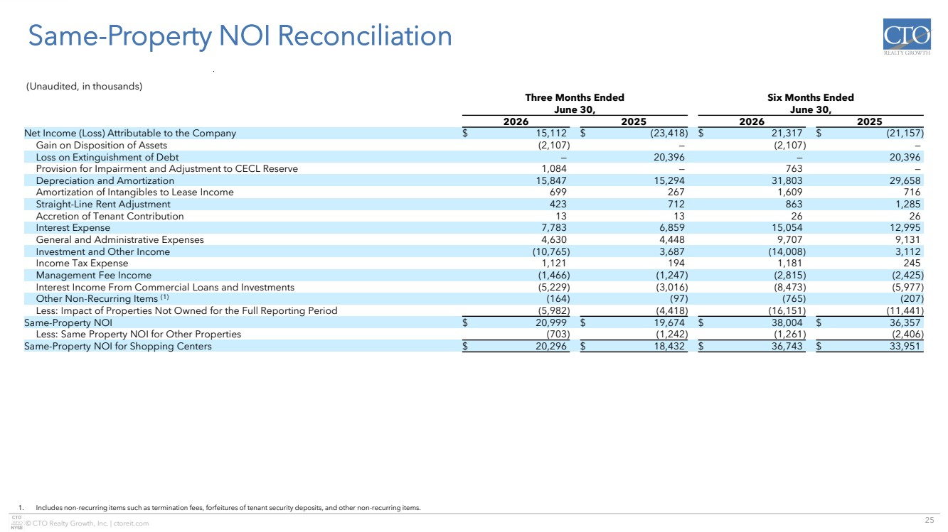 | 25 © CTO Realty Growth, Inc. | ctoreit.com Same-Property NOI Reconciliation 1. Includes non-recurring items such as termination fees, forfeitures of tenant security deposits, and other non-recurring items. (Unaudited, in thousands) Three Months Ended June 30, Six Months Ended June 30, 2026 2025 2026 2025 Net Income (Loss) Attributable to the Company $ 15,112 $ (23,418) $ 21,317 $ (21,157) Gain on Disposition of Assets (2,107) — (2,107) — Loss on Extinguishment of Debt — 20,396 — 20,396 Provision for Impairment and Adjustment to CECL Reserve 1,084 — 763 — Depreciation and Amortization 15,847 15,294 31,803 29,658 Amortization of Intangibles to Lease Income 699 267 1,609 716 Straight-Line Rent Adjustment 423 712 863 1,285 Accretion of Tenant Contribution 13 13 26 26 Interest Expense 7,783 6,859 15,054 12,995 General and Administrative Expenses 4,630 4,448 9,707 9,131 Investment and Other Income (10,765) 3,687 (14,008) 3,112 Income Tax Expense 1,121 194 1,181 245 Management Fee Income (1,466) (1,247) (2,815) (2,425) Interest Income From Commercial Loans and Investments (5,229) (3,016) (8,473) (5,977) Other Non-Recurring Items (1) (164) (97) (765) (207) Less: Impact of Properties Not Owned for the Full Reporting Period (5,982) (4,418) (16,151) (11,441) Same-Property NOI $ 20,999 $ 19,674 $ 38,004 $ 36,357 Less: Same Property NOI for Other Properties (703) (1,242) (1,261) (2,406) Same-Property NOI for Shopping Centers $ 20,296 $ 18,432 $ 36,743 $ 33,951
 | 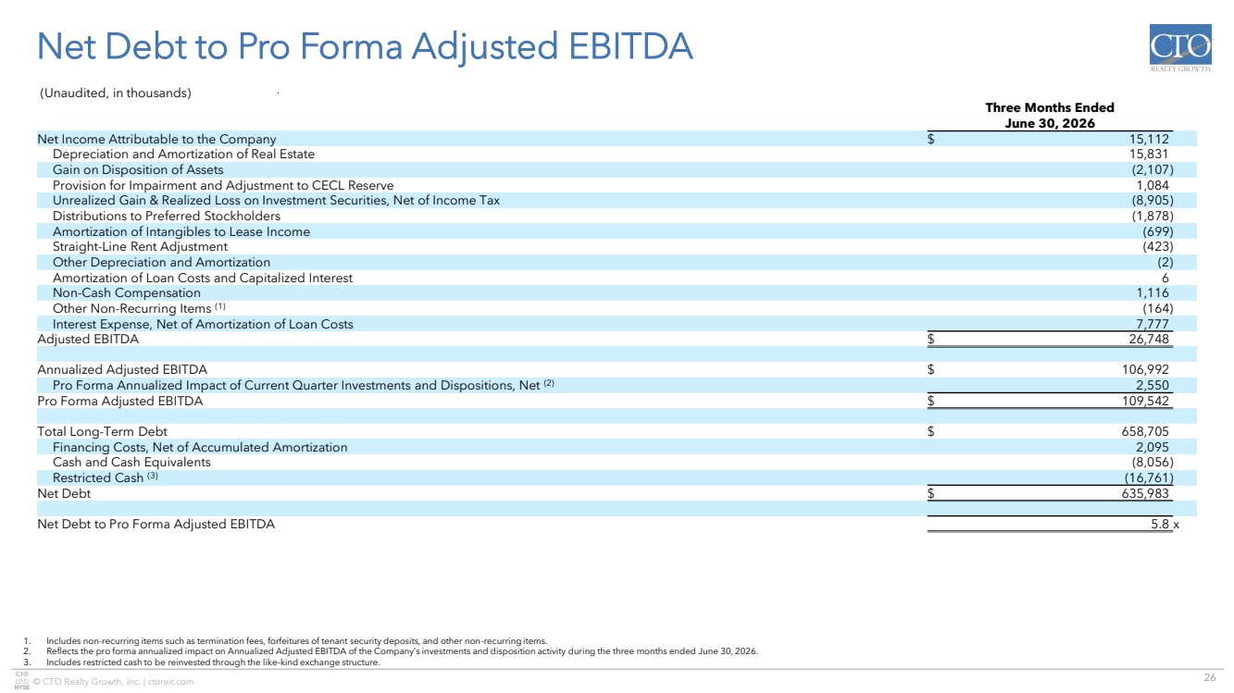 | 26 © CTO Realty Growth, Inc. | ctoreit.com Net Debt to Pro Forma Adjusted EBITDA 1. Includes non-recurring items such as termination fees, forfeitures of tenant security deposits, and other non-recurring items. 2. Reflects the pro forma annualized impact on Annualized Adjusted EBITDA of the Company’s investments and disposition activity during the three months ended June 30, 2026. 3. Includes restricted cash to be reinvested through the like-kind exchange structure. (Unaudited, in thousands) Three Months Ended June 30, 2026 Net Income Attributable to the Company $ 15,112 Depreciation and Amortization of Real Estate 15,831 Gain on Disposition of Assets (2,107) Provision for Impairment and Adjustment to CECL Reserve 1,084 Unrealized Gain & Realized Loss on Investment Securities, Net of Income Tax (8,905) Distributions to Preferred Stockholders (1,878) Amortization of Intangibles to Lease Income (699) Straight-Line Rent Adjustment (423) Other Depreciation and Amortization (2) Amortization of Loan Costs and Capitalized Interest 6 Non-Cash Compensation 1,116 Other Non-Recurring Items (1) (164) Interest Expense, Net of Amortization of Loan Costs 7,777 Adjusted EBITDA $ 26,748 Annualized Adjusted EBITDA $ 106,992 Pro Forma Annualized Impact of Current Quarter Investments and Dispositions, Net (2) 2,550 Pro Forma Adjusted EBITDA $ 109,542 Total Long-Term Debt $ 658,705 Financing Costs, Net of Accumulated Amortization 2,095 Cash and Cash Equivalents (8,056) Restricted Cash (3) (16,761) Net Debt $ 635,983 Net Debt to Pro Forma Adjusted EBITDA 5.8 x
 |  | Investor Inquiries: ir@ctoreit.com
Exhibit 99.3
 | 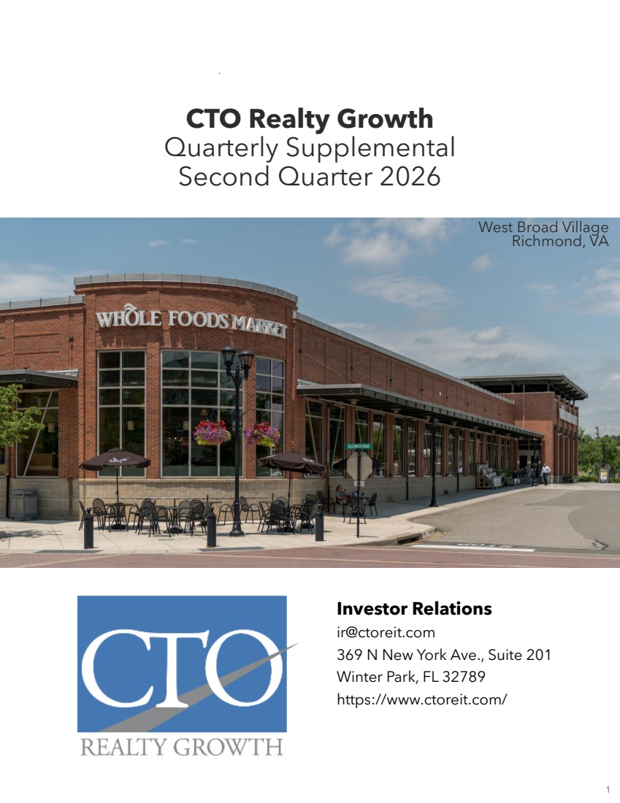 | 9 CTO Realty Growth Quarterly Supplemental Second Quarter 2026 Investor Relations ir@ctoreit.com 369 N New York Ave., Suite 201 Winter Park, FL 32789 https://www.ctoreit.com/ West Broad Village Richmond, VA 1
 | 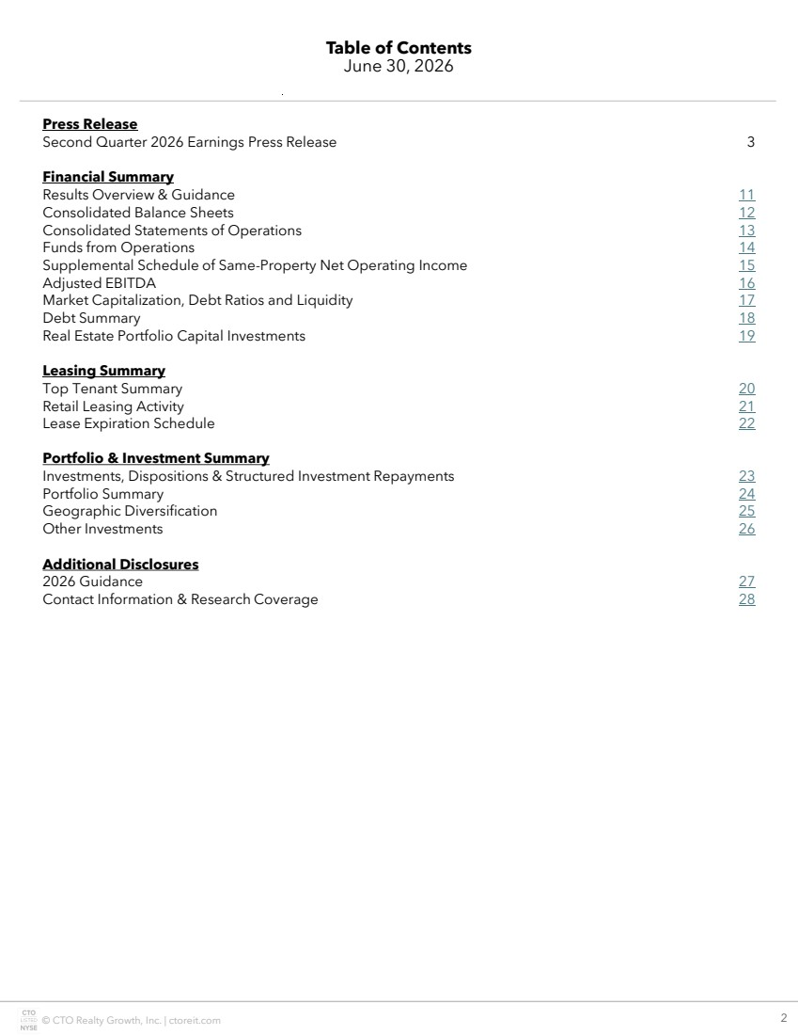 | © CTO Realty Growth, Inc. | ctoreit.com 10 Table of Contents June 30, 2026 Press Release Second Quarter 2026 Earnings Press Release 3 Financial Summary Results Overview & Guidance 11 Consolidated Balance Sheets 12 Consolidated Statements of Operations 13 Funds from Operations 14 Supplemental Schedule of Same-Property Net Operating Income 15 Adjusted EBITDA 16 Market Capitalization, Debt Ratios and Liquidity 17 Debt Summary 18 Real Estate Portfolio Capital Investments 19 Leasing Summary Top Tenant Summary 20 Retail Leasing Activity 21 Lease Expiration Schedule 22 Portfolio & Investment Summary Investments, Dispositions & Structured Investment Repayments 23 Portfolio Summary 24 Geographic Diversification 25 Other Investments 26 Additional Disclosures 2026 Guidance 27 Contact Information & Research Coverage 28 2
 | 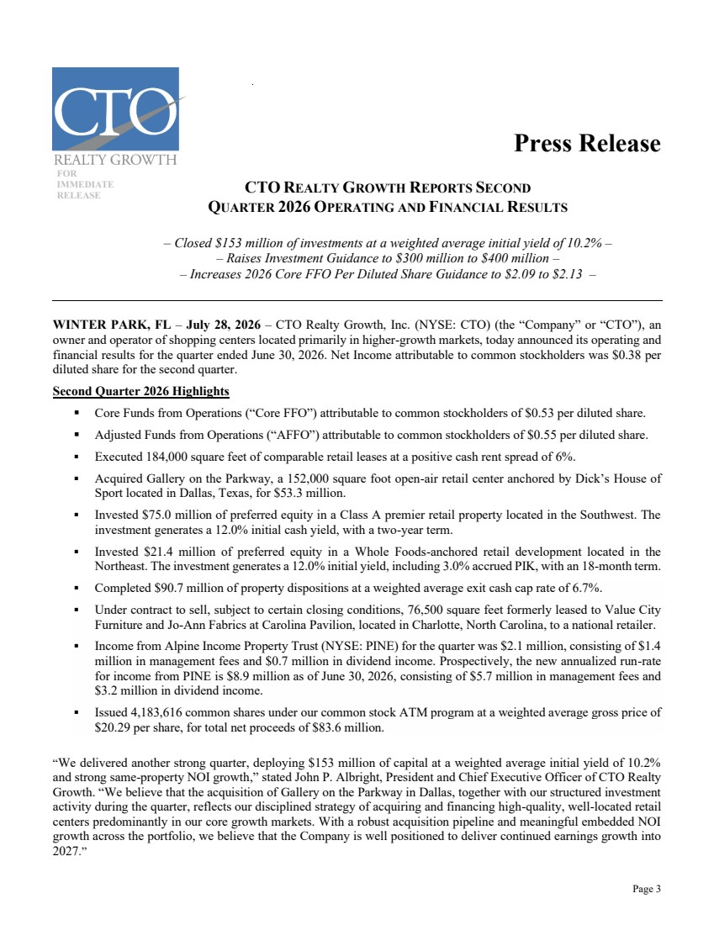 | Page 3 DRAFT DRATDDD Press Release FIRST 2024 OPERATING RESULTS FOR IMMEDIATE RELEASE CTO REALTY GROWTH REPORTS SECOND QUARTER 2026 OPERATING AND FINANCIAL RESULTS – Closed $153 million of investments at a weighted average initial yield of 10.2% – – Raises Investment Guidance to $300 million to $400 million – – Increases 2026 Core FFO Per Diluted Share Guidance to $2.09 to $2.13 – WINTER PARK, FL – July 28, 2026 – CTO Realty Growth, Inc. (NYSE: CTO) (the “Company” or “CTO”), an owner and operator of shopping centers located primarily in higher-growth markets, today announced its operating and financial results for the quarter ended June 30, 2026. Net Income attributable to common stockholders was $0.38 per diluted share for the second quarter. Second Quarter 2026 Highlights ▪ Core Funds from Operations (“Core FFO”) attributable to common stockholders of $0.53 per diluted share. ▪ Adjusted Funds from Operations (“AFFO”) attributable to common stockholders of $0.55 per diluted share. ▪ Executed 184,000 square feet of comparable retail leases at a positive cash rent spread of 6%. ▪ Acquired Gallery on the Parkway, a 152,000 square foot open-air retail center anchored by Dick’s House of Sport located in Dallas, Texas, for $53.3 million. ▪ Invested $75.0 million of preferred equity in a Class A premier retail property located in the Southwest. The investment generates a 12.0% initial cash yield, with a two-year term. ▪ Invested $21.4 million of preferred equity in a Whole Foods-anchored retail development located in the Northeast. The investment generates a 12.0% initial yield, including 3.0% accrued PIK, with an 18-month term. ▪ Completed $90.7 million of property dispositions at a weighted average exit cash cap rate of 6.7%. ▪ Under contract to sell, subject to certain closing conditions, 76,500 square feet formerly leased to Value City Furniture and Jo-Ann Fabrics at Carolina Pavilion, located in Charlotte, North Carolina, to a national retailer. ▪ Income from Alpine Income Property Trust (NYSE: PINE) for the quarter was $2.1 million, consisting of $1.4 million in management fees and $0.7 million in dividend income. Prospectively, the new annualized run-rate for income from PINE is $8.9 million as of June 30, 2026, consisting of $5.7 million in management fees and $3.2 million in dividend income. ▪ Issued 4,183,616 common shares under our common stock ATM program at a weighted average gross price of $20.29 per share, for total net proceeds of $83.6 million. “We delivered another strong quarter, deploying $153 million of capital at a weighted average initial yield of 10.2% and strong same-property NOI growth,” stated John P. Albright, President and Chief Executive Officer of CTO Realty Growth. “We believe that the acquisition of Gallery on the Parkway in Dallas, together with our structured investment activity during the quarter, reflects our disciplined strategy of acquiring and financing high-quality, well-located retail centers predominantly in our core growth markets. With a robust acquisition pipeline and meaningful embedded NOI growth across the portfolio, we believe that the Company is well positioned to deliver continued earnings growth into 2027.”
 | 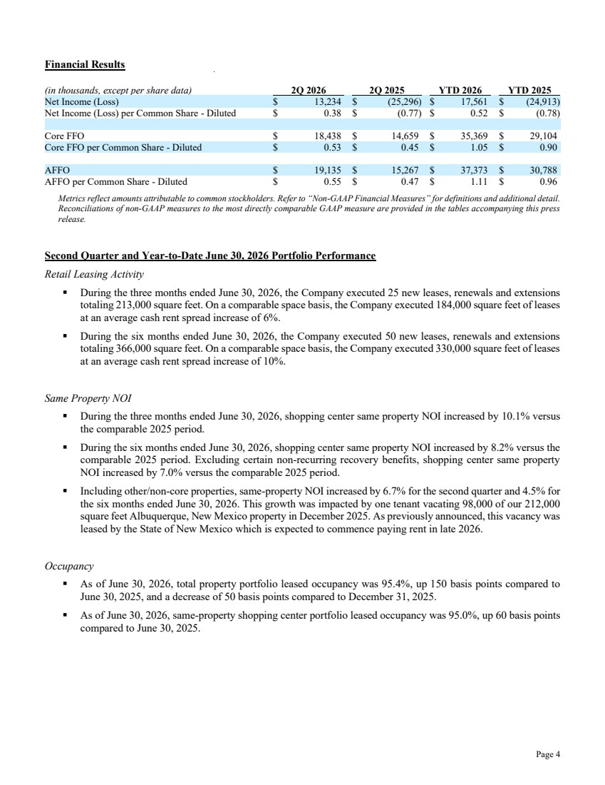 | Page 4 Financial Results (in thousands, except per share data) 2Q 2026 2Q 2025 YTD 2026 YTD 2025 Net Income (Loss) $ 13,234 $ (25,296) $ 17,561 $ (24,913) Net Income (Loss) per Common Share - Diluted $ 0.38 $ (0.77) $ 0.52 $ (0.78) Core FFO $ 18,438 $ 14,659 $ 35,369 $ 29,104 Core FFO per Common Share - Diluted $ 0.53 $ 0.45 $ 1.05 $ 0.90 AFFO $ 19,135 $ 15,267 $ 37,373 $ 30,788 AFFO per Common Share - Diluted $ 0.55 $ 0.47 $ 1.11 $ 0.96 Metrics reflect amounts attributable to common stockholders. Refer to “Non-GAAP Financial Measures” for definitions and additional detail. Reconciliations of non-GAAP measures to the most directly comparable GAAP measure are provided in the tables accompanying this press release. Second Quarter and Year-to-Date June 30, 2026 Portfolio Performance Retail Leasing Activity ▪ During the three months ended June 30, 2026, the Company executed 25 new leases, renewals and extensions totaling 213,000 square feet. On a comparable space basis, the Company executed 184,000 square feet of leases at an average cash rent spread increase of 6%. ▪ During the six months ended June 30, 2026, the Company executed 50 new leases, renewals and extensions totaling 366,000 square feet. On a comparable space basis, the Company executed 330,000 square feet of leases at an average cash rent spread increase of 10%. Same Property NOI ▪ During the three months ended June 30, 2026, shopping center same property NOI increased by 10.1% versus the comparable 2025 period. ▪ During the six months ended June 30, 2026, shopping center same property NOI increased by 8.2% versus the comparable 2025 period. Excluding certain non-recurring recovery benefits, shopping center same property NOI increased by 7.0% versus the comparable 2025 period. ▪ Including other/non-core properties, same-property NOI increased by 6.7% for the second quarter and 4.5% for the six months ended June 30, 2026. This growth was impacted by one tenant vacating 98,000 of our 212,000 square feet Albuquerque, New Mexico property in December 2025. As previously announced, this vacancy was leased by the State of New Mexico which is expected to commence paying rent in late 2026. Occupancy ▪ As of June 30, 2026, total property portfolio leased occupancy was 95.4%, up 150 basis points compared to June 30, 2025, and a decrease of 50 basis points compared to December 31, 2025. ▪ As of June 30, 2026, same-property shopping center portfolio leased occupancy was 95.0%, up 60 basis points compared to June 30, 2025.
 | 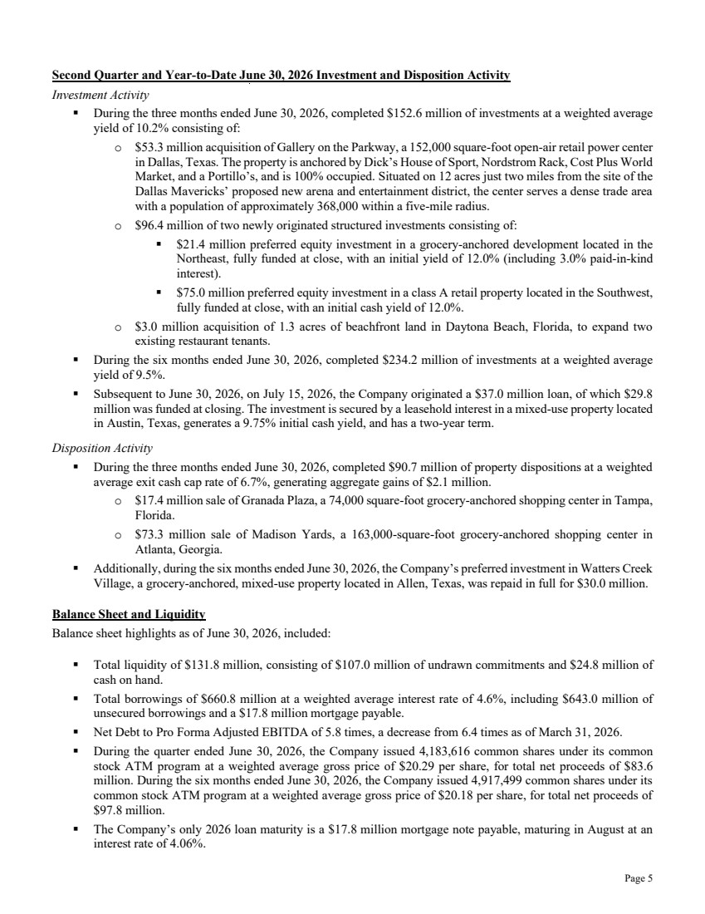 | Page 5 Second Quarter and Year-to-Date June 30, 2026 Investment and Disposition Activity Investment Activity ▪ During the three months ended June 30, 2026, completed $152.6 million of investments at a weighted average yield of 10.2% consisting of: o $53.3 million acquisition of Gallery on the Parkway, a 152,000 square-foot open-air retail power center in Dallas, Texas. The property is anchored by Dick’s House of Sport, Nordstrom Rack, Cost Plus World Market, and a Portillo’s, and is 100% occupied. Situated on 12 acres just two miles from the site of the Dallas Mavericks’ proposed new arena and entertainment district, the center serves a dense trade area with a population of approximately 368,000 within a five-mile radius. o $96.4 million of two newly originated structured investments consisting of: ▪ $21.4 million preferred equity investment in a grocery-anchored development located in the Northeast, fully funded at close, with an initial yield of 12.0% (including 3.0% paid-in-kind interest). ▪ $75.0 million preferred equity investment in a class A retail property located in the Southwest, fully funded at close, with an initial cash yield of 12.0%. o $3.0 million acquisition of 1.3 acres of beachfront land in Daytona Beach, Florida, to expand two existing restaurant tenants. ▪ During the six months ended June 30, 2026, completed $234.2 million of investments at a weighted average yield of 9.5%. ▪ Subsequent to June 30, 2026, on July 15, 2026, the Company originated a $37.0 million loan, of which $29.8 million was funded at closing. The investment is secured by a leasehold interest in a mixed-use property located in Austin, Texas, generates a 9.75% initial cash yield, and has a two-year term. Disposition Activity ▪ During the three months ended June 30, 2026, completed $90.7 million of property dispositions at a weighted average exit cash cap rate of 6.7%, generating aggregate gains of $2.1 million. o $17.4 million sale of Granada Plaza, a 74,000 square-foot grocery-anchored shopping center in Tampa, Florida. o $73.3 million sale of Madison Yards, a 163,000-square-foot grocery-anchored shopping center in Atlanta, Georgia. ▪ Additionally, during the six months ended June 30, 2026, the Company’s preferred investment in Watters Creek Village, a grocery-anchored, mixed-use property located in Allen, Texas, was repaid in full for $30.0 million. Balance Sheet and Liquidity Balance sheet highlights as of June 30, 2026, included: ▪ Total liquidity of $131.8 million, consisting of $107.0 million of undrawn commitments and $24.8 million of cash on hand. ▪ Total borrowings of $660.8 million at a weighted average interest rate of 4.6%, including $643.0 million of unsecured borrowings and a $17.8 million mortgage payable. ▪ Net Debt to Pro Forma Adjusted EBITDA of 5.8 times, a decrease from 6.4 times as of March 31, 2026. ▪ During the quarter ended June 30, 2026, the Company issued 4,183,616 common shares under its common stock ATM program at a weighted average gross price of $20.29 per share, for total net proceeds of $83.6 million. During the six months ended June 30, 2026, the Company issued 4,917,499 common shares under its common stock ATM program at a weighted average gross price of $20.18 per share, for total net proceeds of $97.8 million. ▪ The Company’s only 2026 loan maturity is a $17.8 million mortgage note payable, maturing in August at an interest rate of 4.06%.
 | 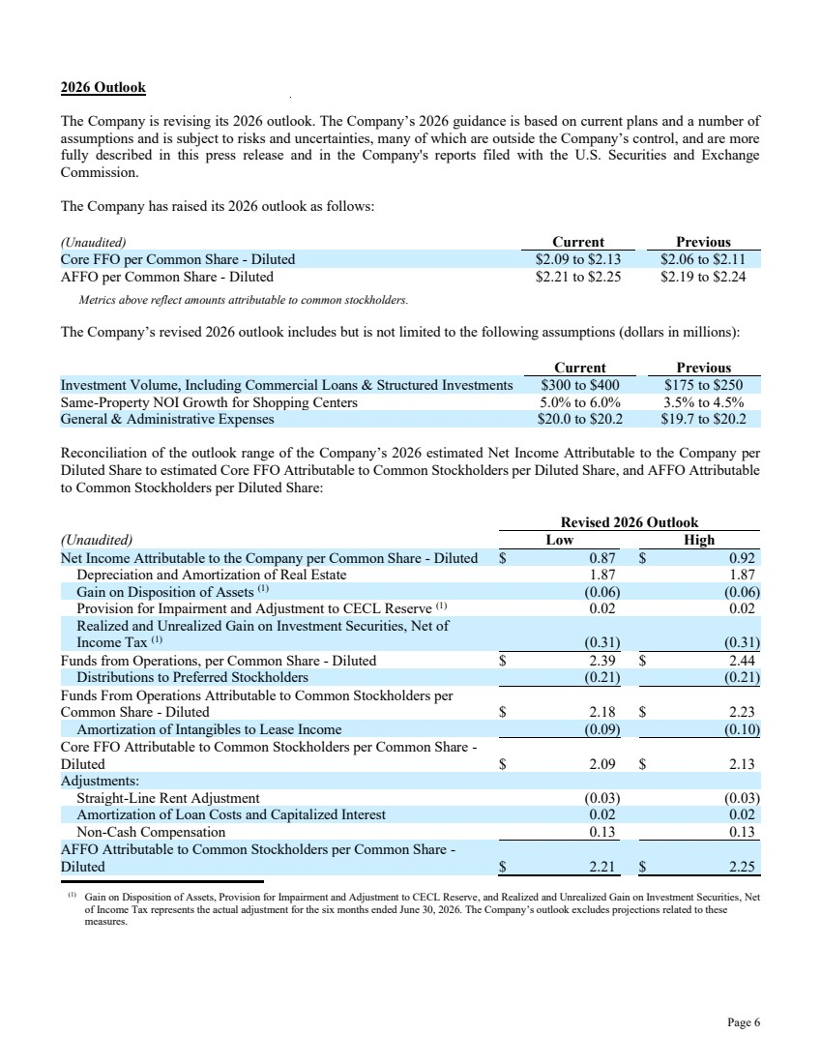 | Page 6 2026 Outlook The Company is revising its 2026 outlook. The Company’s 2026 guidance is based on current plans and a number of assumptions and is subject to risks and uncertainties, many of which are outside the Company’s control, and are more fully described in this press release and in the Company's reports filed with the U.S. Securities and Exchange Commission. The Company has raised its 2026 outlook as follows: (Unaudited) Current Previous Core FFO per Common Share - Diluted $2.09 to $2.13 $2.06 to $2.11 AFFO per Common Share - Diluted $2.21 to $2.25 $2.19 to $2.24 Metrics above reflect amounts attributable to common stockholders. The Company’s revised 2026 outlook includes but is not limited to the following assumptions (dollars in millions): Current Previous Investment Volume, Including Commercial Loans & Structured Investments $300 to $400 $175 to $250 Same-Property NOI Growth for Shopping Centers 5.0% to 6.0% 3.5% to 4.5% General & Administrative Expenses $20.0 to $20.2 $19.7 to $20.2 Reconciliation of the outlook range of the Company’s 2026 estimated Net Income Attributable to the Company per Diluted Share to estimated Core FFO Attributable to Common Stockholders per Diluted Share, and AFFO Attributable to Common Stockholders per Diluted Share: Revised 2026 Outlook (Unaudited) Low High Net Income Attributable to the Company per Common Share - Diluted $ 0.87 $ 0.92 Depreciation and Amortization of Real Estate 1.87 1.87 Gain on Disposition of Assets (1) (0.06) (0.06) Provision for Impairment and Adjustment to CECL Reserve (1) 0.02 0.02 Realized and Unrealized Gain on Investment Securities, Net of Income Tax (1) (0.31) (0.31) Funds from Operations, per Common Share - Diluted $ 2.39 $ 2.44 Distributions to Preferred Stockholders (0.21) (0.21) Funds From Operations Attributable to Common Stockholders per Common Share - Diluted $ 2.18 $ 2.23 Amortization of Intangibles to Lease Income (0.09) (0.10) Core FFO Attributable to Common Stockholders per Common Share - Diluted $ 2.09 $ 2.13 Adjustments: Straight-Line Rent Adjustment (0.03) (0.03) Amortization of Loan Costs and Capitalized Interest 0.02 0.02 Non-Cash Compensation 0.13 0.13 AFFO Attributable to Common Stockholders per Common Share - Diluted $ 2.21 $ 2.25 (1) Gain on Disposition of Assets, Provision for Impairment and Adjustment to CECL Reserve, and Realized and Unrealized Gain on Investment Securities, Net of Income Tax represents the actual adjustment for the six months ended June 30, 2026. The Company’s outlook excludes projections related to these measures.
 | 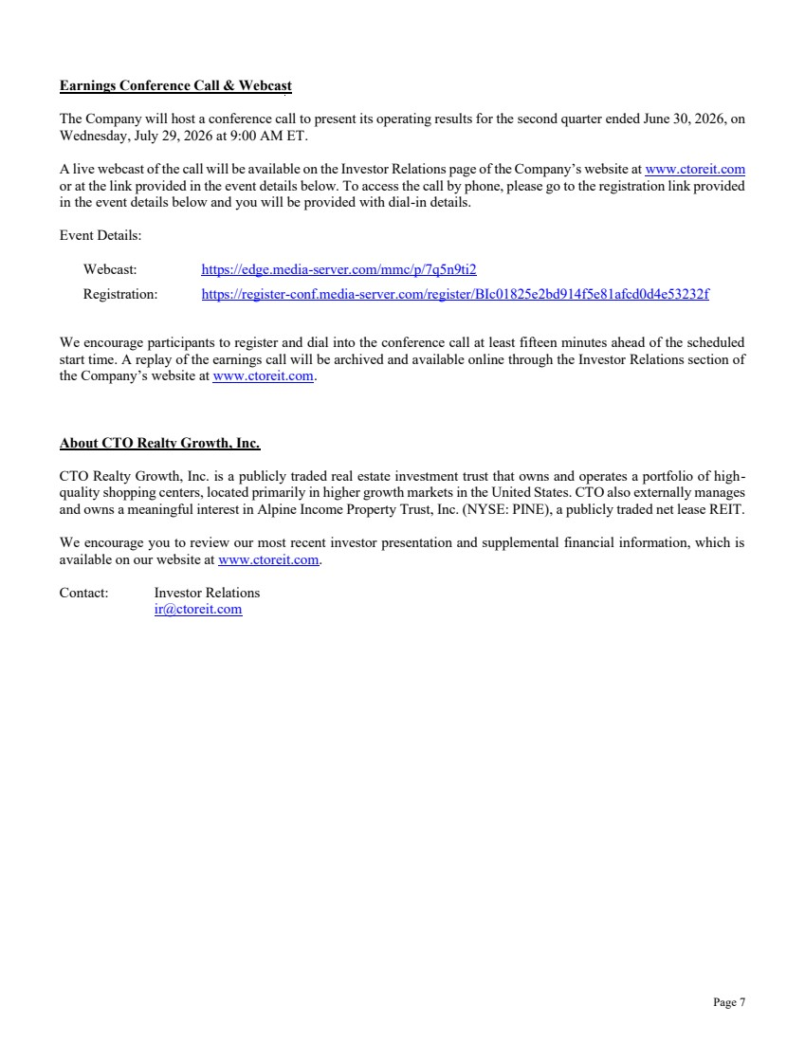 | Page 7 Earnings Conference Call & Webcast The Company will host a conference call to present its operating results for the second quarter ended June 30, 2026, on Wednesday, July 29, 2026 at 9:00 AM ET. A live webcast of the call will be available on the Investor Relations page of the Company’s website at www.ctoreit.com or at the link provided in the event details below. To access the call by phone, please go to the registration link provided in the event details below and you will be provided with dial-in details. Event Details: Webcast: https://edge.media-server.com/mmc/p/7q5n9ti2 Registration: https://register-conf.media-server.com/register/BIc01825e2bd914f5e81afcd0d4e53232f We encourage participants to register and dial into the conference call at least fifteen minutes ahead of the scheduled start time. A replay of the earnings call will be archived and available online through the Investor Relations section of the Company’s website at www.ctoreit.com. About CTO Realty Growth, Inc. CTO Realty Growth, Inc. is a publicly traded real estate investment trust that owns and operates a portfolio of high-quality shopping centers, located primarily in higher growth markets in the United States. CTO also externally manages and owns a meaningful interest in Alpine Income Property Trust, Inc. (NYSE: PINE), a publicly traded net lease REIT. We encourage you to review our most recent investor presentation and supplemental financial information, which is available on our website at www.ctoreit.com. Contact: Investor Relations ir@ctoreit.com
 | 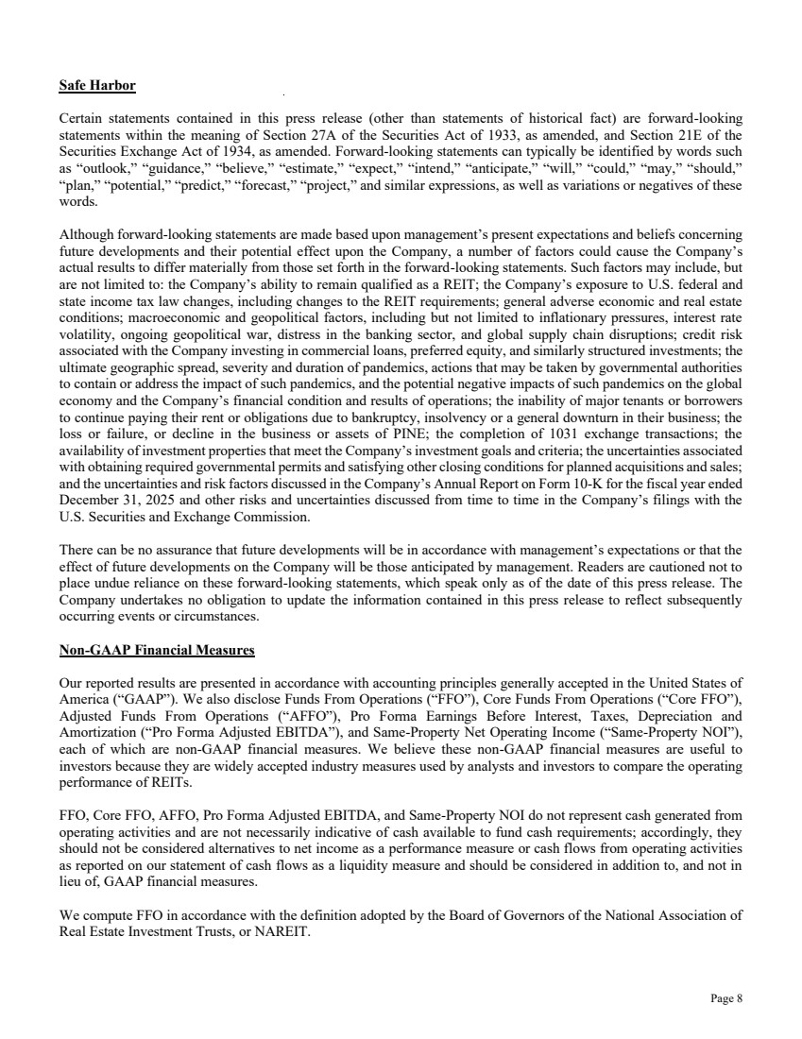 | Page 8 Safe Harbor Certain statements contained in this press release (other than statements of historical fact) are forward-looking statements within the meaning of Section 27A of the Securities Act of 1933, as amended, and Section 21E of the Securities Exchange Act of 1934, as amended. Forward-looking statements can typically be identified by words such as “outlook,” “guidance,” “believe,” “estimate,” “expect,” “intend,” “anticipate,” “will,” “could,” “may,” “should,” “plan,” “potential,” “predict,” “forecast,” “project,” and similar expressions, as well as variations or negatives of these words. Although forward-looking statements are made based upon management’s present expectations and beliefs concerning future developments and their potential effect upon the Company, a number of factors could cause the Company’s actual results to differ materially from those set forth in the forward-looking statements. Such factors may include, but are not limited to: the Company’s ability to remain qualified as a REIT; the Company’s exposure to U.S. federal and state income tax law changes, including changes to the REIT requirements; general adverse economic and real estate conditions; macroeconomic and geopolitical factors, including but not limited to inflationary pressures, interest rate volatility, ongoing geopolitical war, distress in the banking sector, and global supply chain disruptions; credit risk associated with the Company investing in commercial loans, preferred equity, and similarly structured investments; the ultimate geographic spread, severity and duration of pandemics, actions that may be taken by governmental authorities to contain or address the impact of such pandemics, and the potential negative impacts of such pandemics on the global economy and the Company’s financial condition and results of operations; the inability of major tenants or borrowers to continue paying their rent or obligations due to bankruptcy, insolvency or a general downturn in their business; the loss or failure, or decline in the business or assets of PINE; the completion of 1031 exchange transactions; the availability of investment properties that meet the Company’s investment goals and criteria; the uncertainties associated with obtaining required governmental permits and satisfying other closing conditions for planned acquisitions and sales; and the uncertainties and risk factors discussed in the Company’s Annual Report on Form 10-K for the fiscal year ended December 31, 2025 and other risks and uncertainties discussed from time to time in the Company’s filings with the U.S. Securities and Exchange Commission. There can be no assurance that future developments will be in accordance with management’s expectations or that the effect of future developments on the Company will be those anticipated by management. Readers are cautioned not to place undue reliance on these forward-looking statements, which speak only as of the date of this press release. The Company undertakes no obligation to update the information contained in this press release to reflect subsequently occurring events or circumstances. Non-GAAP Financial Measures Our reported results are presented in accordance with accounting principles generally accepted in the United States of America (“GAAP”). We also disclose Funds From Operations (“FFO”), Core Funds From Operations (“Core FFO”), Adjusted Funds From Operations (“AFFO”), Pro Forma Earnings Before Interest, Taxes, Depreciation and Amortization (“Pro Forma Adjusted EBITDA”), and Same-Property Net Operating Income (“Same-Property NOI”), each of which are non-GAAP financial measures. We believe these non-GAAP financial measures are useful to investors because they are widely accepted industry measures used by analysts and investors to compare the operating performance of REITs. FFO, Core FFO, AFFO, Pro Forma Adjusted EBITDA, and Same-Property NOI do not represent cash generated from operating activities and are not necessarily indicative of cash available to fund cash requirements; accordingly, they should not be considered alternatives to net income as a performance measure or cash flows from operating activities as reported on our statement of cash flows as a liquidity measure and should be considered in addition to, and not in lieu of, GAAP financial measures. We compute FFO in accordance with the definition adopted by the Board of Governors of the National Association of Real Estate Investment Trusts, or NAREIT.
 | 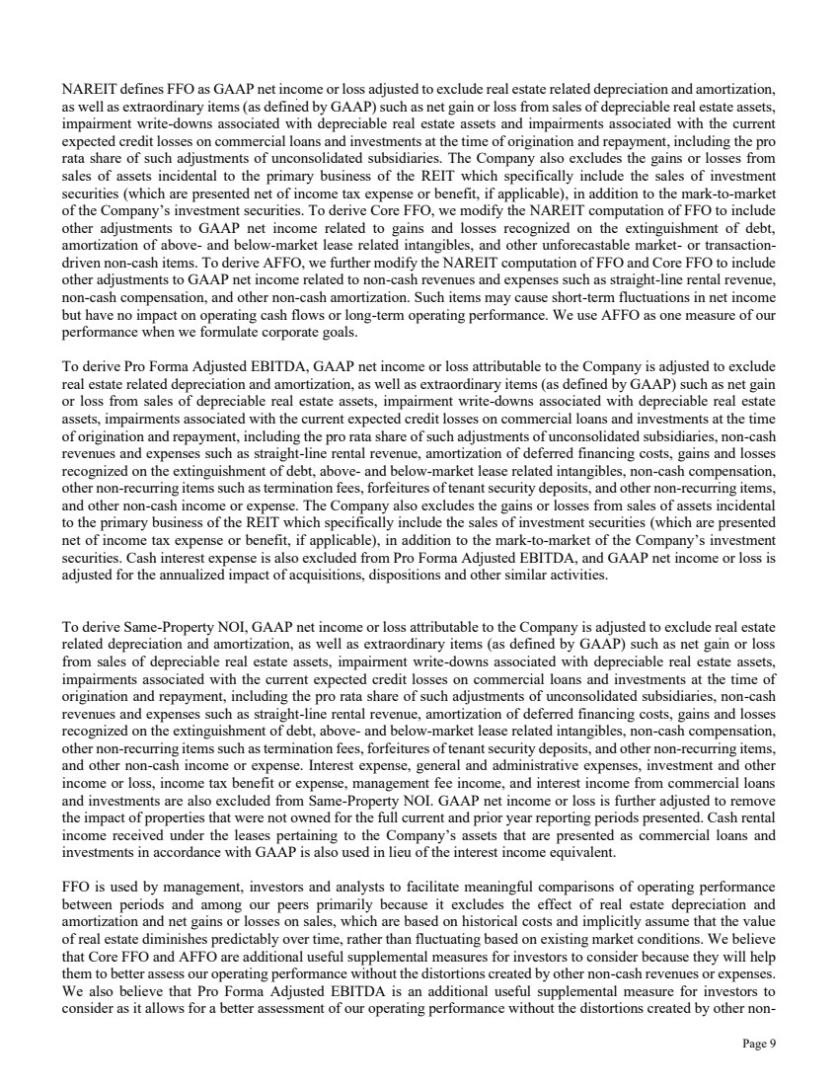 | Page 9 NAREIT defines FFO as GAAP net income or loss adjusted to exclude real estate related depreciation and amortization, as well as extraordinary items (as defined by GAAP) such as net gain or loss from sales of depreciable real estate assets, impairment write-downs associated with depreciable real estate assets and impairments associated with the current expected credit losses on commercial loans and investments at the time of origination and repayment, including the pro rata share of such adjustments of unconsolidated subsidiaries. The Company also excludes the gains or losses from sales of assets incidental to the primary business of the REIT which specifically include the sales of investment securities (which are presented net of income tax expense or benefit, if applicable), in addition to the mark-to-market of the Company’s investment securities. To derive Core FFO, we modify the NAREIT computation of FFO to include other adjustments to GAAP net income related to gains and losses recognized on the extinguishment of debt, amortization of above- and below-market lease related intangibles, and other unforecastable market- or transaction-driven non-cash items. To derive AFFO, we further modify the NAREIT computation of FFO and Core FFO to include other adjustments to GAAP net income related to non-cash revenues and expenses such as straight-line rental revenue, non-cash compensation, and other non-cash amortization. Such items may cause short-term fluctuations in net income but have no impact on operating cash flows or long-term operating performance. We use AFFO as one measure of our performance when we formulate corporate goals. To derive Pro Forma Adjusted EBITDA, GAAP net income or loss attributable to the Company is adjusted to exclude real estate related depreciation and amortization, as well as extraordinary items (as defined by GAAP) such as net gain or loss from sales of depreciable real estate assets, impairment write-downs associated with depreciable real estate assets, impairments associated with the current expected credit losses on commercial loans and investments at the time of origination and repayment, including the pro rata share of such adjustments of unconsolidated subsidiaries, non-cash revenues and expenses such as straight-line rental revenue, amortization of deferred financing costs, gains and losses recognized on the extinguishment of debt, above- and below-market lease related intangibles, non-cash compensation, other non-recurring items such as termination fees, forfeitures of tenant security deposits, and other non-recurring items, and other non-cash income or expense. The Company also excludes the gains or losses from sales of assets incidental to the primary business of the REIT which specifically include the sales of investment securities (which are presented net of income tax expense or benefit, if applicable), in addition to the mark-to-market of the Company’s investment securities. Cash interest expense is also excluded from Pro Forma Adjusted EBITDA, and GAAP net income or loss is adjusted for the annualized impact of acquisitions, dispositions and other similar activities. To derive Same-Property NOI, GAAP net income or loss attributable to the Company is adjusted to exclude real estate related depreciation and amortization, as well as extraordinary items (as defined by GAAP) such as net gain or loss from sales of depreciable real estate assets, impairment write-downs associated with depreciable real estate assets, impairments associated with the current expected credit losses on commercial loans and investments at the time of origination and repayment, including the pro rata share of such adjustments of unconsolidated subsidiaries, non-cash revenues and expenses such as straight-line rental revenue, amortization of deferred financing costs, gains and losses recognized on the extinguishment of debt, above- and below-market lease related intangibles, non-cash compensation, other non-recurring items such as termination fees, forfeitures of tenant security deposits, and other non-recurring items, and other non-cash income or expense. Interest expense, general and administrative expenses, investment and other income or loss, income tax benefit or expense, management fee income, and interest income from commercial loans and investments are also excluded from Same-Property NOI. GAAP net income or loss is further adjusted to remove the impact of properties that were not owned for the full current and prior year reporting periods presented. Cash rental income received under the leases pertaining to the Company’s assets that are presented as commercial loans and investments in accordance with GAAP is also used in lieu of the interest income equivalent. FFO is used by management, investors and analysts to facilitate meaningful comparisons of operating performance between periods and among our peers primarily because it excludes the effect of real estate depreciation and amortization and net gains or losses on sales, which are based on historical costs and implicitly assume that the value of real estate diminishes predictably over time, rather than fluctuating based on existing market conditions. We believe that Core FFO and AFFO are additional useful supplemental measures for investors to consider because they will help them to better assess our operating performance without the distortions created by other non-cash revenues or expenses. We also believe that Pro Forma Adjusted EBITDA is an additional useful supplemental measure for investors to consider as it allows for a better assessment of our operating performance without the distortions created by other non-
 |  | Page 10 cash revenues, expenses or certain effects of the Company’s capital structure on our operating performance. We use Same-Property NOI to compare the operating performance of our assets between periods. It is an accepted and important measurement used by management, investors and analysts because it includes all property-level revenues from the Company’s properties, less operating and maintenance expenses, real estate taxes and other property-specific expenses (“Net Operating Income” or “NOI”) of properties that have been owned and stabilized for the entire current and prior year reporting periods. Same-Property NOI attempts to eliminate differences due to the acquisition or disposition of properties during the particular period presented, and therefore provides a more comparable and consistent performance measure for the comparison of the Company’s properties. FFO, Core FFO, AFFO, Pro Forma Adjusted EBITDA, and Same-Property NOI may not be comparable to similarly titled measures employed by other companies.
 | 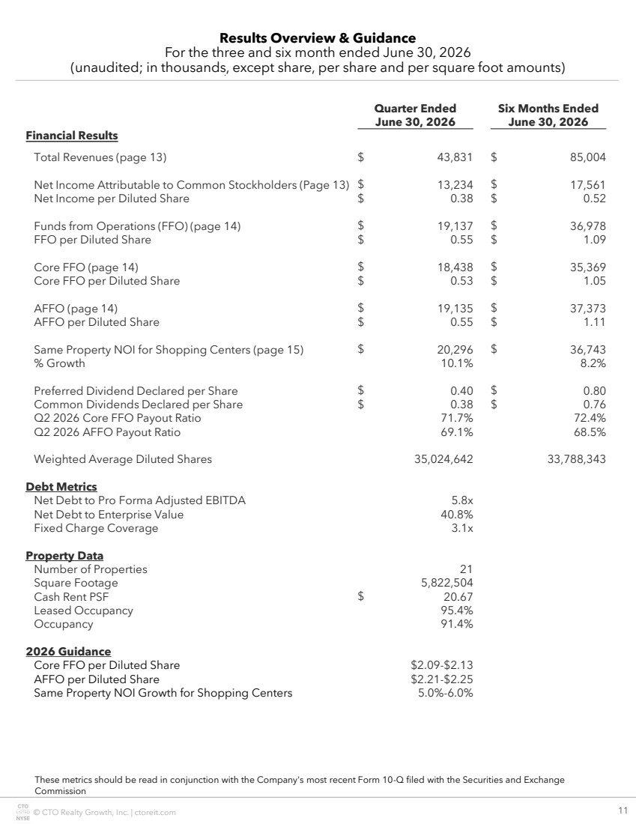 | © CTO Realty Growth, Inc. | ctoreit.com 11 Quarter Ended Six Months Ended June 30, 2026 June 30, 2026 Financial Results Total Revenues (page 13) $ 43,831 $ 85,004 Net Income Attributable to Common Stockholders (Page 13) $ 13,234 $ 17,561 Net Income per Diluted Share $ 0.38 $ 0.52 Funds from Operations (FFO) (page 14) $ 19,137 $ 36,978 FFO per Diluted Share $ 0.55 $ 1.09 Core FFO (page 14) $ 18,438 $ 35,369 Core FFO per Diluted Share $ 0.53 $ 1.05 AFFO (page 14) $ 19,135 $ 37,373 AFFO per Diluted Share $ 0.55 $ 1.11 Same Property NOI for Shopping Centers (page 15) $ 20,296 $ 36,743 % Growth 10.1% 8.2% Preferred Dividend Declared per Share $ 0.40 $ 0.80 Common Dividends Declared per Share $ 0.38 $ 0.76 Q2 2026 Core FFO Payout Ratio 71.7% 72.4% Q2 2026 AFFO Payout Ratio 69.1% 68.5% Weighted Average Diluted Shares 35,024,642 33,788,343 Debt Metrics Net Debt to Pro Forma Adjusted EBITDA 5.8x Net Debt to Enterprise Value 40.8% Fixed Charge Coverage 3.1x Property Data Number of Properties 21 Square Footage 5,822,504 Cash Rent PSF $ 20.67 Leased Occupancy 95.4% Occupancy 91.4% 2026 Guidance Core FFO per Diluted Share $2.09-$2.13 AFFO per Diluted Share $2.21-$2.25 Same Property NOI Growth for Shopping Centers 5.0%-6.0% Results Overview & Guidance For the three and six month ended June 30, 2026 (unaudited; in thousands, except share, per share and per square foot amounts) These metrics should be read in conjunction with the Company's most recent Form 10-Q filed with the Securities and Exchange Commission
 | 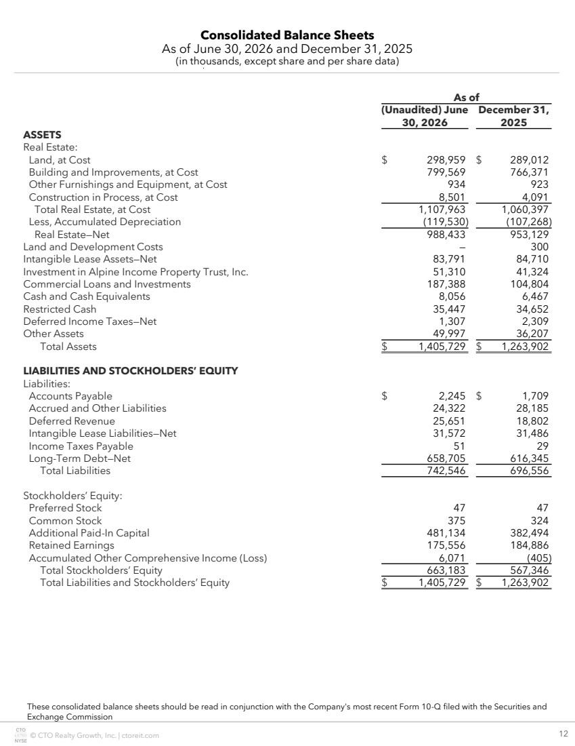 | © CTO Realty Growth, Inc. | ctoreit.com 12 Consolidated Balance Sheets As of June 30, 2026 and December 31, 2025 (in thousands, except share and per share data) As of (Unaudited) June 30, 2026 December 31, 2025 ASSETS Real Estate: Land, at Cost $ 298,959 $ 289,012 Building and Improvements, at Cost 799,569 766,371 Other Furnishings and Equipment, at Cost 934 923 Construction in Process, at Cost 8,501 4,091 Total Real Estate, at Cost 1,107,963 1,060,397 Less, Accumulated Depreciation (119,530) (107,268) Real Estate—Net 988,433 953,129 Land and Development Costs — 300 Intangible Lease Assets—Net 83,791 84,710 Investment in Alpine Income Property Trust, Inc. 51,310 41,324 Commercial Loans and Investments 187,388 104,804 Cash and Cash Equivalents 8,056 6,467 Restricted Cash 35,447 34,652 Deferred Income Taxes—Net 1,307 2,309 Other Assets 49,997 36,207 Total Assets $ 1,405,729 $ 1,263,902 LIABILITIES AND STOCKHOLDERS’ EQUITY Liabilities: Accounts Payable $ 2,245 $ 1,709 Accrued and Other Liabilities 24,322 28,185 Deferred Revenue 25,651 18,802 Intangible Lease Liabilities—Net 31,572 31,486 Income Taxes Payable 51 29 Long-Term Debt—Net 658,705 616,345 Total Liabilities 742,546 696,556 Stockholders’ Equity: Preferred Stock 47 47 Common Stock 375 324 Additional Paid-In Capital 481,134 382,494 Retained Earnings 175,556 184,886 Accumulated Other Comprehensive Income (Loss) 6,071 (405) Total Stockholders’ Equity 663,183 567,346 Total Liabilities and Stockholders’ Equity $ 1,405,729 $ 1,263,902 These consolidated balance sheets should be read in conjunction with the Company's most recent Form 10-Q filed with the Securities and Exchange Commission
 | 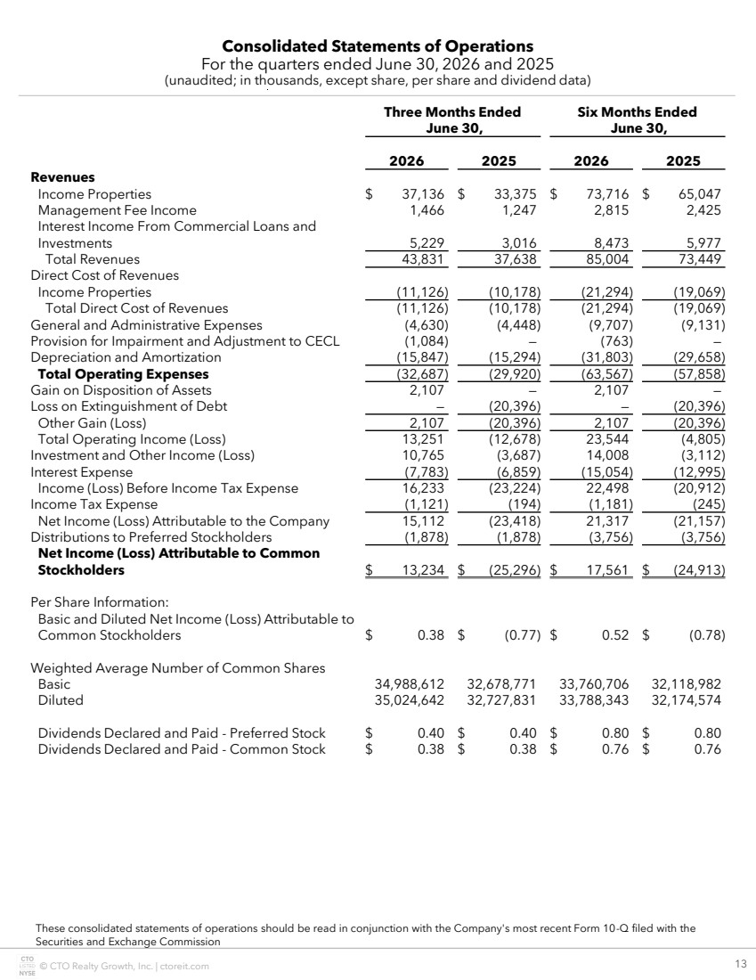 | © CTO Realty Growth, Inc. | ctoreit.com 13 Consolidated Statements of Operations For the quarters ended June 30, 2026 and 2025 (unaudited; in thousands, except share, per share and dividend data) These consolidated statements of operations should be read in conjunction with the Company's most recent Form 10-Q filed with the Securities and Exchange Commission Three Months Ended June 30, Six Months Ended June 30, 2026 2025 2026 2025 Revenues Income Properties $ 37,136 $ 33,375 $ 73,716 $ 65,047 Management Fee Income 1,466 1,247 2,815 2,425 Interest Income From Commercial Loans and Investments 5,229 3,016 8,473 5,977 Total Revenues 43,831 37,638 85,004 73,449 Direct Cost of Revenues Income Properties (11,126) (10,178) (21,294) (19,069) Total Direct Cost of Revenues (11,126) (10,178) (21,294) (19,069) General and Administrative Expenses (4,630) (4,448) (9,707) (9,131) Provision for Impairment and Adjustment to CECL (1,084) — (763) — Depreciation and Amortization (15,847) (15,294) (31,803) (29,658) Total Operating Expenses (32,687) (29,920) (63,567) (57,858) Gain on Disposition of Assets 2,107 — 2,107 — Loss on Extinguishment of Debt — (20,396) — (20,396) Other Gain (Loss) 2,107 (20,396) 2,107 (20,396) Total Operating Income (Loss) 13,251 (12,678) 23,544 (4,805) Investment and Other Income (Loss) 10,765 (3,687) 14,008 (3,112) Interest Expense (7,783) (6,859) (15,054) (12,995) Income (Loss) Before Income Tax Expense 16,233 (23,224) 22,498 (20,912) Income Tax Expense (1,121) (194) (1,181) (245) Net Income (Loss) Attributable to the Company 15,112 (23,418) 21,317 (21,157) Distributions to Preferred Stockholders (1,878) (1,878) (3,756) (3,756) Net Income (Loss) Attributable to Common Stockholders $ 13,234 $ (25,296) $ 17,561 $ (24,913) Per Share Information: Basic and Diluted Net Income (Loss) Attributable to Common Stockholders $ 0.38 $ (0.77) $ 0.52 $ (0.78) Weighted Average Number of Common Shares Basic 34,988,612 32,678,771 33,760,706 32,118,982 Diluted 35,024,642 32,727,831 33,788,343 32,174,574 Dividends Declared and Paid - Preferred Stock $ 0.40 $ 0.40 $ 0.80 $ 0.80 Dividends Declared and Paid - Common Stock $ 0.38 $ 0.38 $ 0.76 $ 0.76
 | 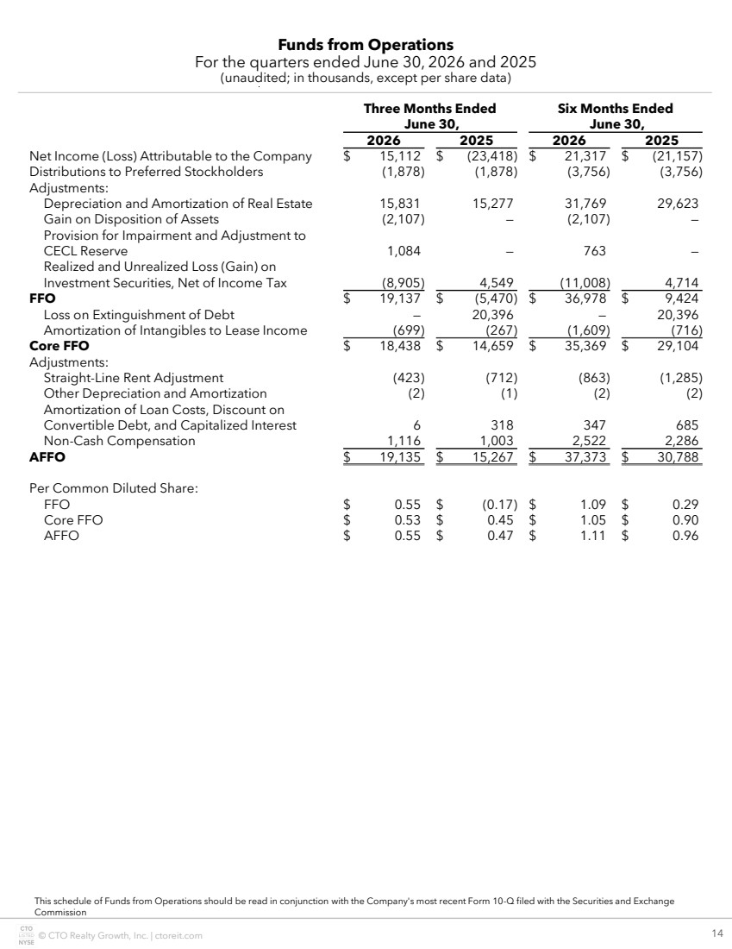 | © CTO Realty Growth, Inc. | ctoreit.com 14 Funds from Operations For the quarters ended June 30, 2026 and 2025 (unaudited; in thousands, except per share data) This schedule of Funds from Operations should be read in conjunction with the Company's most recent Form 10-Q filed with the Securities and Exchange Commission Three Months Ended June 30, Six Months Ended June 30, 2026 2025 2026 2025 Net Income (Loss) Attributable to the Company $ 15,112 $ (23,418) $ 21,317 $ (21,157) Distributions to Preferred Stockholders (1,878) (1,878) (3,756) (3,756) Adjustments: Depreciation and Amortization of Real Estate 15,831 15,277 31,769 29,623 Gain on Disposition of Assets (2,107) — (2,107) — Provision for Impairment and Adjustment to CECL Reserve 1,084 — 763 — Realized and Unrealized Loss (Gain) on Investment Securities, Net of Income Tax (8,905) 4,549 (11,008) 4,714 FFO $ 19,137 $ (5,470) $ 36,978 $ 9,424 Loss on Extinguishment of Debt — 20,396 — 20,396 Amortization of Intangibles to Lease Income (699) (267) (1,609) (716) Core FFO $ 18,438 $ 14,659 $ 35,369 $ 29,104 Adjustments: Straight-Line Rent Adjustment (423) (712) (863) (1,285) Other Depreciation and Amortization (2) (1) (2) (2) Amortization of Loan Costs, Discount on Convertible Debt, and Capitalized Interest 6 318 347 685 Non-Cash Compensation 1,116 1,003 2,522 2,286 AFFO $ 19,135 $ 15,267 $ 37,373 $ 30,788 Per Common Diluted Share: FFO $ 0.55 $ (0.17) $ 1.09 $ 0.29 Core FFO $ 0.53 $ 0.45 $ 1.05 $ 0.90 AFFO $ 0.55 $ 0.47 $ 1.11 $ 0.96
 | 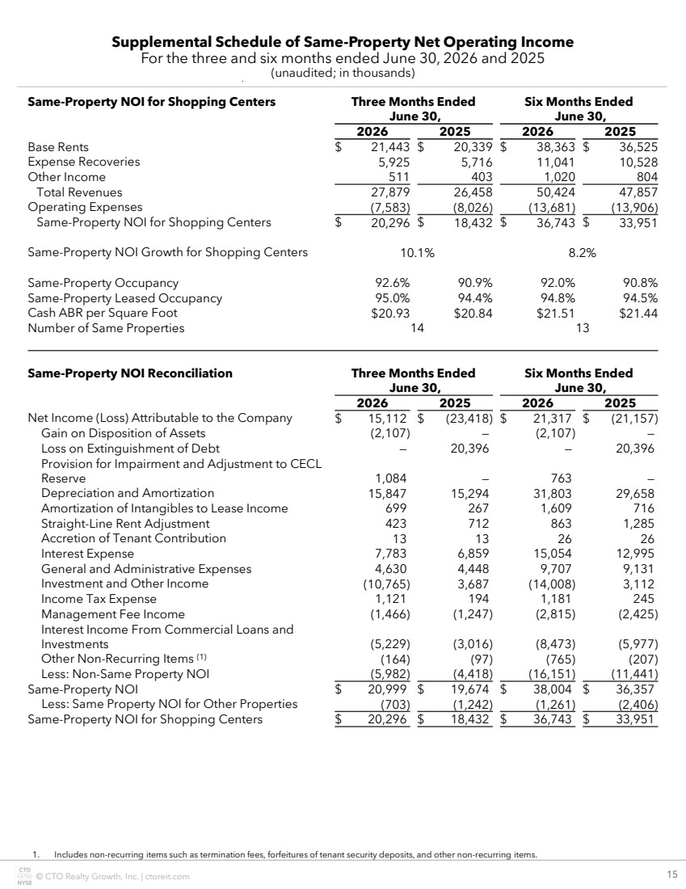 | © CTO Realty Growth, Inc. | ctoreit.com 15 Supplemental Schedule of Same-Property Net Operating Income For the three and six months ended June 30, 2026 and 2025 (unaudited; in thousands) 1. Includes non-recurring items such as termination fees, forfeitures of tenant security deposits, and other non-recurring items. Same-Property NOI for Shopping Centers Three Months Ended June 30, Six Months Ended June 30, 2026 2025 2026 2025 Base Rents $ 21,443 $ 20,339 $ 38,363 $ 36,525 Expense Recoveries 5,925 5,716 11,041 10,528 Other Income 511 403 1,020 804 Total Revenues 27,879 26,458 50,424 47,857 Operating Expenses (7,583) (8,026) (13,681) (13,906) Same-Property NOI for Shopping Centers $ 20,296 $ 18,432 $ 36,743 $ 33,951 Same-Property NOI Growth for Shopping Centers 10.1% 8.2% Same-Property Occupancy 92.6% 90.9% 92.0% 90.8% Same-Property Leased Occupancy 95.0% 94.4% 94.8% 94.5% Cash ABR per Square Foot $20.93 $20.84 $21.51 $21.44 Number of Same Properties 14 13 Same-Property NOI Reconciliation Three Months Ended June 30, Six Months Ended June 30, 2026 2025 2026 2025 Net Income (Loss) Attributable to the Company $ 15,112 $ (23,418) $ 21,317 $ (21,157) Gain on Disposition of Assets (2,107) — (2,107) — Loss on Extinguishment of Debt — 20,396 — 20,396 Provision for Impairment and Adjustment to CECL Reserve 1,084 — 763 — Depreciation and Amortization 15,847 15,294 31,803 29,658 Amortization of Intangibles to Lease Income 699 267 1,609 716 Straight-Line Rent Adjustment 423 712 863 1,285 Accretion of Tenant Contribution 13 13 26 26 Interest Expense 7,783 6,859 15,054 12,995 General and Administrative Expenses 4,630 4,448 9,707 9,131 Investment and Other Income (10,765) 3,687 (14,008) 3,112 Income Tax Expense 1,121 194 1,181 245 Management Fee Income (1,466) (1,247) (2,815) (2,425) Interest Income From Commercial Loans and Investments (5,229) (3,016) (8,473) (5,977) Other Non-Recurring Items (1) (164) (97) (765) (207) Less: Non-Same Property NOI (5,982) (4,418) (16,151) (11,441) Same-Property NOI $ 20,999 $ 19,674 $ 38,004 $ 36,357 Less: Same Property NOI for Other Properties (703) (1,242) (1,261) (2,406) Same-Property NOI for Shopping Centers $ 20,296 $ 18,432 $ 36,743 $ 33,951
 | 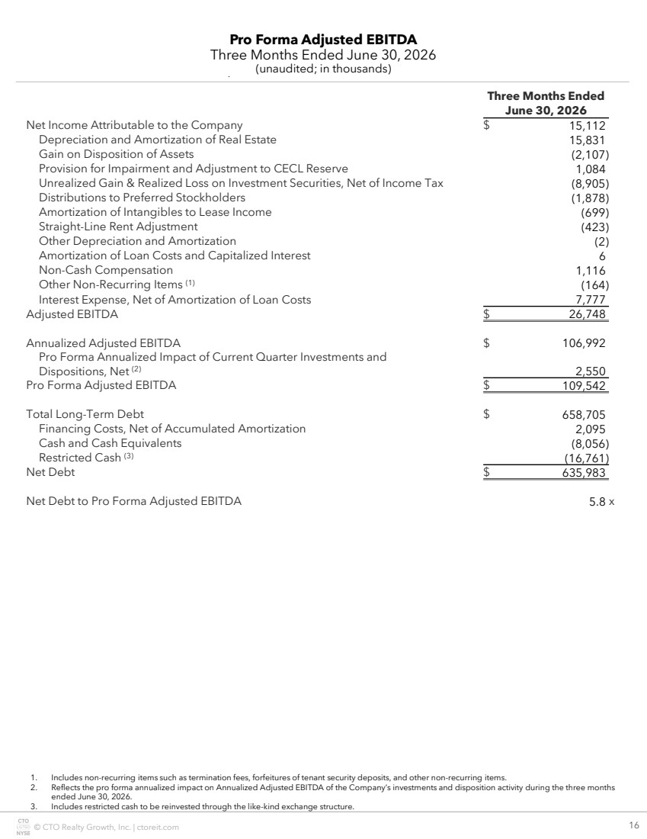 | © CTO Realty Growth, Inc. | ctoreit.com 16 Pro Forma Adjusted EBITDA Three Months Ended June 30, 2026 (unaudited; in thousands) Three Months Ended June 30, 2026 Net Income Attributable to the Company $ 15,112 Depreciation and Amortization of Real Estate 15,831 Gain on Disposition of Assets (2,107) Provision for Impairment and Adjustment to CECL Reserve 1,084 Unrealized Gain & Realized Loss on Investment Securities, Net of Income Tax (8,905) Distributions to Preferred Stockholders (1,878) Amortization of Intangibles to Lease Income (699) Straight-Line Rent Adjustment (423) Other Depreciation and Amortization (2) Amortization of Loan Costs and Capitalized Interest 6 Non-Cash Compensation 1,116 Other Non-Recurring Items (1) (164) Interest Expense, Net of Amortization of Loan Costs 7,777 Adjusted EBITDA $ 26,748 Annualized Adjusted EBITDA $ 106,992 Pro Forma Annualized Impact of Current Quarter Investments and Dispositions, Net (2) 2,550 Pro Forma Adjusted EBITDA $ 109,542 Total Long-Term Debt $ 658,705 Financing Costs, Net of Accumulated Amortization 2,095 Cash and Cash Equivalents (8,056) Restricted Cash (3) (16,761) Net Debt $ 635,983 Net Debt to Pro Forma Adjusted EBITDA 5.8 x 1. Includes non-recurring items such as termination fees, forfeitures of tenant security deposits, and other non-recurring items. 2. Reflects the pro forma annualized impact on Annualized Adjusted EBITDA of the Company’s investments and disposition activity during the three months ended June 30, 2026. 3. Includes restricted cash to be reinvested through the like-kind exchange structure.
 | 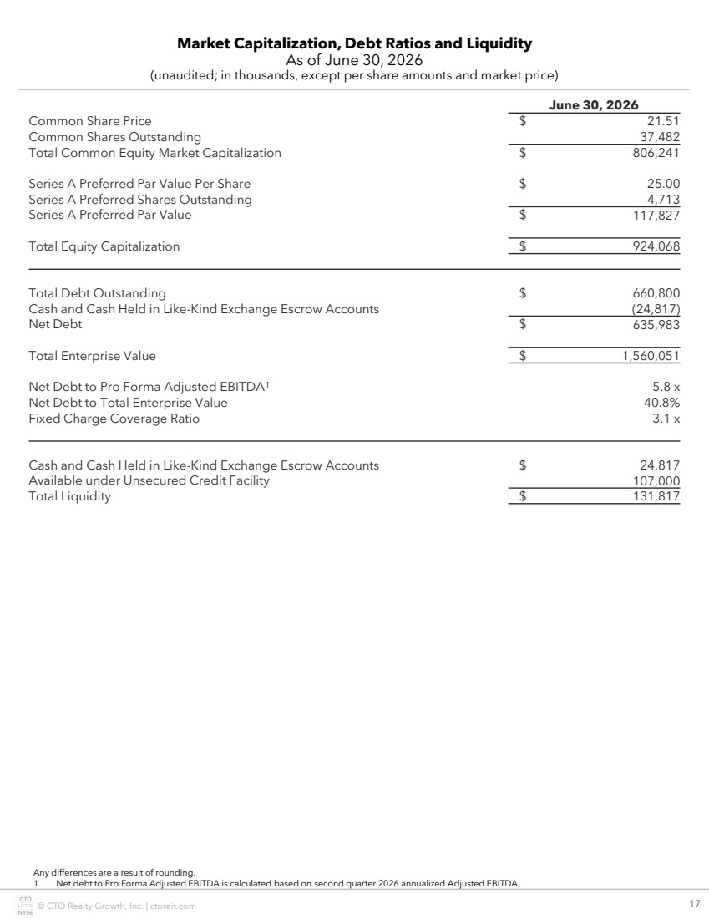 | © CTO Realty Growth, Inc. | ctoreit.com 17 Market Capitalization, Debt Ratios and Liquidity As of June 30, 2026 (unaudited; in thousands, except per share amounts and market price) Any differences are a result of rounding. 1. Net debt to Pro Forma Adjusted EBITDA is calculated based on second quarter 2026 annualized Adjusted EBITDA. June 30, 2026 Common Share Price $ 21.51 Common Shares Outstanding 37,482 Total Common Equity Market Capitalization $ 806,241 Series A Preferred Par Value Per Share $ 25.00 Series A Preferred Shares Outstanding 4,713 Series A Preferred Par Value $ 117,827 Total Equity Capitalization $ 924,068 Total Debt Outstanding $ 660,800 Cash and Cash Held in Like-Kind Exchange Escrow Accounts (24,817) Net Debt $ 635,983 Total Enterprise Value $ 1,560,051 Net Debt to Pro Forma Adjusted EBITDA1 5.8 x Net Debt to Total Enterprise Value 40.8% Fixed Charge Coverage Ratio 3.1 x Cash and Cash Held in Like-Kind Exchange Escrow Accounts $ 24,817 Available under Unsecured Credit Facility 107,000 Total Liquidity $ 131,817
 | 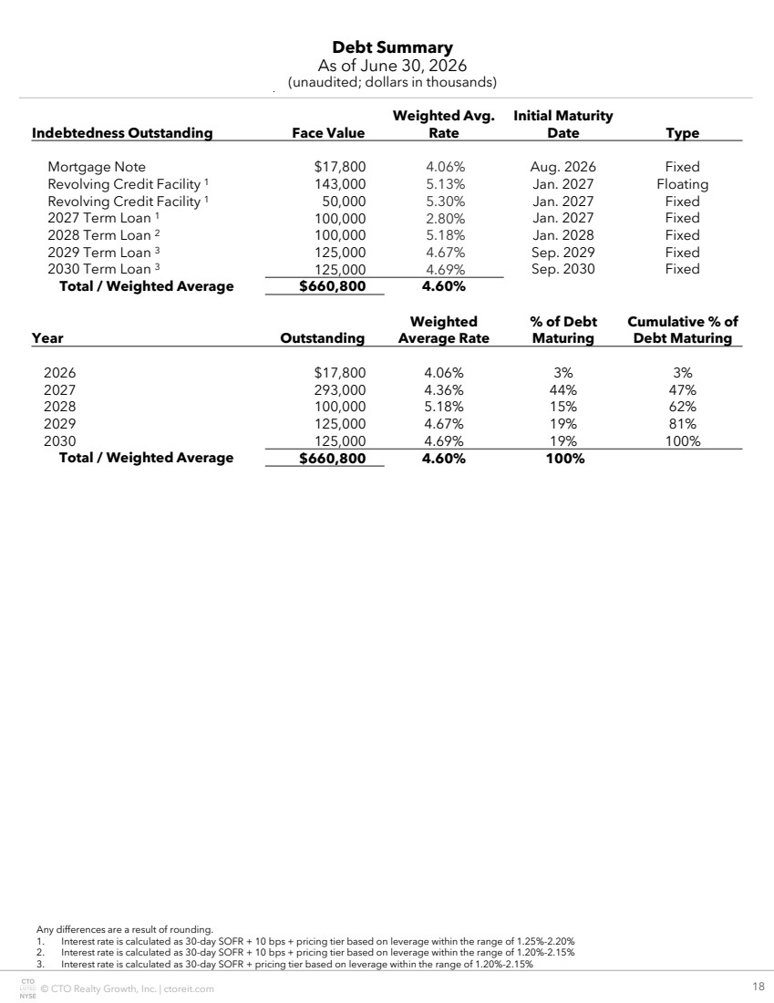 | © CTO Realty Growth, Inc. | ctoreit.com 18 Debt Summary As of June 30, 2026 (unaudited; dollars in thousands) Any differences are a result of rounding. 1. Interest rate is calculated as 30-day SOFR + 10 bps + pricing tier based on leverage within the range of 1.25%-2.20% 2. Interest rate is calculated as 30-day SOFR + 10 bps + pricing tier based on leverage within the range of 1.20%-2.15% 3. Interest rate is calculated as 30-day SOFR + pricing tier based on leverage within the range of 1.20%-2.15% Indebtedness Outstanding Face Value Weighted Avg. Rate Initial Maturity Date Type Mortgage Note $17,800 4.06% Aug. 2026 Fixed Revolving Credit Facility 1 143,000 5.13% Jan. 2027 Floating Revolving Credit Facility 1 50,000 5.30% Jan. 2027 Fixed 2027 Term Loan 1 100,000 2.80% Jan. 2027 Fixed 2028 Term Loan 2 100,000 5.18% Jan. 2028 Fixed 2029 Term Loan 3 125,000 4.67% Sep. 2029 Fixed 2030 Term Loan 3 125,000 4.69% Sep. 2030 Fixed Total / Weighted Average $660,800 4.60% Year Outstanding Weighted Average Rate % of Debt Maturing Cumulative % of Debt Maturing 2026 $17,800 4.06% 3% 3% 2027 293,000 4.36% 44% 47% 2028 100,000 5.18% 15% 62% 2029 125,000 4.67% 19% 81% 2030 125,000 4.69% 19% 100% Total / Weighted Average $660,800 4.60% 100%
 | 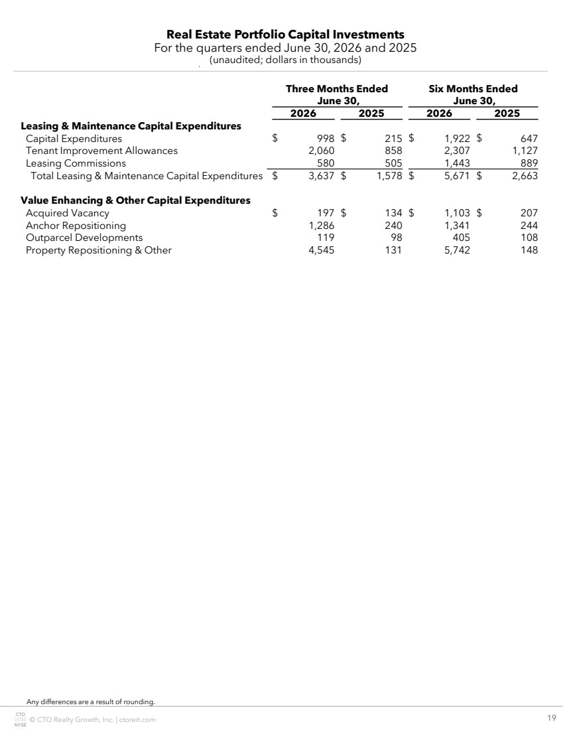 | © CTO Realty Growth, Inc. | ctoreit.com 19 Real Estate Portfolio Capital Investments For the quarters ended June 30, 2026 and 2025 (unaudited; dollars in thousands) Any differences are a result of rounding. Three Months Ended June 30, Six Months Ended June 30, 2026 2025 2026 2025 Leasing & Maintenance Capital Expenditures Capital Expenditures $ 998 $ 215 $ 1,922 $ 647 Tenant Improvement Allowances 2,060 858 2,307 1,127 Leasing Commissions 580 505 1,443 889 Total Leasing & Maintenance Capital Expenditures $ 3,637 $ 1,578 $ 5,671 $ 2,663 Value Enhancing & Other Capital Expenditures Acquired Vacancy $ 197 $ 134 $ 1,103 $ 207 Anchor Repositioning 1,286 240 1,341 244 Outparcel Developments 119 98 405 108 Property Repositioning & Other 4,545 131 5,742 148
 | 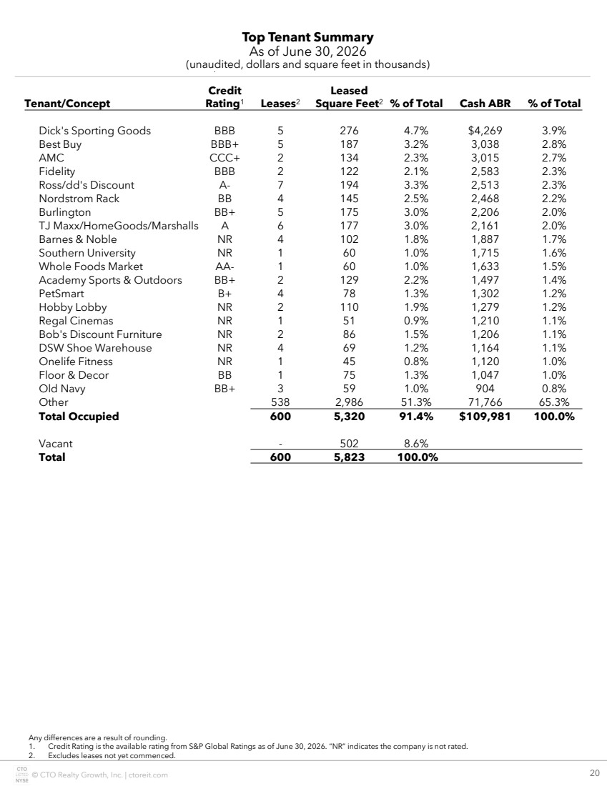 | © CTO Realty Growth, Inc. | ctoreit.com 20 Top Tenant Summary As of June 30, 2026 (unaudited, dollars and square feet in thousands) Any differences are a result of rounding. 1. Credit Rating is the available rating from S&P Global Ratings as of June 30, 2026. “NR” indicates the company is not rated. 2. Excludes leases not yet commenced. Tenant/Concept Credit Rating1 Leases2 Leased Square Feet2 % of Total Cash ABR % of Total Dick's Sporting Goods BBB 5 276 4.7% $4,269 3.9% Best Buy BBB+ 5 187 3.2% 3,038 2.8% AMC CCC+ 2 134 2.3% 3,015 2.7% Fidelity BBB 2 122 2.1% 2,583 2.3% Ross/dd's Discount A- 7 194 3.3% 2,513 2.3% Nordstrom Rack BB 4 145 2.5% 2,468 2.2% Burlington BB+ 5 175 3.0% 2,206 2.0% TJ Maxx/HomeGoods/Marshalls A 6 177 3.0% 2,161 2.0% Barnes & Noble NR 4 102 1.8% 1,887 1.7% Southern University NR 1 60 1.0% 1,715 1.6% Whole Foods Market AA- 1 60 1.0% 1,633 1.5% Academy Sports & Outdoors BB+ 2 129 2.2% 1,497 1.4% PetSmart B+ 4 78 1.3% 1,302 1.2% Hobby Lobby NR 2 110 1.9% 1,279 1.2% Regal Cinemas NR 1 51 0.9% 1,210 1.1% Bob's Discount Furniture NR 2 86 1.5% 1,206 1.1% DSW Shoe Warehouse NR 4 69 1.2% 1,164 1.1% Onelife Fitness NR 1 45 0.8% 1,120 1.0% Floor & Decor BB 1 75 1.3% 1,047 1.0% Old Navy BB+ 3 59 1.0% 904 0.8% Other 538 2,986 51.3% 71,766 65.3% Total Occupied 600 5,320 91.4% $109,981 100.0% Vacant - 502 8.6% Total 600 5,823 100.0%
 | 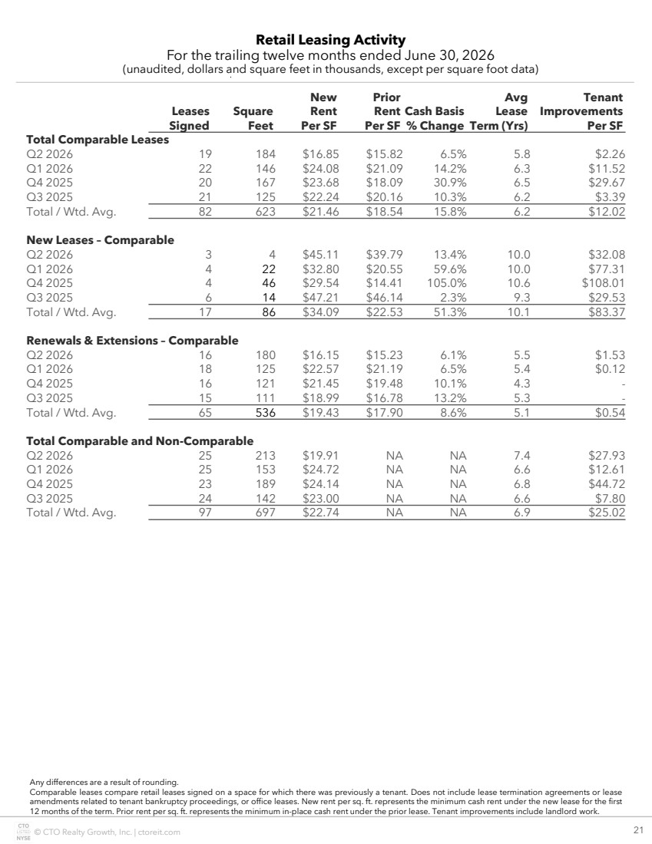 | © CTO Realty Growth, Inc. | ctoreit.com 21 Retail Leasing Activity For the trailing twelve months ended June 30, 2026 (unaudited, dollars and square feet in thousands, except per square foot data) Any differences are a result of rounding. Comparable leases compare retail leases signed on a space for which there was previously a tenant. Does not include lease termination agreements or lease amendments related to tenant bankruptcy proceedings, or office leases. New rent per sq. ft. represents the minimum cash rent under the new lease for the first 12 months of the term. Prior rent per sq. ft. represents the minimum in-place cash rent under the prior lease. Tenant improvements include landlord work. Leases Signed Square Feet New Rent Per SF Prior Rent Per SF Cash Basis % Change Avg Lease Term (Yrs) Tenant Improvements Per SF Total Comparable Leases Q2 2026 19 184 $16.85 $15.82 6.5% 5.8 $2.26 Q1 2026 22 146 $24.08 $21.09 14.2% 6.3 $11.52 Q4 2025 20 167 $23.68 $18.09 30.9% 6.5 $29.67 Q3 2025 21 125 $22.24 $20.16 10.3% 6.2 $3.39 Total / Wtd. Avg. 82 623 $21.46 $18.54 15.8% 6.2 $12.02 New Leases – Comparable Q2 2026 3 4 $45.11 $39.79 13.4% 10.0 $32.08 Q1 2026 4 22 $32.80 $20.55 59.6% 10.0 $77.31 Q4 2025 4 46 $29.54 $14.41 105.0% 10.6 $108.01 Q3 2025 6 14 $47.21 $46.14 2.3% 9.3 $29.53 Total / Wtd. Avg. 17 86 $34.09 $22.53 51.3% 10.1 $83.37 Renewals & Extensions – Comparable Q2 2026 16 180 $16.15 $15.23 6.1% 5.5 $1.53 Q1 2026 18 125 $22.57 $21.19 6.5% 5.4 $0.12 Q4 2025 16 121 $21.45 $19.48 10.1% 4.3 - Q3 2025 15 111 $18.99 $16.78 13.2% 5.3 - Total / Wtd. Avg. 65 536 $19.43 $17.90 8.6% 5.1 $0.54 Total Comparable and Non-Comparable Q2 2026 25 213 $19.91 NA NA 7.4 $27.93 Q1 2026 25 153 $24.72 NA NA 6.6 $12.61 Q4 2025 23 189 $24.14 NA NA 6.8 $44.72 Q3 2025 24 142 $23.00 NA NA 6.6 $7.80 Total / Wtd. Avg. 97 697 $22.74 NA NA 6.9 $25.02
 | 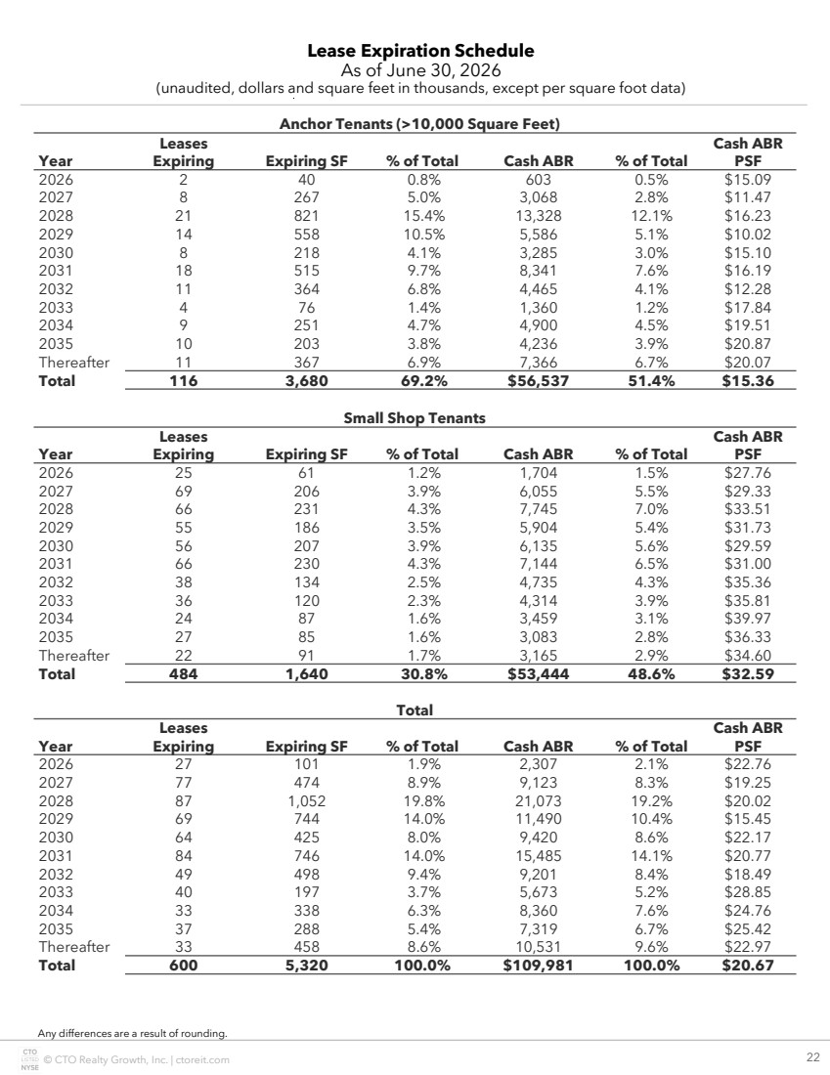 | © CTO Realty Growth, Inc. | ctoreit.com 22 Lease Expiration Schedule As of June 30, 2026 (unaudited, dollars and square feet in thousands, except per square foot data) Any differences are a result of rounding. Anchor Tenants (>10,000 Square Feet) Year Leases Expiring Expiring SF % of Total Cash ABR % of Total Cash ABR PSF 2026 2 40 0.8% 603 0.5% $15.09 2027 8 267 5.0% 3,068 2.8% $11.47 2028 21 821 15.4% 13,328 12.1% $16.23 2029 14 558 10.5% 5,586 5.1% $10.02 2030 8 218 4.1% 3,285 3.0% $15.10 2031 18 515 9.7% 8,341 7.6% $16.19 2032 11 364 6.8% 4,465 4.1% $12.28 2033 4 76 1.4% 1,360 1.2% $17.84 2034 9 251 4.7% 4,900 4.5% $19.51 2035 10 203 3.8% 4,236 3.9% $20.87 Thereafter 11 367 6.9% 7,366 6.7% $20.07 Total 116 3,680 69.2% $56,537 51.4% $15.36 Small Shop Tenants Year Leases Expiring Expiring SF % of Total Cash ABR % of Total Cash ABR PSF 2026 25 61 1.2% 1,704 1.5% $27.76 2027 69 206 3.9% 6,055 5.5% $29.33 2028 66 231 4.3% 7,745 7.0% $33.51 2029 55 186 3.5% 5,904 5.4% $31.73 2030 56 207 3.9% 6,135 5.6% $29.59 2031 66 230 4.3% 7,144 6.5% $31.00 2032 38 134 2.5% 4,735 4.3% $35.36 2033 36 120 2.3% 4,314 3.9% $35.81 2034 24 87 1.6% 3,459 3.1% $39.97 2035 27 85 1.6% 3,083 2.8% $36.33 Thereafter 22 91 1.7% 3,165 2.9% $34.60 Total 484 1,640 30.8% $53,444 48.6% $32.59 Total Year Leases Expiring Expiring SF % of Total Cash ABR % of Total Cash ABR PSF 2026 27 101 1.9% 2,307 2.1% $22.76 2027 77 474 8.9% 9,123 8.3% $19.25 2028 87 1,052 19.8% 21,073 19.2% $20.02 2029 69 744 14.0% 11,490 10.4% $15.45 2030 64 425 8.0% 9,420 8.6% $22.17 2031 84 746 14.0% 15,485 14.1% $20.77 2032 49 498 9.4% 9,201 8.4% $18.49 2033 40 197 3.7% 5,673 5.2% $28.85 2034 33 338 6.3% 8,360 7.6% $24.76 2035 37 288 5.4% 7,319 6.7% $25.42 Thereafter 33 458 8.6% 10,531 9.6% $22.97 Total 600 5,320 100.0% $109,981 100.0% $20.67
 | 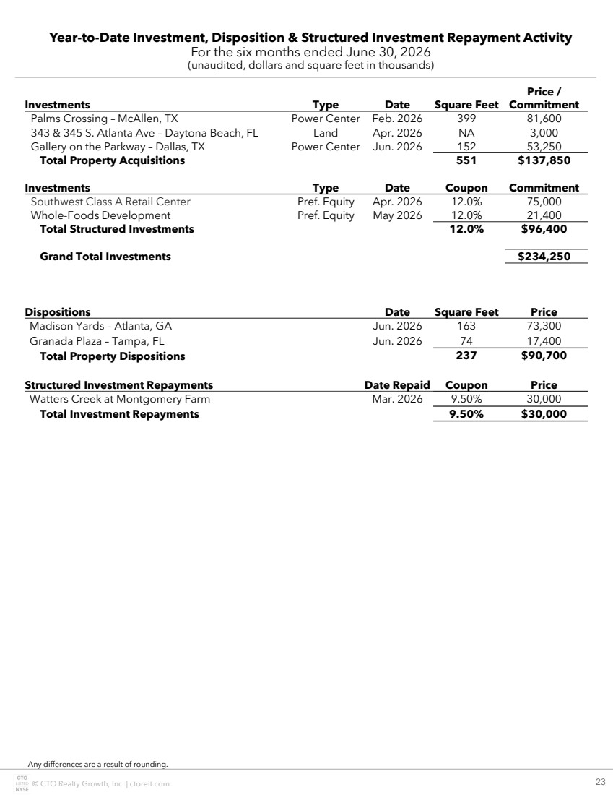 | © CTO Realty Growth, Inc. | ctoreit.com 23 Year-to-Date Investment, Disposition & Structured Investment Repayment Activity For the six months ended June 30, 2026 (unaudited, dollars and square feet in thousands) Any differences are a result of rounding. Investments Type Date Square Feet Price / Commitment Palms Crossing – McAllen, TX Power Center Feb. 2026 399 81,600 343 & 345 S. Atlanta Ave – Daytona Beach, FL Land Apr. 2026 NA 3,000 Gallery on the Parkway – Dallas, TX Power Center Jun. 2026 152 53,250 Total Property Acquisitions 551 $137,850 Investments Type Date Coupon Commitment Southwest Class A Retail Center Pref. Equity Apr. 2026 12.0% 75,000 Whole-Foods Development Pref. Equity May 2026 12.0% 21,400 Total Structured Investments 12.0% $96,400 Grand Total Investments $234,250 Dispositions Date Square Feet Price Madison Yards – Atlanta, GA Jun. 2026 163 73,300 Granada Plaza – Tampa, FL Jun. 2026 74 17,400 Total Property Dispositions 237 $90,700 Structured Investment Repayments Date Repaid Coupon Price Watters Creek at Montgomery Farm Mar. 2026 9.50% 30,000 Total Investment Repayments 9.50% $30,000
 | 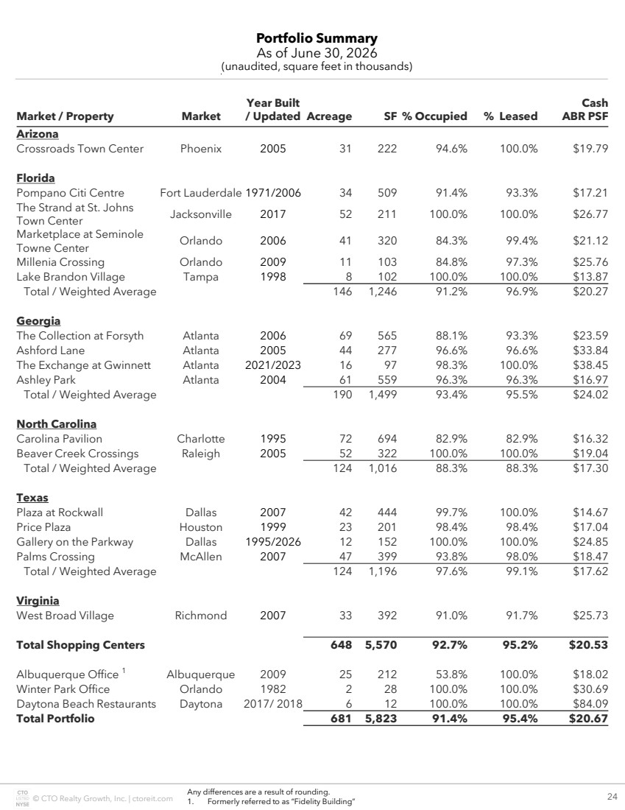 | © CTO Realty Growth, Inc. | ctoreit.com 24 Portfolio Summary As of June 30, 2026 (unaudited, square feet in thousands) Any differences are a result of rounding. 1. Formerly referred to as “Fidelity Building” Market / Property Market Year Built / Updated Acreage SF % Occupied % Leased Cash ABR PSF Arizona Crossroads Town Center Phoenix 2005 31 222 94.6% 100.0% $19.79 Florida Pompano Citi Centre Fort Lauderdale 1971/2006 34 509 91.4% 93.3% $17.21 The Strand at St. Johns Town Center Jacksonville 2017 52 211 100.0% 100.0% $26.77 Marketplace at Seminole Towne Center Orlando 2006 41 320 84.3% 99.4% $21.12 Millenia Crossing Orlando 2009 11 103 84.8% 97.3% $25.76 Lake Brandon Village Tampa 1998 8 102 100.0% 100.0% $13.87 Total / Weighted Average 146 1,246 91.2% 96.9% $20.27 Georgia The Collection at Forsyth Atlanta 2006 69 565 88.1% 93.3% $23.59 Ashford Lane Atlanta 2005 44 277 96.6% 96.6% $33.84 The Exchange at Gwinnett Atlanta 2021/2023 16 97 98.3% 100.0% $38.45 Ashley Park Atlanta 2004 61 559 96.3% 96.3% $16.97 Total / Weighted Average 190 1,499 93.4% 95.5% $24.02 North Carolina Carolina Pavilion Charlotte 1995 72 694 82.9% 82.9% $16.32 Beaver Creek Crossings Raleigh 2005 52 322 100.0% 100.0% $19.04 Total / Weighted Average 124 1,016 88.3% 88.3% $17.30 Texas Plaza at Rockwall Dallas 2007 42 444 99.7% 100.0% $14.67 Price Plaza Houston 1999 23 201 98.4% 98.4% $17.04 Gallery on the Parkway Dallas 1995/2026 12 152 100.0% 100.0% $24.85 Palms Crossing McAllen 2007 47 399 93.8% 98.0% $18.47 Total / Weighted Average 124 1,196 97.6% 99.1% $17.62 Virginia West Broad Village Richmond 2007 33 392 91.0% 91.7% $25.73 Total Shopping Centers 648 5,570 92.7% 95.2% $20.53 Albuquerque Office 1 Albuquerque 2009 25 212 53.8% 100.0% $18.02 Winter Park Office Orlando 1982 2 28 100.0% 100.0% $30.69 Daytona Beach Restaurants Daytona 2017/ 2018 6 12 100.0% 100.0% $84.09 Total Portfolio 681 5,823 91.4% 95.4% $20.67
 | 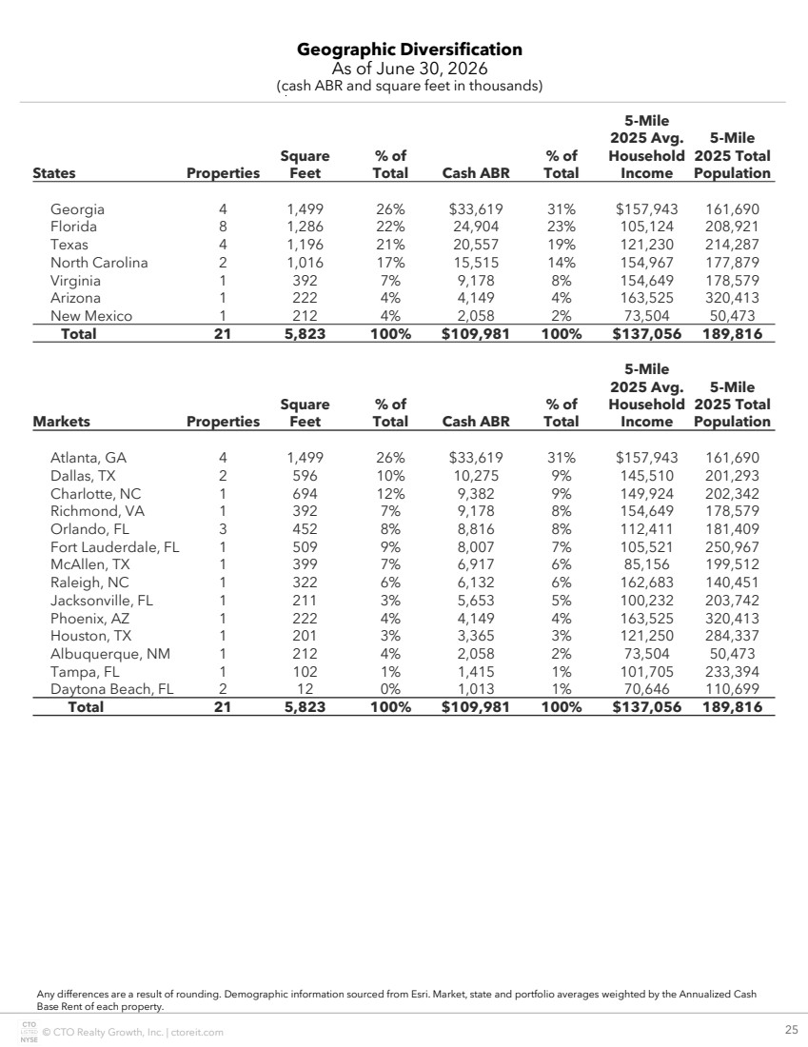 | © CTO Realty Growth, Inc. | ctoreit.com 25 Geographic Diversification As of June 30, 2026 (cash ABR and square feet in thousands) Any differences are a result of rounding. Demographic information sourced from Esri. Market, state and portfolio averages weighted by the Annualized Cash Base Rent of each property. States Properties Square Feet % of Total Cash ABR % of Total 5-Mile 2025 Avg. Household Income 5-Mile 2025 Total Population Georgia 4 1,499 26% $33,619 31% $157,943 161,690 Florida 8 1,286 22% 24,904 23% 105,124 208,921 Texas 4 1,196 21% 20,557 19% 121,230 214,287 North Carolina 2 1,016 17% 15,515 14% 154,967 177,879 Virginia 1 392 7% 9,178 8% 154,649 178,579 Arizona 1 222 4% 4,149 4% 163,525 320,413 New Mexico 1 212 4% 2,058 2% 73,504 50,473 Total 21 5,823 100% $109,981 100% $137,056 189,816 Markets Properties Square Feet % of Total Cash ABR % of Total 5-Mile 2025 Avg. Household Income 5-Mile 2025 Total Population Atlanta, GA 4 1,499 26% $33,619 31% $157,943 161,690 Dallas, TX 2 596 10% 10,275 9% 145,510 201,293 Charlotte, NC 1 694 12% 9,382 9% 149,924 202,342 Richmond, VA 1 392 7% 9,178 8% 154,649 178,579 Orlando, FL 3 452 8% 8,816 8% 112,411 181,409 Fort Lauderdale, FL 1 509 9% 8,007 7% 105,521 250,967 McAllen, TX 1 399 7% 6,917 6% 85,156 199,512 Raleigh, NC 1 322 6% 6,132 6% 162,683 140,451 Jacksonville, FL 1 211 3% 5,653 5% 100,232 203,742 Phoenix, AZ 1 222 4% 4,149 4% 163,525 320,413 Houston, TX 1 201 3% 3,365 3% 121,250 284,337 Albuquerque, NM 1 212 4% 2,058 2% 73,504 50,473 Tampa, FL 1 102 1% 1,415 1% 101,705 233,394 Daytona Beach, FL 2 12 0% 1,013 1% 70,646 110,699 Total 21 5,823 100% $109,981 100% $137,056 189,816
 | 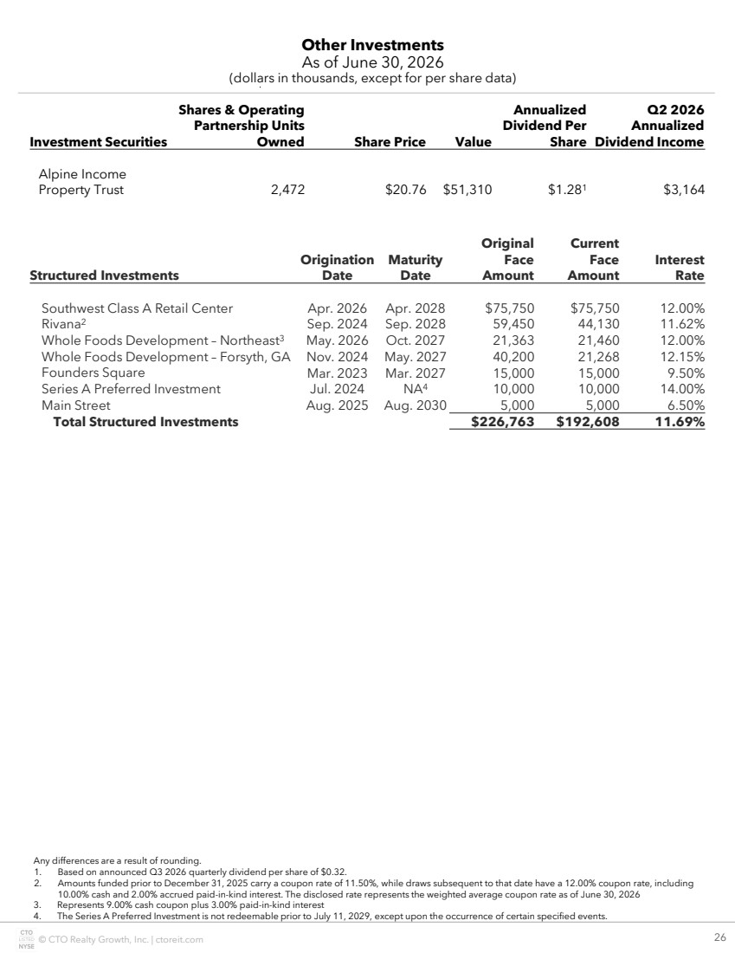 | © CTO Realty Growth, Inc. | ctoreit.com 26 Other Investments As of June 30, 2026 (dollars in thousands, except for per share data) Any differences are a result of rounding. 1. Based on announced Q3 2026 quarterly dividend per share of $0.32. 2. Amounts funded prior to December 31, 2025 carry a coupon rate of 11.50%, while draws subsequent to that date have a 12.00% coupon rate, including 10.00% cash and 2.00% accrued paid-in-kind interest. The disclosed rate represents the weighted average coupon rate as of June 30, 2026 3. Represents 9.00% cash coupon plus 3.00% paid-in-kind interest 4. The Series A Preferred Investment is not redeemable prior to July 11, 2029, except upon the occurrence of certain specified events. Investment Securities Shares & Operating Partnership Units Owned Share Price Value Annualized Dividend Per Share Q2 2026 Annualized Dividend Income Alpine Income Property Trust 2,472 $20.76 $51,310 $1.281 $3,164 Structured Investments Origination Date Maturity Date Original Face Amount Current Face Amount Interest Rate Southwest Class A Retail Center Apr. 2026 Apr. 2028 $75,750 $75,750 12.00% Rivana2 Sep. 2024 Sep. 2028 59,450 44,130 11.62% Whole Foods Development – Northeast3 May. 2026 Oct. 2027 21,363 21,460 12.00% Whole Foods Development – Forsyth, GA Nov. 2024 May. 2027 40,200 21,268 12.15% Founders Square Mar. 2023 Mar. 2027 15,000 15,000 9.50% Series A Preferred Investment Jul. 2024 NA4 10,000 10,000 14.00% Main Street Aug. 2025 Aug. 2030 5,000 5,000 6.50% Total Structured Investments $226,763 $192,608 11.69%
 | 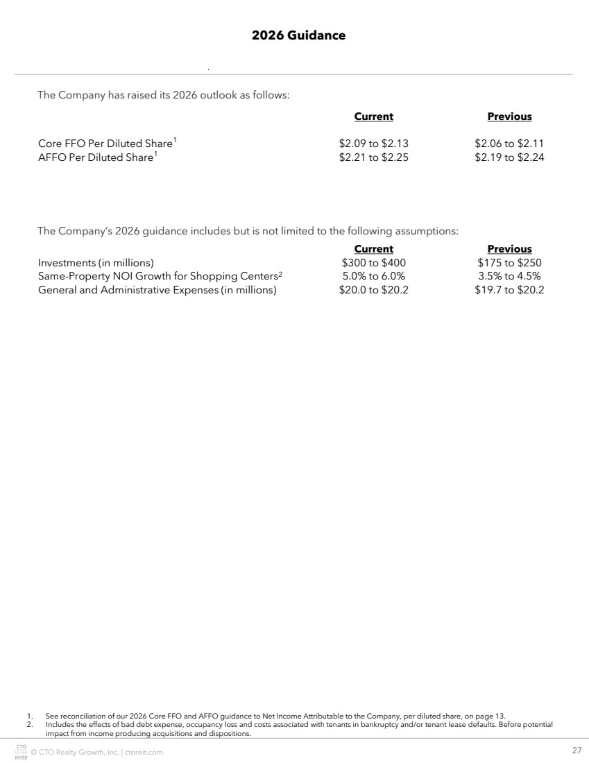 | © CTO Realty Growth, Inc. | ctoreit.com 27 2026 Guidance 1. See reconciliation of our 2026 Core FFO and AFFO guidance to Net Income Attributable to the Company, per diluted share, on page 13. 2. Includes the effects of bad debt expense, occupancy loss and costs associated with tenants in bankruptcy and/or tenant lease defaults. Before potential impact from income producing acquisitions and dispositions. Current Previous Core FFO Per Diluted Share1 $2.09 to $2.13 $2.06 to $2.11 AFFO Per Diluted Share1 $2.21 to $2.25 $2.19 to $2.24 The Company has raised its 2026 outlook as follows: The Company’s 2026 guidance includes but is not limited to the following assumptions: Current Previous Investments (in millions) $300 to $400 $175 to $250 Same-Property NOI Growth for Shopping Centers2 5.0% to 6.0% 3.5% to 4.5% General and Administrative Expenses (in millions) $20.0 to $20.2 $19.7 to $20.2
 | 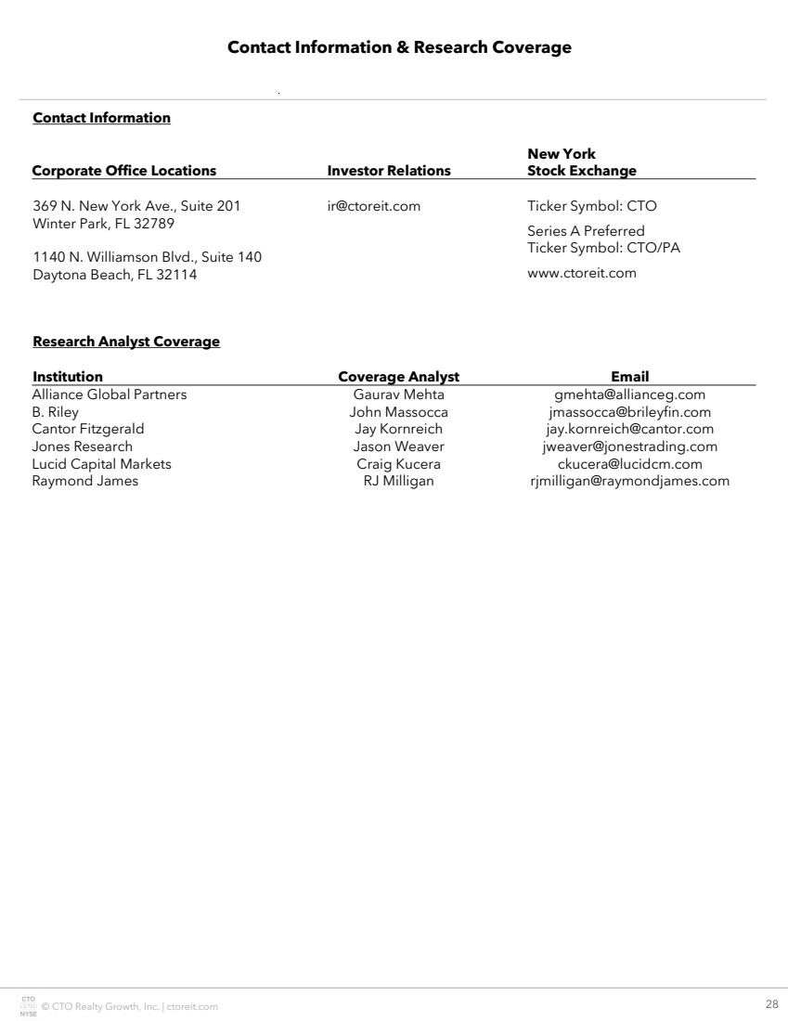 | © CTO Realty Growth, Inc. | ctoreit.com 28 Contact Information & Research Coverage Contact Information Corporate Office Locations Investor Relations New York Stock Exchange 369 N. New York Ave., Suite 201 Winter Park, FL 32789 1140 N. Williamson Blvd., Suite 140 Daytona Beach, FL 32114 ir@ctoreit.com Ticker Symbol: CTO Series A Preferred Ticker Symbol: CTO/PA www.ctoreit.com Research Analyst Coverage Institution Coverage Analyst Email Alliance Global Partners Gaurav Mehta gmehta@allianceg.com B. Riley John Massocca jmassocca@brileyfin.com Cantor Fitzgerald Jay Kornreich jay.kornreich@cantor.com Jones Research Jason Weaver jweaver@jonestrading.com Lucid Capital Markets Craig Kucera ckucera@lucidcm.com Raymond James RJ Milligan rjmilligan@raymondjames.com

